u
Deliverable 2.5
report on
National and International R&I Programs and Needs

BATTERY 2030+ CSA3

Deliverable 2.5
report on
National and International R&I Programmes and needs
BATTERY 2030+ CSA3

 | Document Classification
Deliverable Number & Title | D2.5 National and International R&I Programs and Needs.
Work Package | WP2 – Maintain and develop roadmaps and identify future research needs
Author(s) | VDI/VDE-IT - Monika Curto Fuentes  VDI/VDE-IT - Dr. Marlene Eisenträger  VDI/VDE-IT - Kai Giringer
Delivery due date | 2026-06-30
Dissemination Level | Public

 |  | Document History
Draft version | 2026-06-01 | VDI/VDE-IT
Internal review | 2026-06-15 | Project Coordinator  P1 UPPSALA – Patrik Johansson
External validation | 2026-06-20 | Battery experts in the selected countries
Final version | 2026-06-30 | Submission

Views and opinions expressed are those of the author(s) only and do not necessarily reflect those of the European Union or the European Climate, Infrastructure and Environment Executive Agency (CINEA). Neither the European Union nor the granting authority can be held responsible for them.

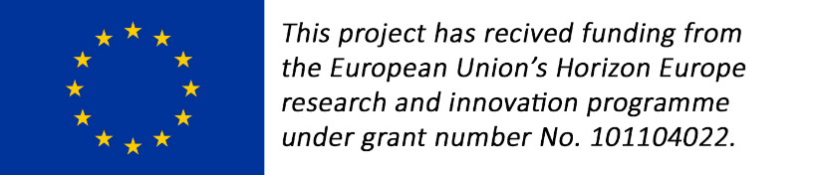
Table of contents

1 Introduction 5
1.1 Background 5
1.2 Methodology 7
2 The Strategic Landscape of Battery R&D 9
2.1 Europe´s Battery Ecosystem 9
2.2 Global Battery Landscape and Geopolitical Challenges 13
3 Battery R&D Activities 16
3.1 Europe 16
3.1.1 Austria 16
3.1.2 Belgium 17
3.1.3 Croatia 18
3.1.4 Czech Republic 18
3.1.5 Denmark 20
3.1.6 Estonia 22
3.1.7 Finland 24
3.1.8 France 26
3.1.9 Germany 29
3.1.10 Greece 33
3.1.11 Hungary 34
3.1.12 Ireland 37
3.1.13 Italy 39
3.1.14 Latvia 41
3.1.15 Lithuania 42
3.1.16 The Netherlands 43
3.1.17 Norway 46
3.1.18 Poland 48
3.1.19 Portugal 51
3.1.20 Romania 52
3.1.21 Serbia 53
3.1.22 Slovakia 54
3.1.23 Slovenia 56
3.1.24 Spain 58
3.1.25 Sweden 60
3.1.26 Switzerland 63
3.1.27 United Kingdom 65
3.2 International 68
3.2.1 Canada 68
3.2.2 China 71
3.2.3 India 74
3.2.4 Japan 77
3.2.5 South Africa 79
3.2.6 South Korea 81
3.2.7 USA 84
4 Conclusions 88

Acknowledgments
The authors gratefully acknowledge the battery experts from the countries analysed who participated in the validation of the information and findings presented in this document. Their contributions significantly enhanced the accuracy, reliability, and overall quality of the final report.

Introduction

This report provides a systematic mapping of national research and innovation (R&I) activities in the field of batteries, covering Europe and selected international regions and countries. Its primary purpose is to serve as an analytical basis for aligning ongoing and planned research programs across national, European, and key international levels, thereby helping to avoid fragmentation and ensure strategic coherence.
The report therefore presents an overview of the European and international battery research landscapes, with a focus on publicly funded programs as well as relevant research activities. It builds on and extends earlier analytical work conducted by VDI/VDE-IT within the framework of ETIP Batteries Europe, which concluded in April 2025. In contrast to the ETIP-focused analyses, this delivery adopts a broader scope by systematically incorporating company-driven R&I activities, in particular outside Europe, where they significantly shape global technological trajectories.
A central objective of this work is to support the harmonization of the long-term research initiative BATTERY 2030+ with national and regional research programs. Such harmonization is an enabler for establishing a coherent European strategic research agenda and for creating framework conditions that facilitate industrial uptake and investment. In this context, the report contributes to the objectives of BATT4EU, the co-programmed partnership under Horizon Europe and its association BEPA, by providing an evidence-based foundation for coordination between public research policy and industrial development. Maintaining and strengthening a European battery industry remains strategically necessary, and this delivery provides concrete analytical support to that aim.

Background

The large-scale long-term European research initiative, coordinated by BATTERY 2030+ CSA3, presently comprises 21 Research and Innovation Action (RIA) projects, all working collaboratively to implement the BATTERY 2030+ roadmap (see Figure 1).
The initiative is designed to meet the European Commission's objectives under the European Green Deal and the REPowerEU strategy, which remain pertinent despite the current global context.
The guiding principle of BATTERY 2030+ is to fundamentally redesign the invention process for batteries of the future. By doing so, the initiative aims to accelerate research progress and to strengthen the competitiveness of European industry in the global battery market.
To achieve these aims, the projects within the BATTERY 2030+ portfolio must cooperate on the development and use of common methods, tools, and data-handling procedures, as well as share technical competencies to address challenges and obstacles more rapidly.
Consequently, an accurate and up-to-date overview of the global battery research and innovation landscape is essential. Such a perspective supports both the ongoing refinement of the BATTERY 2030+ roadmap and effective collaboration among the RIA projects, enabling the CSA to provide targeted assistance and maximise the leverage of existing capabilities.
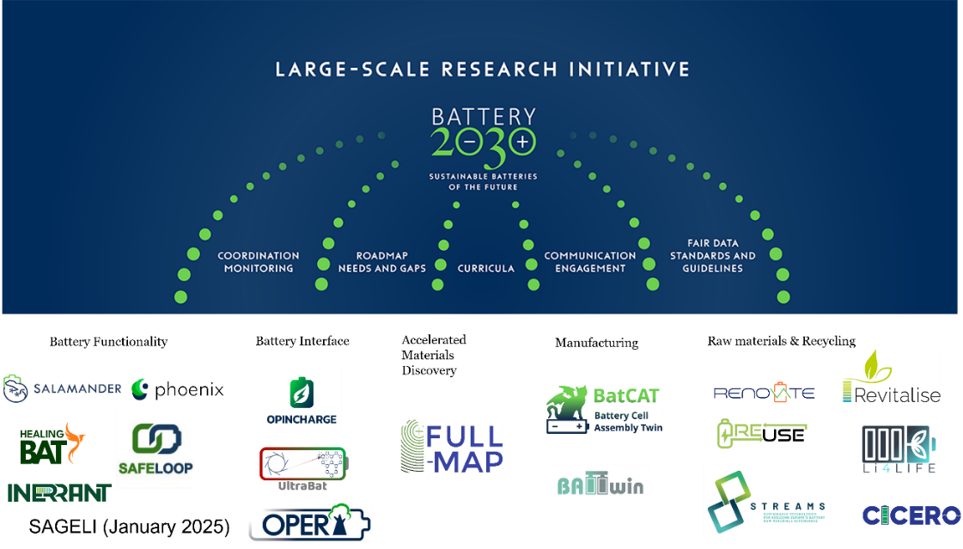
Figure 1 The BATTERY 2030+ Umbrella Picture of Projects as of 2025-06-16.
There are currently 21 RIA projects alongside the CSA BATTERY 2030+ CSA3 as listed below.
These are grouped into five clusters, to reflect different parts of the battery R&D& value chain and to enable the best possible exchanges of knowledge and skill (see Figure 1).
- ANGeLiC, coordinated by Marta Putrinš CIVITTA, Estonia
- BatCat, coordinated by Martin Horsch, NMBU, Norwegian University of Life Science, Norway
- Battwin, coordinated by UMilano, Marcello Colledani, Polimi, Polytechnic of Milan, Italy
- Cicero, coordinated by Peter Tom Jones, KU Leuven, The Netherlands
- CIRCUBATT, coordinated by Li Zhou University of Greenwich, UK
- FULL-MAP, coordinated by Dr. Mesfin Haile Mamme, Vrije Universiteit Brussel (VUB), Belgium
- Healingbat, coordinated by Stefan Palzer, TU Dortmund, Germany
- Inerrant, coordinated by Spyros Yannopoulos, FORTH, Foundation of Research and Technology – Hellas, Greece
- Li4LIFE, coordinated by Myriam Montes, Fundación ICAMCYL (International Center for Advanced Materials and raw materials of Castilla y León), Spain
- Opera, coordinated by Celia Polop, UAM, Autonomous University of Madrid, Spain
- Opincharge, coordinated by Santhana Eswara Morthy, LIST, Luxemburg Institute of Science and Technology, Luxemburg
- Phoenix, coordinated by Joris de Hoog, VUB, Vrije University Brussel, Belgium
- Renovate, coordinated by Eliana Quartarone, INSTM, National Interuniversity Consortium of Materials Science and Technology, Italy
- Reuse, coordinated by Claudia Stauch, Fraunhofer, Germany
- Revitalise, coordinated by Sulalit Bandyopadhyay, NTNU, Norwegian University of Science and Technology, Norway
- Safeloop, coordinated by Ulla Lassi, University of Oulu, Finland
- Sageli, coordinated by Loic Simonin, CEA, The French Alternative Energies and Atomic Energy Commission, France
- Salamander, coordinated by Samson Yuxiu Lai, Institute for Energy Technology, Norway
- STELLAR, coordinated by Rahmandhika Firdauzha Hary Hernandha, AVESTA Holding, Belgium
- Streams, coordinated by Damian Cupid, AIT, Austrian Institute of Technology, Austria
- Ultrabat, coordinated by Martin Meedom Nielsen, DTU, Technical University of Denmark, Denmark.
Past projects:
- BAT4EVER, coordinated by Prof. Dr. Maitane Berecibar, Vrije University Brussel, Belgium
- BIG-MAP, coordinated by Prof. Tejs Vegge, Danmarks tekniske Universitet (DTU), Denmark
- HIDDEN, coordinated by Dr. Marja Vilkman, VTT Technical Research Centre of Finland, Finland
- INSTABAT, coordinated by Dr Olivier Raccurt, Commissariat à l’Energie Atomique et aux Energies Alternatives (CEA), France
- SENSIBAT, coordinated by Iñigo Gandiaga, Ikerlan Technology Research Centre, Spain
- SPARTACUS, coordinated by Gerhard Domann, Fraunhofer Gesellschaft zur Foerderung der Angewandten Forschung E.V. (Fraunhofer), Germany
Cross-cutting domains, particularly education and standardization, are incorporated into every project through activities coordinated by the CSA. These domains are also embedded as integral components of the BATTERY 2030+ roadmap.

Methodology

The evidence base draws on a wide variety of documents, including institutional reports (e.g., from the U.S. Department of Energy), strategic policy frameworks such as the European Strategic Energy Technology Plan, national battery strategies from multiple countries, proceedings from regional BATTERY 2030+ meetings in 2025 and 2026, as well as materials from industry associations, newsletters, peer-reviewed scientific publications, and records of oral presentations.
In addition, a broad group of organizations, who are direct stakeholders in their national ecosystems and therefore possess first-hand insights, contributed to the compilation of the scientific overview of national battery research-and-innovation (R&I) landscapes. To leverage the regional expertise and harness synergies, VDI/VDE-IT, acting on behalf of BATTERY 2030+ CSA3, organised a series of five digital events “Connect to Power up!”, specifically intended to map national battery research-and development ecosystems and funding landscapes, as well as to identify national R&D priorities and trends in 18 European countries, as follows:
- 17 June 2025, Denmark, Finland, Norway and Sweden
- 26 June 2025, France, Germany and the Netherlands
- 02 October 2025, Portugal, Italy and Spain
- 16 October 2025, Czech Republic, Slovakia, Poland, Slovenia and Hungary
- 05 November 2025, the UK, Ireland and Switzerland,
Based on the input gathered from the aforementioned workshops and consultations, the present report offers a comprehensive analysis of the current landscape of research-and-development (R&D) programs dedicated to battery technologies, outlining the strategic priorities set by national governments and the funding mechanisms that underpin these initiatives. It identifies the principal stakeholders within each country's battery R&D ecosystem - including policy makers, funding agencies, research institutions, and industry clusters - examining how these actors interact with one another. Building on this mapping, the report proposes a series of concrete strategies aimed at strengthening collaboration across the European ecosystems, with the goal of leveraging synergies, amplifying scientific output and accelerating technological impact. Finally, it assesses the principal challenges that are likely to arise in the coming years and highlights emerging opportunities that can be harnessed to drive innovation in the battery sector. The detailed synthesis of these findings, together with recommended measures for improved alignment and cooperation, will be presented as a foundational input for future strategic planning the activities under the new CSA BATT-Bridge.

The Strategic Landscape of Battery R&D

Europe´s Battery Ecosystem

Batteries are a key enabler for a society free from greenhouse gas emissions, as expressed in the European Green Deal and further elaborated in the act RepowerEU.
When BATTERY 2030+ was launched in 2018, Europe was attempting to ramp up production and meet the growing demand for electrical vehicles (EV). The European automotive industry representatives, like Volkswagen, Renault, and Volvo, have made heavy investments in electric powertrains and batteries. The current state of battery research and cell manufacturing in Europe is undergoing significant changes. The rapidly evolving ecosystem is shaped by political and technological urgency, industrial policy, and scientific capacity. Batteries are the strategic enabling technology for the energy transition – for the decarbonization of mobility and industry, as well as for strengthening Europe’s technological sovereignty. Beyond these aspects, batteries are becoming a critical component in sectors such as medicine and defense. In parallel, the European battery landscape is increasingly interconnected through a network of research institutions, public funding mechanisms, and industrial scale-up efforts. Governments and stakeholders are working to reduce dependencies and build resilient value chains.
At the industrial level, the expansion of battery cell manufacturing across Europe is evident, as Figure 2 shows, even though numerous projects and companies have failed in this highly competitive international market. The success of European players increasingly depends on their ability to successfully translate research output into industrial capacity with high efficiency and competitive costs. This applies not only to cell manufacturing but to the entire battery value chain. Cell manufacturing serves as an indicator of both industrial investment and the maturity of the broader ecosystem in which research, pilot production, supply chains, and innovation policy interact.
The installed European cell-manufacturing capacity has reached 210-250 GWh per year, driven by both mature factories such as LG Energy Solutions’ plant in Poland and new plants such as the AESC gigafactory in France. Nevertheless, the sector remains fragile: the filing for bankruptcy of both Northvolt and Morrow illustrate how quickly capacity can become stranded. In addition, there is evidence that other regions have a stronger innovation pipeline, especially in emerging battery technologies.
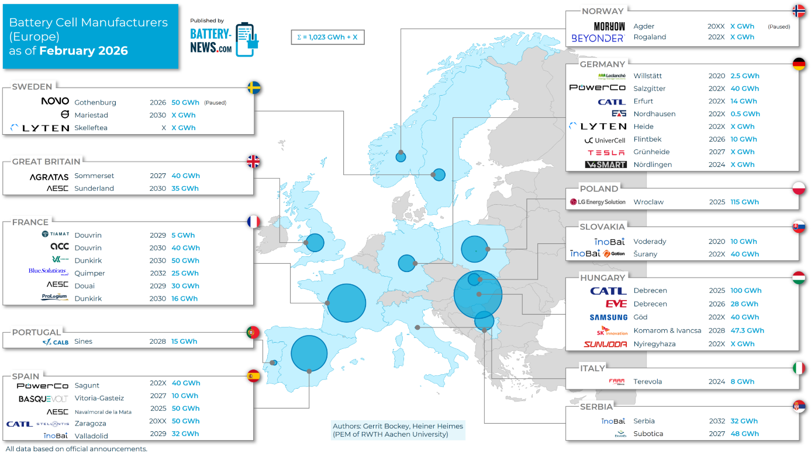
Figure 2 Battery News Map on Battery Cell Manufacturers in Europe (status in 02/2026), Source: Battery News
The EU's Clean Industrial Deal and the BATTERY 2030+ roadmap are channeling public funds to de-risk these investments and to encourage the formation of clusters that combine battery research, production, and recycling. Also, pan-European supply chains arise – one example is depicted in Figure 3 , covering several stages of the value chain, from raw material extraction through cell, battery, and EV production to recycling.
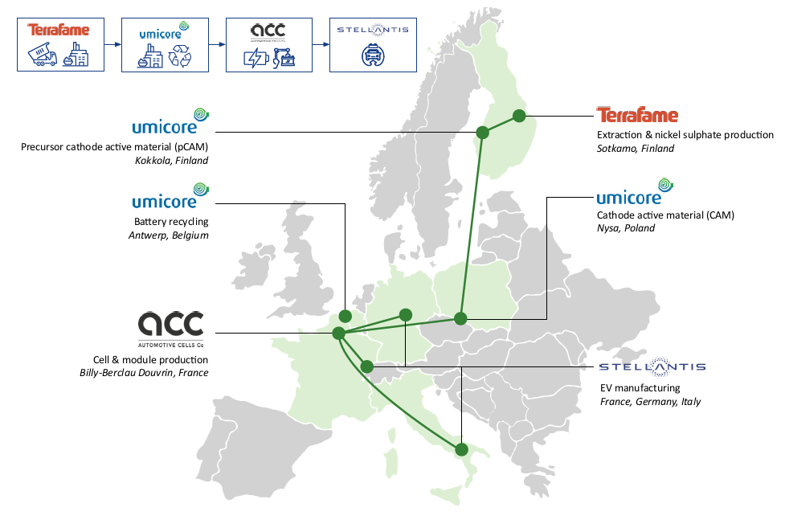
Figure 3 Examples of supply relationships and supply chains in Europe, from raw material extraction to the manufacture of EVs. Source: Market Analysis Update Q4 2025, Accompanying Research Battery Cell Production
The EU supports the battery sector through several key funding schemes:
- The IPCEI Batteries program pools large public funding to accelerate research, development and high-performance, sustainable cell manufacturing.
- Horizon Europe (2021-2027) and the co-programmed BATT4EU partnership support the entire value chain, from materials and cell design to recycling and life-cycle assessment.
- The Innovation Fund (2020-2030) provides approximately €6 billion for large-scale, low-carbon industrial projects, including battery-plant scaling and decarbonization. This also includes the recently announced Battery Booster Facility, where large scale battery projects are supported with loans during the ramp-up phase.
- The Temporary Crisis Transition Framework (TCTF) provides up to €3 billion funding specifically for building a resilient European battery ecosystem.
Together, these instruments create an integrated financing network that drives research, pilot and mass production, raw-material security and recycling, underpinning the EU's goal of a competitive, climate-neutral battery industry by 2030.
To depict the scientific dimension of the ecosystem, the map of battery conferences in Europe serves as a proxy for the activity, connectivity, and visibility of the research community (see Figure 4). The dense network of events reflects the active exchange between academia, industry, and policy actors. Research activities span the full battery value chain, ranging from material precursors and materials through electrodes, battery cells, applications, processes, production and system integration research, to recycling.
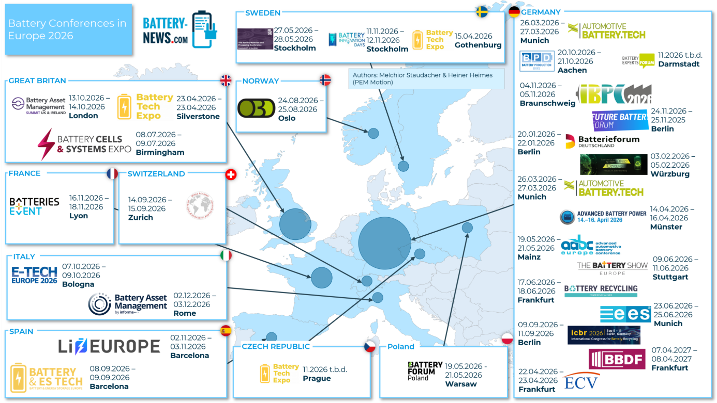
Figure 4 Battery News Map on Battery Conferences in Europe (status in 2026) (Source: Battery News⁹)
BATTERY 2030+ aims for a strong European battery knowledgebase in long-term research on next generation batteries, thereby enabling Europe’s leadership in highly demanding markets and fulfilling end user expectations. The activities are guided by the BATTERY 2030+ roadmap , which outlines a forward-looking strategy for battery research in Europe. It follows a chemistry-neutral approach to sustainable batteries of the future, focusing on accelerated discovery of interfaces and materials, integration of smart functionalities and cross-cutting areas such as data, standards and ontologies. In doing so, Europe can exceed the ambitious battery performance targets for the full battery value chain, as agreed upon in the Strategic Energy Technology Plan (the SET Plan).
As part of the activities within BATTERY 2030+, connecting and benchmarking the European battery ecosystem is one of the key objectives. The report therefore provides an overview of the battery R&D landscapes in 28 European Member States, with a structured focus on funding schemes, national research priorities, and emerging trends. This approach enables a systematic comparison of countries while also situating individual developments within the broader European context. It aims to capture the diversity and structure of battery research across Europe and to provide insights into how battery research and innovation are organized and supported at the national level.
The report is based on the networking and knowledge exchange facilitated in BATTERY 2030+, involving researchers and policymakers across European Member States. A central reference point for this analysis is the BATTERY 2030+ event series “Connect to Power up!”, which was a focused exchange forum between stakeholders from academia, industry, and policy. Each of the five sessions focused on selected European countries (see section 1.2. Methodology) and for each country, typically two speakers reported the national research structure and priorities. The contributions provided in-depth insights into national research landscapes with key actors, strategic frameworks, and current as well as emerging research priorities in the respective countries.
For this report, the 18 countries covered in the event series are presented following a common structure: national ecosystem, funding schemes, and research priorities and trends. This structured approach enables a systematic comparison of how battery research is organized, supported, and strategically developed across Europe. In addition, the state of battery research in a further 10 countries is summarized in concise profiles, building on updated previous analyzes and an earlier BATTERY 2030+ report. These shorter descriptions provide complementary context and ensure broader coverage of the European research landscape while maintaining a clear analytical focus on the selected core countries.

Global Battery Landscape and Geopolitical Challenges

The global lithium-ion battery market exceeded USD 150 billion in 2025, growing over 20% from 2024. Beyond its market size, batteries are becoming a foundational technology for modern economies, underpinning electric vehicles, power system flexibility, digital infrastructure, and strategic industries. As battery prices continue to fall - declining on average by 8% in 2025 due to technological advances and intensifying competition - and applications expand, demand is rising rapidly, with significant implications for economic competitiveness, supply security, and industrial policy. At the same time, regional price disparities have widened: in 2025, battery pack prices in China were 30% lower than in the United States and 35% lower than in Europe (see Figure 5).
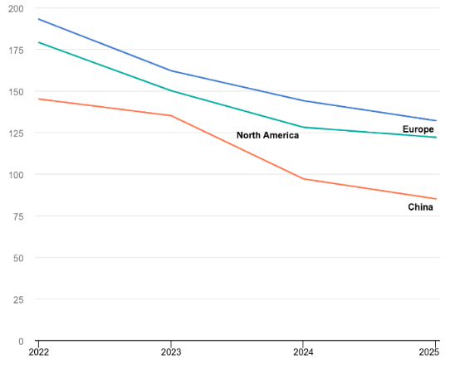
Figure 5 Average lithium-ion battery pack price per watt-hour index by region, 2022-2025;
Source: IEA. Licence CC BY 4.0
Global lithium-ion battery deployment in 2025 was six times higher than in 2020, driven mainly by electric vehicles, which account for over 70% of total lithium-ion battery deployment, followed by battery energy storage at over 15%. In contrast, portable electronics, which made up nearly half of demand in 2015, now account for less than 5%, marking a major structural shift in battery use. Battery deployment remains concentrated in China, but is growing quickly in emerging and developing economies. In these markets, LFP batteries now power more than half of electric car sales - twice the share in 2023 - largely driven by imports from China.18
Lithium remains essential for the global energy transition. However, existing supply projections are insufficient to meet anticipated demand, and without significant investment, supply deficits could emerge as early as 2028. Meeting this demand may require up to $276 billion in new capacity, highlighting the challenge of mobilizing appropriate levels of capital while navigating an increasingly fragmented global trade environment.

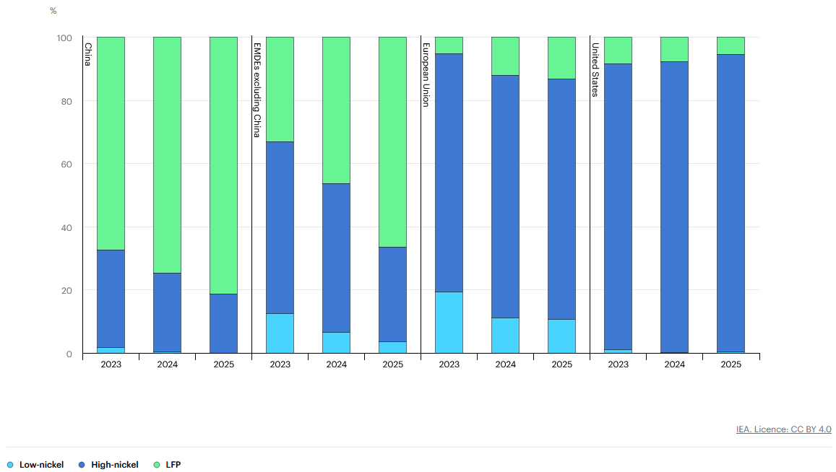
Figure 6 Share of four wheelers electric vehicle battery sales by chemistry and region, 2023-2025;
Source: IEA. Licence CC BY 4.0
As batteries become more central to the global economy, supply chain risks are increasing. China dominates production, manufacturing over 80% of batteries in 2025, while Chinese, Korean, and Japanese companies account for nearly all global cell output. Europe and the United States depend heavily on imports - mainly from China - for key components, as midstream production and technical expertise for essential components, such as active materials and their precursors, remain highly concentrated there. As a result, most grid batteries and over 70% of electric vehicles produced outside China rely on Chinese batteries or components, raising concerns about supply security (see Figure 7).18
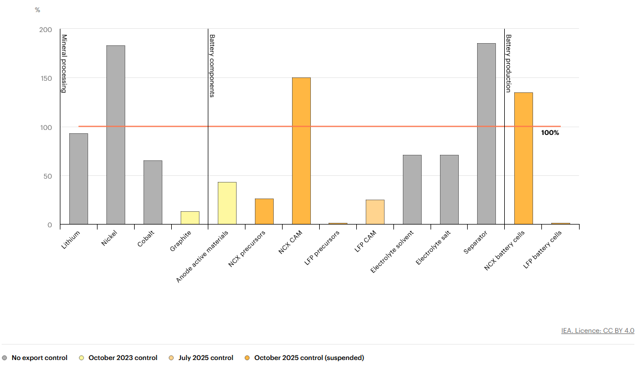
Figure 7 Share of lithium-ion battery deployment outside China that could be met without supply from China, 2024; Source: IEA. Licence CC BY 4.0
The current imbalance in global battery supply chains is unlikely to shift soon without major investment and stronger international co-operation. China’s export controls on key components highlight existing vulnerabilities. Although Europe and the United States are expanding battery manufacturing, higher production costs - up to 50% above China’s - and lower initial efficiencies hinder competitiveness. Building a diversified supply chain will require sustained investment, stable demand, and international partnerships. Emerging technologies such as sodium-ion batteries could offer diversification opportunities, but planned capacity is currently concentrated almost entirely in China.18
In addition to that, a growing pattern in the global battery value chain is the strategic use of critical minerals as instruments of geopolitical influence. States increasingly treat access to lithium, cobalt, nickel, and rare earth elements as a matter of economic security and industrial policy, tightening export controls, promoting domestic processing, and leveraging resource ownership to shape global supply chains. In the short term, such policies can lead to supply disruptions for battery manufacturers, particularly given the high geographic concentration of mining and refining capacity.
In the longer term, this dynamic is fostering a geopolitical contest over control of mineral processing infrastructure, strategic stockpiles, and allied industrial alliances aimed at securing resilient supply chains for energy-transition technologies. The concentration of refining capacity - especially in countries such as China, which dominates large shares of global processing for several battery-related minerals - further amplifies these strategic dependencies and reinforces the political dimension of battery material supply chains.,,,

Battery R&D Activities

Europe

Austria

National Ecosystem
Battery-related activities are currently overseen by the Austrian Federal Ministry for Innovation, Mobility and Infrastructure. While Austria does not have a dedicated national battery strategy, the Battery Initiative - a complement to the European Battery Alliance (EBA) - has served as a guideline and the main funding instrument in Austria in this field since 2019.
Battery research in Austria is well established. TU Graz acts as a key driver of more fundamental research, while Austrian Institute of Technology (AIT) focuses more on the applied side, with strong engagements in various EU projects and BATTERY 2030+. TU Wien and Technical University of Leoben are further active research institutions. Besides research on generation 3 Li-ion batteries, there is a fundamental research effort towards multivalent ion batteries (such as magnesium in the HighMag project) as future alternatives to lithium. This is well in line with current research roadmaps and is seeing increased activity in Austria, with TU Graz and AIT among the main contributors. New laboratory has been established at University of Salzburg, with a focus on methodology of characterization and development of Gen5 batteries. Furthermore, research on generation 4 batteries has intensified, with particular infrastructure investments in the Christian Doppler laboratory in Graz for fundamental research on interface phenomena, while AIT is currently building a laboratory for investigating the scalable assembly of various solid-state battery concepts. Other parts of the value chain are also being investigated, including through a new Christian Doppler lab for battery recycling.

National Funding Schemes
Battery R&D in Austria is financed through a mix of existing national schemes and EU instruments. The Battery Initiative functions as the main Austrian guiding framework, but available descriptions indicate that it largely channels battery-related projects into broader funding programs rather than creating a separate battery-only budget line.
Public support is also visible through FFG, Christian Doppler laboratories, and regionally supported cooperative calls, which together fund topics such as solid-state batteries, multivalent-ion concepts, and recycling. In practical terms, this means Austrian battery R&D is supported by a layered funding architecture: national innovation funding, industrial-academic cooperation schemes, and participation in European collaborative projects.
European collaboration and funding instruments (such as Horizon 2020/Europe and M-ERA.NET) complement these national efforts. Austria has also participated in the IPCEI European Battery Innovation.

R&D Priorities and Trends
Austria’s battery R&D priorities are increasingly cantered on solid-state batteries, interface science, recycling, and selected alternative chemistries. TU Graz’s Christian Doppler laboratory on solid-state batteries focuses on lowering interface resistances, improving solid electrolytes, and understanding electrochemical processes and degradation, while Austria’s research on battery circularity is expanding through new Christian Doppler activity on lithium-ion battery recycling and related FFG-supported projects. Austria also has a smaller but visible research stream on multivalent-ion systems, including magnesium-based concepts such as HighMag, indicating interest in post-lithium alternatives. Overall, the Austrian battery research profile is collaborative and infrastructure-rich, with emphasis on next-generation cells, applied scale-up, and recycling rather than domestic mass production of cells.

Belgium

National Ecosystem
In Belgium, there is no specific top-down battery strategy; R&D plans and support are mainly coordinated on the regional level: Flanders, Brussels and the Walloon region. Belgium is home to several companies and research institutes with battery activities which develop advanced products and services, like Toyota Motor Europe (TME), Umicore, Solvay, Syensqo, SORBAT (Société de Recyclage de Batteries), Avesta Battery & Energy Engineering, and PEC Corporation. Research centres and universities active on batteries include: Vrije Universiteit Brussel (VUB), Ghent University, Katholieke Universiteit Leuven, Hasselt University, University of Antwerp, Université libre de Bruxelles (ULB), Université Catholique de Louvain (UCL), Vlaamse Instelling voor Technologisch Onderzoek (Flemish Institute for Technological Research VITO), and Interuniversity Microelectronics Centre imec.

National Funding Schemes
Research activities are carried out across the complete value chain. Main research areas are advanced models and algorithms development and next-generation battery development. The content of funded R&I activities is determined through a bottom-up approach. There are several R&D projects on batteries funded by agencies such as VLAIO, FWO, INNOVIRIS, Flanders Make, SIM, Flux 50, FOD Economie, and SPW Recherche, operating on a bottom-up nature.

R&D Priorities and Trends
The start-up Solithor is one of the pioneers at EU level on solid state technology. Some of the ongoing research projects in Belgium are FULL-MAP - fully integrated, autonomous and chemistry agnostic Materials Acceleration Platform for sustainable batteries, REBORN – innovation leading to smooth transition from 1st life batteries to 2nd life, and PHOENIX - integrating sensors, self-healing and triggering properties - one of BATTERY 2030+ research projects, all coordinated by VUB.

Croatia

National Ecosystem
Battery R&D in Croatia remains largely driven by individual efforts rather than coordinated national initiatives. Minor research activities are concentrated around Zagreb University and the Ruđer Bošković Institute. The most prominent player in the field of transport electrification is Rimac Technology, a company specialized in battery pack and electrification equipment development for different European and non-European OEM’s.

National Funding Schemes
Croatia’s Integrated National Energy and Climate Plan 2021-2030 (NECP) includes targets for energy storage deployment, also including research, innovation, and increased competitiveness. The proposed (and partially implemented) measures include financing for R&D&I projects, technology transfer, and collaboration, with low carbon and energy storage projects being one of the focus topics.

R&D Priorities and Trends
Croatia’s battery R&D priorities are still emerging, but they are clearly aligned with transport electrification, grid integration, and the practical deployment of battery storage. In the research sphere, the most visible activities remain concentrated around electrified mobility and battery-pack engineering, where Rimac Technology provides strong industrial pull. On the academic side, institutional activity is still limited in scale, but the national focus is gradually expanding toward storage integration, system-level design, and collaboration with European partners.

Czech Republic

National Ecosystem
Battery R&I is not centrally organised. The Czech Battery Cluster (CBC) was established in May 2022 as a bottom‑up initiative to develop a national battery innovation ecosystem. Inspired by western cluster culture, it stands on co-operation of three pillars – the Czech universities and research institutes, the industry and the governance. It aims to cover the entire value chain, from raw material extraction to recycling and end products. Working closely with the Ministry of Industry and Trade based on a Memorandum of Understanding from beginning of 2025, the CBC contributes to the growth of the Czech battery economy. In cooperation with CzechInvest, it promotes foreign investment and business development, while joint projects with the Ministry of Education, Youth and Sports focus on mapping educational capacities in e‑mobility and battery technologies at schools and universities.
The CBC network forms the core of the Czech battery ecosystem, linking research, education, and industrial application at the national level. To strengthen its international integration, CBC joined the European Battery Alliance (EBA250) in June 2024 and the Batteries European Partnership Association (BEPA) in August 2025, ensuring strategic alignment with EU battery initiatives.

National Funding Schemes
The Czech Republic supports battery-related topics through general project calls and programs. Provided by the Ministry of Industry and Trade, the initiative for Strategic Investments for a Neutral Climate Economy was launched in 2025 with €1 billion budget (including other topics apart from batteries) and prioritizes industrial production. The Technologies and Applications for Competitiveness (6th Call) funds deep-tech projects with up to 85% cost coverage for private companies (€100 million budget per year). Additional support comes from the Twist Program (Transfer, R&D&I for Strategic Technologies), which provides industrial R&D funding for several technologies, including batteries. Provided by the Technology Agency of the Czech Republic (TACR), the Clean Energy Transition Call 2025 contains the Energy Flexibility module for funding practical research focused on BESS. International partnerships are supported by the Czech Science Foundation (GACR) with connections to Swiss, Austrian, German, and U.S. research schemes.
However, post-election policy shifts are bringing funding changes or even (temporary) pauses up cancelling funding, as the winning parties are opposed to e-mobility - therefore, the uncertainty is currently high regarding battery funding in the Czech Republic.

R&D Priorities and Trends
Czech R&D focuses on battery materials, modeling and simulation, as well as resource extraction (notably lithium and manganese), and recycling, in line with EU battery regulations. Industry-led work targets automotive applications, BESS, and materials analysis (e.g., SEM microscopy). The academic sector remains the main innovation driver, some of them increasingly joining Horizon Europe projects, while other start projects without previous experience in the battery field.
Currently, Czech legislation is in line with EU legislation and has implemented legislation relating to battery recycling, although the amount of bureaucracy and lack of production waste (no battery production in Czechia) render battery recycling very difficult. At the same time, two strategic projects related to batteries, the Cínovec lithium mining and processing project in the Ústí and Labem region, recognized as the Europe´s second largest lithium deposit found, and the Chvaletice manganese recovery project from mine tailings, recognized as the only known European source of battery grade manganese discovered so far, have been defined within the framework of the Raw Materials Act.
In the field of electromobility, Czech Republic used for long time to support cars with combustion engines mainly, as car manufacturing has a long tradition in the Czech Republic and represents a significant part of the Czech economy. The situation is bound to change as Toyota Motors has selected its Kolín site as its first BEV production site in Europe as such and Hyundai Motors in Nošovice steadily ramping up the share if its PHEV/BEV production as well. The success of ŠKODA-Auto with its recent line of EV models might be of an important mind changer as well.
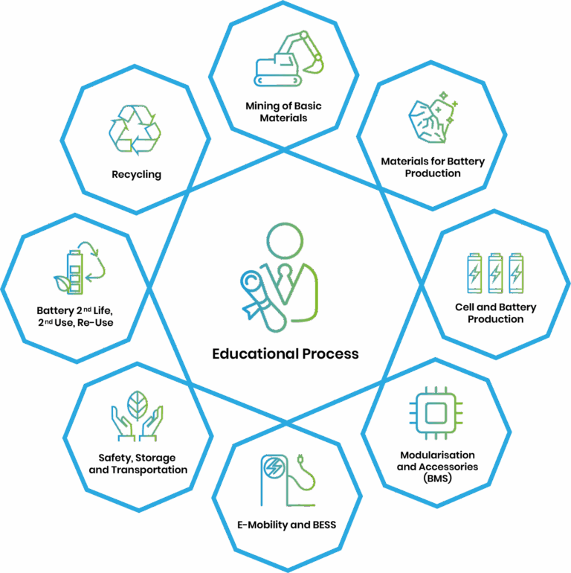
Figure 8 Areas of interest regarding the battery value chain for the Czech Battery Cluster
(Source: Connect To Power Up! Presentation by J. Vejbor from CBC)

Denmark

National Ecosystem
Denmark has a historically rooted battery ecosystem, with early work in dry-cell and later lithium-ion technologies, e.g. the Apple Newton (from 1993) was powered by a Danish lithium-ion battery. The Danish Technological Institute (DTI) acts as a central research and technology organization (RTO) with around 1,100 specialists and strong industrial link. The company Topsoe develops cobalt-free, high-voltage lithium nickel manganese oxide (LNMO) and sodium-ion cathode active materials. Other relevant Danish companies in the ecosystem are Cotes A/S for drying equipment, FOM Technologies A/S for new cathode materials as a leading supplier of lab-scale and pilot-scale slot-die coating tools for advanced materials research and development and InnoCell ApS (supercapacitor technologies) as well as VisBlue A/S (vanadium redox flow batteries) for battery cell and pack production.
Technical University of Denmark (DTU), Aalborg University, and Aarhus University are key academic hubs in materials modeling, electrode development, solid-state electrolytes, and battery systems. Figure 9 provides an overview of the relevant actors along the battery value chain.
The Danish ecosystem is tightly embedded in European research alliances and initiatives such as BATTERY 2030+ and collaborating with institutes like CEA, Fraunhofer, TNO, VTT, SINTEF, and IMEC along the battery value chain, making Denmark an important node in the international battery research landscape. DTU, for example, coordinates the BIG-MAP project under the BATTERY 2030+ umbrella, which aims to reinvent how batteries are discovered by combining high-throughput experiments, multiscale modeling, and artificial intelligence.
National Funding Schemes
Battery research in Denmark is primarily supported by three types of national funding instruments. The main source of funding is the Innovation Fund Denmark. The institutional and project-based funding is provided by the Ministry of Higher Education and Science (via universities and RTOs such as DTI), supporting both fundamental and applied battery research. Third, Denmark participates in targeted programs and national platforms on energy storage that act as think tanks and coordination hubs, linking academia, industry, and public authorities. These are complemented by EU programs like Horizon Europe and BATTERY 2030+ that promote cross-border, application-oriented projects.
The main actors regarding national funding for battery R&D are the DaCES (Danish Center for Energy Storage), a national think-tank on energy storage, the partnership Danish Battery Society (Dansk Batteiselskab) and the Energy Cluster Denmark as neutrals innovation platform for the sector.

R&D Priorities and Trends
Danish research focuses on computer-aided electrochemical materials discovery and characterization, such as AI- and data-driven self-driving labs for materials discovery (see European BIG-MAP project). Another R&D priority lies in advanced battery electrode material development – cobalt-free, high-voltage LNMO, next-generation materials and solid-state electrolyte technologies. Additional focal points are special-purpose BMS algorithms with state-of-charge and state-of-health estimation, modular pack architectures as well as predictive maintenance and failure analysis. Denmark also aims to improve battery repair, recycling and second-life use.
A clear R&D trend is the shift from cell-centric products to integrated energy-storage systems – motivated by the increase in renewable energies (wind and solar power). R&D also focuses on redox-flow, sodium-ion, and solutions tailored to maritime, micro-mobility, and space applications.
European regulation (e.g. the Batteries Regulation) and funding programs increasingly steer research agendas and value-chain collaboration, while Danish universities and RTOs expand battery-related education and training to secure skilled labor and deepen ties between industry, academia, and international partners.
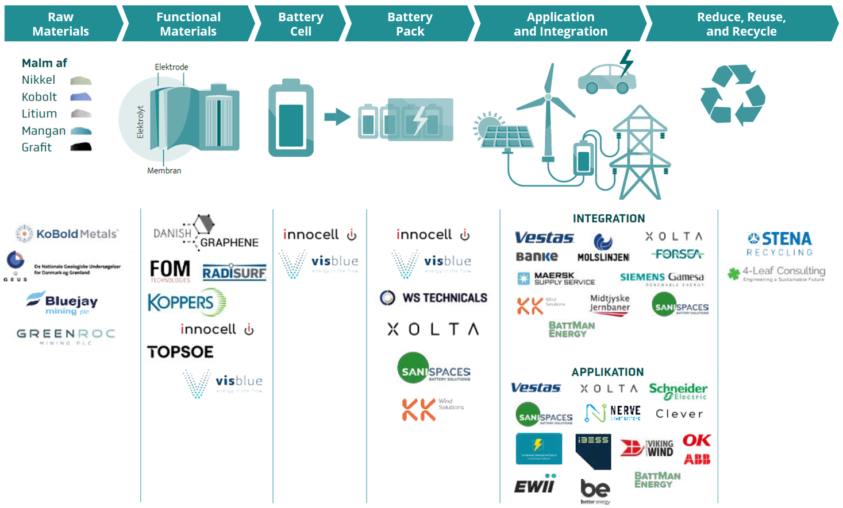
Figure 9 Danish Actors along the battery value chain (Source: Connect To Power Up! Presentation by G. Rohde, DTI)

Estonia

National Ecosystem
Estonia’s battery R&D ecosystem is small but scientifically capable, built around three core research institutions: University of Tartu (UTartu), Tallinn University of Technology (TalTech), and the National Institute of Chemical Physics and Biophysics (NICPB).
Together they form a complementary research base covering electrochemistry, materials science, carbon nanomaterials, and energy systems engineering.
Estonia's battery-related commercial landscape comprises a small number of deep-tech companies and startups: UP Catalyst, a spin-off of UTartu, develops battery-grade carbon materials, including synthetic graphite and carbon nanotubes, based on CO₂ utilisation technologies; Jälle Technologies, a spin-off from NICPB, focuses on lithium-ion battery recycling and critical materials recovery; Skeleton Technologies, founded in 2009, is the flagship Estonian energy-storage company and one of Europe’s leading supercapacitor manufacturers. While not a conventional battery company, Skeleton has become a central actor in European energy storage through its Curved Graphene technology and expansion into hybrid “SuperBattery” systems; GaltTec, a spin-off of UTartu, represents another adjacent but relevant dimension of Estonia’s electrochemical innovation landscape. Although not a battery company, it operates in micro solid oxide fuel cell technologies, a field closely related to electrochemical energy conversion.
Overall, Estonia demonstrates a focused but high-quality ecosystem combining strong academic research, selective industrial spinouts, and internationally visible deep-tech companies. However, the ecosystem remains limited in scale and would benefit from deeper integration into European pilot-scale battery manufacturing and industrial value chains.

National Funding Schemes
Battery-related R&D in Estonia is primarily supported through a combination of national research funding, applied innovation instruments, and private venture capital, rather than dedicated sector-specific battery programmes.
The Estonian Research Council (ETAG) provides the main funding base for fundamental research in electrochemistry, materials science, and energy systems. These grants support long-term scientific capacity building in institutions such as UTartu, TalTech, and NICPB, and form the upstream foundation for later applied developments.
In addition to project-based funding, Estonia invests in long-term scientific capacity through national Centres of Excellence. Two centres established for 2024–2030 are particularly relevant for battery-related research: the Centre of Excellence in Sustainable Green Hydrogen and Energy Technologies, coordinated by the UTartu in partnership with TalTech, and the Centre of Excellence in Circular Economy for Strategic Mineral and Carbon Resources, coordinated by TalTechnology together with the UTartu and NICPB.
These initiatives support interdisciplinary research in electrochemical energy technologies, sustainable materials, critical raw materials, and circular resource use, creating a strong scientific basis for future battery innovation.
The Estonian Business and Innovation Agency (EIS) plays a critical role in bridging research and commercialisation. Its Applied Research Programme (RUP) is the most important national instrument for battery-related innovation, enabling collaboration between universities and companies in projects that typically sit in the TRL 3–7 range. This instrument is particularly relevant for deep-tech ventures such as UP Catalyst and emerging energy materials companies, as it supports prototyping, pilot validation, and early-stage industrialisation.
In parallel to public research and innovation funding, venture capital, strategic industrial investment, and European innovation networks provide important pathways for scaling deep-tech companies in Estonia.
For example, Skeleton Technologies has grown through international venture capital, industrial partnerships, and support from European innovation initiatives. EIT InnoEnergy was an important early backer and stakeholder, facilitating investments in the company's ultracapacitor and SuperBattery technologies and helping connect it with European industrial networks.
UP Catalyst received early support through UniTartu Ventures, the university's intellectual property and venture investment arm, which became a shareholder through an IP-for-equity arrangement. The company has also benefited from international support programmes, including Norway Grants and EIT RawMaterials and EIT Manufacturing grants.
These examples illustrate the diversity of funding and commercialisation mechanisms available to Estonian deep-tech companies, including university spin-out support, applied research funding, venture capital, industrial investment, and European innovation programs.

R&D Priorities and Trends
Estonia's research and development priorities for batteries are influenced by national strategic goals as well as geopolitical events. Estonian Research and Development, Innovation and Entrepreneurship Strategy 2021—2035 emphasises knowledge-intensive innovation, research commercialisation, and the development of globally competitive deep-tech sectors. The Estonian Energy Development Plan (ENMAK/ESDP 2035) identifies energy security, system resilience, and the transition to a low-carbon energy system as key national priorities.
These priorities have gained additional importance following Russia's invasion of Ukraine and the Baltic States' disconnection from Russia's electricity system. As a result, research and innovation activities related to energy security, energy storage, grid resilience, strategic materials, and domestic technological capabilities have received increased attention. This is reflected, among others, in the establishment of the above-mentioned national Centres of Excellence.
Given Estonia’s size and geopolitical location, the most natural competitive positioning lies in enabling technologies, materials innovation, digitalisation of energy systems, and niche deep-tech components, rather than large-scale manufacturing. Strengthening structured collaboration with European battery pilot lines, industrial consortia, and scale-up infrastructures would be the most effective way to amplify Estonia’s existing strengths.

Finland

National Ecosystem
Finland’s National battery strategy, developed by the Ministry of Economic Affairs and Employment in 2020 and updated in 2025, aims to strengthen the innovation, export and investment environment of the battery sector and to accelerate Finland’s sustainable and low-carbon economic growth with responsible and competitive businesses. It also supports the climate targets of Finland, in industrial and transport sector. The strategy emphasizes the need for close collaboration at both national and international levels, and places particular focus on the entire battery value chain: raw material extraction, battery metal refining, advanced battery materials, cell manufacturing, and recycling. On the application side, it addresses charging systems, e-mobility and electrification of heavy-duty moving machines. The results of implementing the strategy are positive across the entire value chain, particularly in the development of upstream battery material production by international companies. The success of national value chain development will depend on Finland´s ability to remain a globally competitive location for investment and RTD in the evolving European battery market.
The Finnish Minerals Group Oy (FMG), a special-purpose company fully owned by the Finnish government, has a mission to promote the Finnish battery and minerals value chains. FMG aligns state and industrial interests, facilitates access to critical materials, and promotes the goals of national industrial policy and resilience of the society.
Other key actors in the ecosystem include, for example, Umicore Battery Materials Finland, Terrafame, Jervois Finland, Kemira, Easpring Finland New Materials, Fortum Battery Recycling, Metso, Tracegrow, Akkuser, Hycamite, Skeleton Technologies and Sibanye Stillwater Keliber.
For start-ups, the list includes companies such as CeLLife Technologies (battery diagnostics), Geysir (fast-charging systems) and Broadbit (advanced sodium-based batteries) as well as established companies such as IONCOR (part of the FMG group), which is expanding its position in battery pack manufacturing for electric vehicles.
Battery energy storage systems and integration activities are driven by companies such as Cactos, Fortum, Helen, and Wärtsilä, while the research institution VTT develops batteries with self-healing properties and contributes to BATTERY 2030+.
The national research and development landscape is coordinated through the BATCircle network, a research and innovation hub led by Aalto University, established in 2021 to connect academia and industry, and the Finnish Battery Industries association (Akkuteollisuus ry), established in early 2023, represents the interests of currently thirteen member companies.

National Funding Schemes
The implementation of the battery strategy is largely supported by funding instruments. Finland is an active member of both battery IPCEIs since 2019 with several companies participating with FID projects. Business Finland launched dedicated calls for industrial decarbonization and net-zero transformation in spring 2025, based on the European Temporary Crisis and Transition Framework (TCTF). In addition, Business Finland provides tax incentives under the TCTF program for decarbonizing investments. The organization has also been running the six-year Hydrogen and Batteries program since 2023, supporting both research and market entry of new technologies.
The Ministry of Economic Affairs and Employment aligns the battery strategy with the national mineral strategy, industrial policy strategy, and European initiatives such as the Critical Raw Materials Act (CRMA), the Net-Zero Industry Act (NZIA) and the Industry Accelerator Act (IAA). Streamlined permitting procedures are intended to strengthen the battery economy.
At the European level, Finland participates in networks such as the European Battery Alliance (EBA), IPCEI, and Batteries Europe to advance joint research and innovation activities.

R&D Priorities and Trends
In the field of research and development, Finland continues to focus strongly on the mining and processing of battery raw materials (lithium, cobalt, nickel, copper, graphite), building on a long tradition and a broad network of research institutions and companies. The development of advanced inorganic electrode materials for lithium- and sodium-ion batteries is supported by strong expertise in precursor and cathode active materials at several universities, particularly the University of Oulu, and is reflected in numerous Horizon Europe projects.
New research laboratory facilities and dry room at University of Oulu will enable the integration of printed electronics and additive manufacturing as a part of battery cell manufacturing. In addition, VTT, GTK, LUT, UEF, and Aalto are all working intensively with battery and battery materials research.
Recycling and circular economy solutions are another key research area, supported by the national research network BATCircle3.0 aiming to close the loop in the battery value chain. Emerging trends indicate growing interest in biomass-based electrode materials, including hard carbon and bio-graphite, as well as in the integration of battery technologies into broader energy system electrification.
In addition, next-generation battery technologies are a research trend, such as redox flow batteries and more sustainable sodium-, zinc-, or other metal-based systems.
In the application segment, Finland focus is on heavy duty, off-road segment and system level electrification, e.g. inclusion of BESS. One important aspect is innovation in the battery value chains, which have generated large number of patents during the past three years.
These developments are supported by a strong but still fragmented battery ecosystem, which is expected to be further consolidated through improved infrastructure and targeted investment in resources and talent.

France

National Ecosystem
Since 2021, the national battery strategy France 2030 has consolidated the domestic research and innovation ecosystem - with 90 projects resulting in over €10 billion in private investments. It brings together academic institutions, public technology organizations and industrial actors under a common strategic framework aligned with the European BATTERY 2030+ initiative.
French parties involved in battery research are therefore strongly interconnected, e.g. in the RS2E network (Réseau sur le stockage électrochimique de l'énergie – French electrochemical energy storage network). It aims to solve the scientific and technological bottlenecks in electrochemical storage systems (batteries, supercapacitors) for mobile and stationary applications. 17 research laboratories all over the country, two state technology centres (CEA, INERIS) and 13 industrial partners as well as selected institutional partners are grouped in RS2E (see Figure 10). This way, it unites the majority of French laboratories specializing in batteries and supercapacitors and acts as a national hub for electrochemical energy storage.49 Another initiative started in 2018 is the COMUTES² consortium (COnsortium pour la MUtualization de Tests Electriques sur Systèmes de Stockage – consortium for the pooling of electric tests on storage systems). It includes IFPEN, CEA-LITEN, EIGSI, Gustave Eiffel University, IMS and UTC, with the aim to carry out joint battery aging test campaigns.
On the industrial side, 2025 marks a turning point for France. While the first block of ACC´s gigafactory in Douvrin has been operational for one year, AESC Envision started commercial production in Douai in June, and Verkor is commissioning its gigafactory in Dunkirk. Both ACC, AESC and Verkor are producing NMC batteries, contributing to France’s ambition to reach large-scale manufacturing capacity by 2030. In addition to state aid, ACC and Verkor have secured support from the European Commission’s Innovation Fund.
Other industrial projects have announced start of production in France in the second half of the 2020s: Tiamat (from 2028) on Na-ion batteries, Prologium (from 2029) and Blue Solutions (from 2030) on solid-state batteries. Announced projects sum up to 115 GWh in battery cell production capacity by 2030. These developments encourage efforts along the value chain, in recycling, precursor and cathode active material production, electrolyte manufacturing and lithium extraction and refining, supported by both national and European industrial policy instruments.
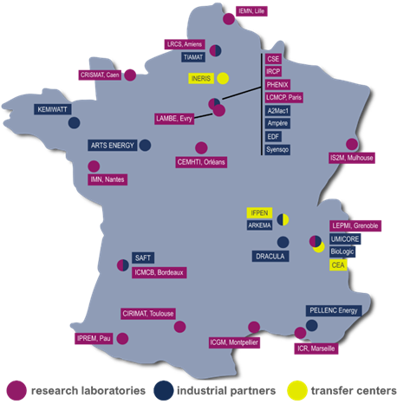
Figure 10 Overview of the RS2E Network (2025)
(Source: Connect To Power Up! Presentation by M. Morcrette, Co-Director of the RS2E Network)

National Funding Schemes
The French battery sector is supported by a multi-layered funding architecture that combines national strategic programs with European instruments. The program France 2030 with subsidies of €54 billion plays a central role by providing substantial funding for research, innovation and industrial deployment in strategic sectors, including batteries, through targeted calls and financial schemes.
Under this umbrella, the PEPR Batteries program (Priority Research Programs and Equipments), endowed with a €50 million budget over a seven-year period, coordinates upstream research activities with low to intermediate technology maturity (TRL 1–4). Co-led by CEA and CNRS, this program aims to develop new generations of more efficient, long-lasting, safer and also cheaper batteries. PEPR is also facilitating technology transfer toward industrial partners. PEPR finances upstream research on innovative chemistries, advanced battery management systems and new characterization and simulation tools, with the explicit objective of supporting future generations of batteries and strengthening the national battery value chain.
A complementing measure is the BATMAT (BATtery MATerials) consortium of 16 players from public R&D&I conducts projects with a TRL 4-6. Managed by CNRS Innovation and SATT Linksium, BATMAT supports proof-of-concept and prototype development and builds a bridge toward commercialization. BATMAT links academic results to funding instruments for more commercially mature technologies provided by Bpifrance and the French Agency for Ecological Transition (ADEME).
Franco-German cooperation further reinforces this funding landscape: the HiPoBat (High Power Batteries) project, launched in 2024, is a joint initiative supported by French and German funding agencies. HiPoBat focuses on the development of high-power solid-state batteries based on lithium and sodium chemistries.
The IPCEI on batteries (Important Project of Common European Interest on batteries) is an essential forum to coordinate French industrial projects with their counterparts in other Member States and accelerate industrial deployment. In addition, large French gigafactory projects benefit from European-level financial support, notably through the EU Innovation Fund.
Since early 2025, a key fiscal instrument to support the battery industry is the new Green Industry Investment Tax Credit (Crédit d’impôt pour l’industrie verte, C3IV). The credit covers a significant share of eligible investment costs: up to 45% (depending on company size) of investment expenditure in green technologies including batteries, capped at €200 million per company.

R&D Priorities and Trends
One of the priorities in the national battery strategy, which is coordinated by DGE (Direction générale des Entreprises), is to develop a competitive industrial offering across the entire battery value chain, by supporting research, innovation and industrialization. In addition, the focus for R&D lays on environmentally responsible and virtuous batteries as well as supporting the demand for batteries, in particular by speeding up the transition of the transport sector.
France’s research and innovation priorities in batteries are framed by the European BATTERY 2030+ initiative and are translated into concrete national activities through the PEPR Batteries roadmap. At the core of these priorities is the development of high-energy batteries and next-generation materials. This includes so-called Generation 4/5 systems and alternative chemistries beyond conventional lithium-ion, such as Na-ion, Potassium-ion and Fluoride-ion solid-state batteries, with the ambition of improving performance, safety, cost and sustainability. In parallel, advanced battery management systems (BMS) are being pursued, optimizing the design for safe disassembly processes.
Another major research axis concerns digital methods such as advanced characterization and modeling. Operando techniques (analysis during battery operation) and AI-assisted multiscale simulation are used to analyze fundamental processes, guide materials design and support the virtual prototyping of cells and systems. High-power solid-state batteries constitute a specific priority area, exemplified by the HiPoBat project, which aims to develop solid-state cells capable of fast charging, high energy density, and long cycle life.
Recent developments in the French battery landscape show a clear move toward higher technology readiness levels and a broader range of chemistries, with solid-state and Na-ion systems emerging as strategic complements to conventional lithium-ion technologies. At the same time, system-level and software innovation, especially advanced BMS concepts, data-driven optimization and predictive maintenance, have become a key lever of competitiveness and is firmly embedded in national research roadmaps (national battery strategy France 2030, PEPR). The French strategy also promotes vertical integration from upstream raw materials and processing via gigafactory cell production to downstream recycling and second-life uses, in close connection with international cooperation, in particular Franco-German projects and EU funding initiatives. Together, these trends reinforce France’s position as an increasingly important player in next-generation battery technologies.

Germany

National Ecosystem
Following its ambition for leading in both industry and research, Germany is one of the central pillars of Europe’s emerging battery value chain. Although some initiatives and companies have so far not achieved their desired goals, the national ecosystem is robust, especially on the research side.
Germany has built a dense, multi-layered ecosystem for battery research and development. The national landscape spans leading research institutes and universities. To name a few, the University of Giessen, the Karlsruhe Institute of Technology, the University of Münster, TU Munich, Ulm University, RWTH Aachen and University of Bayreuth are established academic institutions in this field.
The research center Battery LabFactory Braunschweig (BLB) at the University of Braunschweig is a widely acknowledged infrastructure for collaborative R&D. It covers the entire value chain from material and electrode production to cell manufacturing, system integration and recycling. The BLB is also coordinating the LiPLANET network, gathering the most relevant pilot lines for research and development of Lithium battery cells in Europe.
Another important battery research institution in Germany is the Münster Electrochemical Energy Technology (MEET) at the University of Münster. Internationally, the MEET is well-known for its research in the fields of battery materials (especially on lithium-metal batteries), cells and electrochemistry.
In addition, Max-Planck institutes are important for basic research in the battery field, namely the Institute for Solid State Research in Stuttgart, the Institute for Iron Research in Düsseldorf, the Institute for Polymer Research in Mainz, and the Institute of Colloids and Interfaces in Potsdam. For applied research, Helmholtz institutes in Ulm and Münster as well as Fraunhofer and Leibniz institutes provide valuable resources, complemented by a growing network of application-oriented centers that focus specifically on cell and systems manufacturing. The Fraunhofer Gesellschaft with more than 20 institutes involved in battery-related research bridges the gap to industrial research along most of the value chain.
In the last years, Germany has invested in large pilot and research manufacturing facilities for cells and modules, designed to bridge the gap between laboratory results and industrial gigafactories. This includes the Fraunhofer Research Institution for Battery Cell Production FFB in Münster (Fraunhofer FFB), a cooperative initiative of several Fraunhofer Institutes, among others, the Fraunhofer Institute for Silicate Research ISC. The Fraunhofer FFB focuses on the advancement of manufacturing processes in its fully digitalized production environment under giga conditions with all process steps and common cell formats.
The Center for Solar Energy and Hydrogen Research Baden-Wuerttemberg (ZSW) with its lab for battery technology (eLaB) runs one of the largest pilot plants for industry-formatted battery cells in Europe. In addition, it has founded “Powder-Up!” - a pilot plant in Ulm to produce cathode materials in batches of up to 100 kg.
There are several other relevant battery organizations, e.g. KLiB – Der Batterieverbund (German association of industries and research facilities along the value chain for lithium-ion batteries), the Fraunhofer Battery Alliance, and CELEST (Center for Electrochemical Energy Storage Ulm – Karlsruhe), which plays an important coordinating role in Germany’s battery research landscape. With members drawn from 31 institutes across the partner institutions, CELEST strengthens collaboration between fundamental electrochemistry, materials research, and application-oriented battery development, thereby supporting knowledge transfer across scales and institutions.
The whole ecosystem is tightly coupled to a strong automotive and machinery industry, both a driver of research questions and an early application field for new technologies. However, the build-up of gigafactories and suppliers of turn-key manufacturing machines for giga scale production of battery cells has not yet resulted from these activities. Several industrial initiatives downsized, are delayed, on hold or even bankrupt. Overall, the ramp-up of production capacities in Europe is harder than expected, however, there has been significant progress. OEMs such as Mercedes Benz with its Industrial Cell Lab in Stuttgart or BMW with its Cell Manufacturing Competence Centre in Parsdorf operate their own R&D infrastructures for battery cells. In addition, innovative start-ups such as
E-Lyte Innovations GmbH from Kaiserslautern (full-service partner in the field of development and production of customized high-performance electrolytes for electrical energy storage device) and
cylib GmbH from Aachen (research-based battery recycling) show clear success. The same holds for cost-effective electrode production (based on an innovative, and dry extrusion based electrode coating method) by UniverCell Holding GmbH (and partners) as well as for project consortia designing cross-industry content-related and technical standards for a battery passport including a demonstrator (BatteryPass project led by SystemiQ) and a test environment enabling companies to verify the conformity of their digital product passport system with the required data completeness, structure, and formats (BatteryPass-Ready project leaded by Fraunhofer IPK).

National Funding Schemes
The expansion of battery cell production, including upstream and downstream segments of the value chain, as well as funding for battery innovation, remains a priority in the coalition agreement of Germany's current Federal Government.
In recent years, both the Federal Ministry for Economic Affairs and Energy (BMWE) and the Federal Ministry of Research, Technology, and Space (BMFTR) have been involved in funding and strategically steering the battery R&D activities in Germany. Traditionally, funding for fundamental research and lower TRL research and development lies within the responsibility of the BMFTR. The BMFTR’s initiatives include funding for battery competence clusters and research initiatives e.g. on cell production technologies or solid-state batteries. Since 2019, the BMWE has launched complementary large scale funding initiatives to bridge the gap between high TRL R&D and industrial deployment. This complementary approach allows to leverage the technical expertise and resources of both ministries, yet it requires close coordination and communication with the national ecosystem, especially the private sector.
National funding schemes play a decisive role in structuring the battery ecosystem. Germany combines broad funding programs for fundamental research with targeted initiatives for applied and industrial R&D and pre-competitive consortia along the battery value chain. Dedicated calls support topics such as advanced materials, production technologies, digitalization of manufacturing and recycling processes, often in multi-partner projects that require collaboration between academia, SMEs and large corporations.
In addition, Germany participates in major European initiatives and makes use of state aid frameworks that enable substantial public resources for integrated projects spanning materials, cells, systems and circular-economy aspects, most notably through the battery IPCEIs (Important Projects of Common European Interest). Under this framework, 12 German companies have received BMWE grants with an approved funding volume exceeding €1 billion, supplemented by additional funding from the federal states. Examples include BASF's projects to establish an innovative CAM production facility and a prototype battery recycling plant in Schwarzheide, as well as VARTA's development of high-energy-density small-format lithium-ion cells.
While the IPCEI targets large-scale projects that seek to translate innovation into industrial deployment, the BMWE has introduced an additional funding scheme for a broader range of smaller-scale applied R&D projects under the General Block Exemption Regulation (GBER). This ecosystem support provides funding for 136 companies, universities and RTOs with a budget of €220 million. Both initiatives are coordinated so that BMWE funding contributes to the development of an ecosystem centered around the large-scale IPCEI projects. Additionally, the BMWE has made use of the Temporary Crisis and Transition Framework (TCTF) to fund upscaling of production capacities in the battery value chain, including raw material production and recycling. This is complemented by instruments such as equity bonds, loans, and the EU Innovation Fund.
This funding architecture incentivizes scientific excellence and rapid transfer into industrial practice. To support this, Germany has been active in funding training for skilled workers for the battery industry. Notable examples are the six regionally-located projects for the development and validation of qualification and training measures for battery cell production (KombiH, B3-Bayern, QualiBatt BW, ABAKOS, BatterieMD, QuW-LIB) funded by the BMWE and the European Learning Laboratory Battery, which is part of the Fraunhofer FFB and is funded by the BMFTR.

R&D Priorities and Trends
Germany’s R&D priorities in batteries reflect the country’s industrial profile and policy ambitions. On the materials side, research focuses on high-energy and high-power chemistries, safety improvements and the reduction of critical raw materials. On the process side, a strong emphasis lies on scalable, cost-efficient and highly automated manufacturing technologies, including process monitoring, inline quality control and digital twins of production lines. System-level research addresses battery management, lifetime prediction and the integration of batteries into vehicles and stationary applications, increasingly under real-world operating conditions. Across all these areas, sustainability is a cross-cutting theme, from life-cycle assessment to design-for-recycling and circular business models.
Germany is collaborating bilaterally and multilaterally with partner countries to expand global knowledge and address global challenges. A clear focus lays on international research partnerships for shaping the future technologies. In cooperation with the USA, activities focus on interfaces with solid and liquid electrolytes, while the German-French-cooperation aims for high-power batteries. Regarding Asia, there are cooperations with Japan on post lithium-ion batteries and with Taiwan on lithium-ion and solid-state batteries as well as battery safety.
There is a clear shift towards holistic optimization across the full value chain, linking material development, cell design, production, use phase and end-of-life strategies in integrated models. Data-driven methods, including machine learning for materials discovery, process optimization and predictive maintenance, are becoming core components of research projects. In addition, regulatory drivers such as carbon-footprint requirements and digital product passports are expected to steer R&D towards transparent, low-emission and traceable battery systems.
The German government pursues the High-Tech Agenda as its strategic research approach over the next three years. In the context of the key technology “Fusion and climate-neutral energy production”, battery technology is also defined as a strategic research area. In particular, the lack of experience in scaling battery factories to giga scale is to be addressed – by analyzing battery applications (e.g., cars, drones, ships) and derive the requirements for production, battery materials, and scale-up specific to each application. To achieve upscaling and produce at or close to giga factory level, Germany's priorities lay on vertical alliances for battery applications. The aim of such alliances is to develop a battery cell or battery system through an industry-led consortium. This strengthens value chains from the product or application level and integrates relevant industry partners from the beginning. This also includes closer international cooperation in this sector, especially with the Netherlands, the United Kingdom, Sweden and Norway.
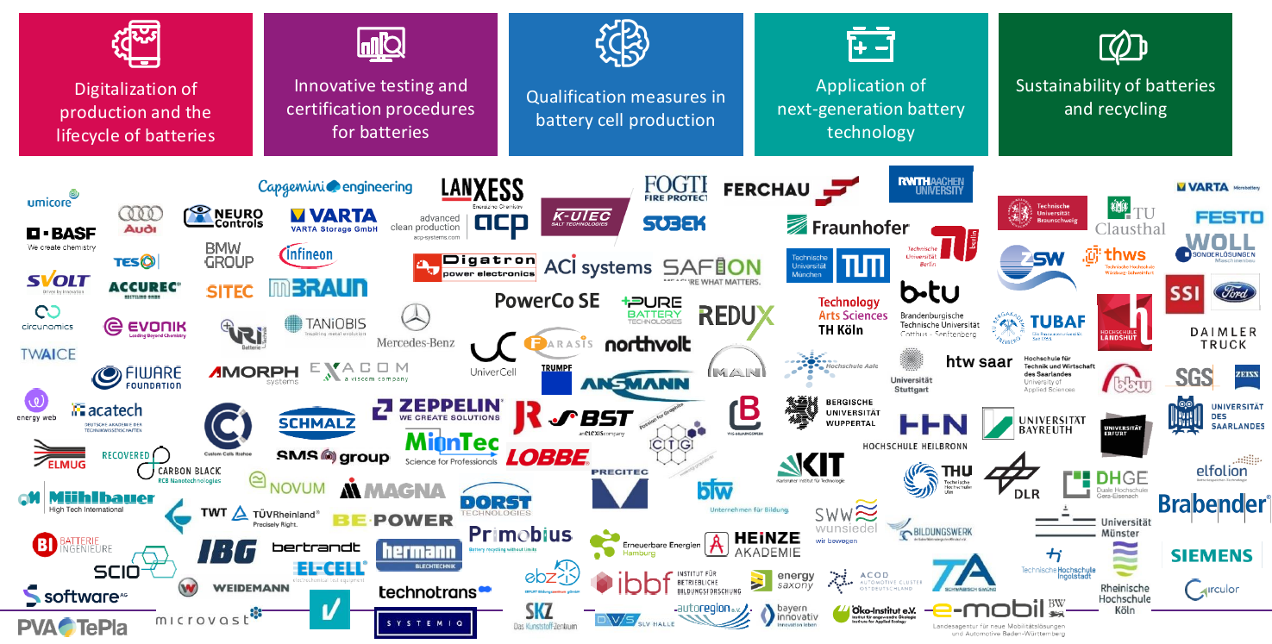
Figure 11 Overview on funded actors in the battery ecosystem ((Source: Connect To Power Up! Presentation by S. Brunner, VDI/VDE-IT)

Greece

National Ecosystem
The battery and energy-storage landscape in Greece is shaped by national climate and energy policy, European and national innovation funding, and a focused but increasingly active R&I ecosystem in advanced materials, graphene-enabled electrodes, safer lithium-ion batteries, battery management, recycling, and stationary energy storage. Although Greece does not currently host large-scale passenger-EV cell manufacturing comparable to the leading European battery-manufacturing countries, it has developed relevant capabilities across materials R&D, prototype cell development, pilot-line activity, battery recycling, energy-storage systems, and space-oriented electrochemical energy-storage technologies.

A central public research actor is the Foundation for Research and Technology – Hellas (FORTH), and particularly FORTH/ICE-HT, which coordinates two highly relevant Horizon Europe projects. INERRANT, implemented within the BATTERY 2030+ framework, focuses on safer and recyclable Gen-3 lithium-ion batteries. The project addresses safe-and-sustainable-by-design materials, novel electrode and separator components, stimuli-responsive electrolyte formulations, sustainable recycling routes, advanced electrochemical and operando characterization, machine-learning-assisted ageing prediction, and scalable processes suitable for progression toward industrially relevant battery manufacturing.
FORTH also coordinates GRAPHERGIA, a Horizon Europe project on innovative pilot lines for sustainable graphene-based flexible and structural energy-harvesting and energy-storage devices. GRAPHERGIA is directly relevant to the lithium-ion battery landscape because it develops laser-assisted graphene processing and a dry-electrode approach for next-generation Li-ion battery electrodes. The project includes pilot-scale development of graphene/Si-based electrodes for Li-ion batteries and energy-storage modules, including space-relevant applications.
The Greek ecosystem also includes technology-oriented SMEs with strong links to advanced materials and energy storage. PLEIONE Energy is a relevant SME active in graphene-based energy-storage technologies and participates in both INERRANT and GRAPHERGIA. The company is active in energy-conversion, energy-distribution and energy-storage applications, with a focus on advanced materials and nanotechnology, including graphene. PLEIONE Energy has also implemented or participated in European Space Agency activities related to graphene-based electrochemical energy storage, including COORAGE on graphene-based lithium battery cells with extended life cycle, GRACE and GRACE II on graphene-based supercapacitors for space applications, and GADGET on graphene-based energy-storage components.
Sunlight Group is the main industrial battery actor in Greece. Its activities are focused primarily on industrial and off-road mobility batteries, energy-storage systems, lithium-ion technologies, pilot-scale cell development, and recycling rather than passenger-EV gigafactory production. Sunlight has participated in the European Battery Innovation IPCEI/EuBatIn framework and has received support for lithium battery R&D. The EIB-backed investment in Xanthi supports RDI facilities and a pilot line for prototype Li-ion cells, with a nominal capacity of up to 200 MWh. The company is also developing circular-economy capabilities through ReLiFe project, which established a pilot lithium battery recycling unit in Xanthi with a capacity of 500 tonnes per year for LFP batteries and production scrap.
Additional Greek R&I capabilities include SOLIDEL, a national collaboration involving Sunlight, FORTH, Democritus University of Thrace and the National and Kapodistrian University of Athens on solid polymer electrolytes for next-generation Li-ion batteries and solid-state battery concepts.

Battery R&D Funding Landscape
Greece does not currently have a single dedicated national battery mission equivalent to the large battery strategies of the main European cell-manufacturing countries. Instead, battery-relevant R&I is funded through a combination of European programs and broader national instruments. Horizon Europe remains a key source of funding, as demonstrated by INERRANT and GRAPHERGIA. National and regional instruments also contribute through the National Smart Specialization Strategy, the Competitiveness 2021–2027 Program, HFRI/Greece 2.0, and other innovation and recovery-funding schemes that support energy, materials, circular economy, green transition and industrial innovation.
The National Energy and Climate Plan (NECP) provides the broader policy framework for energy transition, renewable-energy integration, electromobility, storage and research/innovation. Under the National Recovery and Resilience Plan (NRRP), Greece has also supported grid-connected energy-storage deployment through a dedicated scheme approved by the European Commission, with a budget of EUR 341 million to support approximately 900 MW of storage. This deployment-oriented storage policy reinforces the need for domestic R&I in battery systems, safety, lifetime, recycling, control, and integration with renewable energy.

R&D Priorities and Trends
Current Greek battery-related R&I is concentrated in areas that include safer and more sustainable Gen-3 lithium-ion batteries; advanced electrode, separator and electrolyte materials; graphene-enabled electrodes and dry-electrode processing; EV battery management and lifetime extension; and electrochemical energy-storage systems for space and other demanding applications.
Greece is therefore an emerging and specialized contributor to the European battery ecosystem, with strengths in advanced materials, graphene-related technologies, space-oriented energy storage, and system-level battery management. The main gaps remain the limited scale of domestic cell manufacturing, the need for stronger pilot-line and testing/metrology infrastructure, and the absence of a fully dedicated national battery R&I mission.

Hungary

National Ecosystem
In the recent years, the battery industry, namely cell and component manufacturing, rapidly grew in Hungary. This development was driven largely by major East-Asian companies that have chosen the country as a European production base. South Korean companies including Samsung SDI and SK On (Spin-Off by SK Innovation) as well as Chinese producers such as CATL, EVE Power and Sunwoda are active in Hungary. They have established plants or announced large new facilities, particularly around Debrecen and in the Budapest region. Suppliers for cathode active materials, copper and aluminum foils, carbon additives, electrolyte solutions, separators, binders and casings have established production as well. The involvement of the Slovenian company TAB d.d. in a new recycling plant in Hungary underlines the increasingly international character of the national industrial battery ecosystem.
At present, the largest battery-related waste stream in Hungary originates from manufacturing scrap rather than end-of-life batteries, reflecting the early stage of EV battery retirement in Europe. Current recycling activities focus primarily on mechanical pre-processing and black-mass production. However, the implementation of the EU Battery Regulation is expected to significantly increase demand for domestic recycling, material recovery and battery traceability solutions. As a result, several industrial and research initiatives are exploring technologies for critical raw material recovery, second-life battery applications and circular value-chain development.
Regarding R&D capabilities, research is mainly conducted at universities and research institutes based on existing competences, such as the Budapest University of Technology and Economics, Széchenyi István University Győr, Eötvös Loránd University (ELTE), the University of Debrecen and HUN-REN institute network (state-owned applied research facilities of 7 research centers and 8 research institutes). In conclusion, academia drives the battery-related research, while industry involvement is emerging but not yet dominant.
The rapid expansion of battery manufacturing has also increased demand for skilled engineers, technicians and battery specialists. Universities and vocational education institutions have launched dedicated programs in battery technologies, electromobility and energy storage to address workforce needs. Nevertheless, attracting and retaining qualified personnel remains a challenge due to the pace of industrial growth and increasing competition for talent across the region.
Hungary has become one of the most significant battery manufacturing locations in Europe, with announced battery production capacities placing the country among the continent’s leading battery-producing nations. The concentration of cell manufacturers, material suppliers and logistics infrastructure creates a strategically important industrial cluster that supports both the European automotive industry and the broader energy transition. This position is expected to further strengthen as newly announced production facilities become operational during the second half of the decade.

National Funding Schemes
The National Research, Development and Innovation Office (NKFIH) is the central public body for research and innovation funding in Hungary, it channels resources from EU and national instruments into battery-related projects. Programs such as Széchenyi Plan Plus provide several relevant calls, e.g. on “Installation of Network Energy Storage Systems at Energy Market Participants” (€155 million budget, additional € 125 million budget for the Ányos Jedlik Energy Program), and another announced R&D funding scheme on “Support for energy research and development projects” (€32,5 million budget). These calls support research, deployment of energy storage and energy efficiency measures, ranging from larger grid-scale storage schemes, backed by state aid of about €1.1 billion (around HUF 436 billion), to subsidies for residential and commercial battery installations. Additional

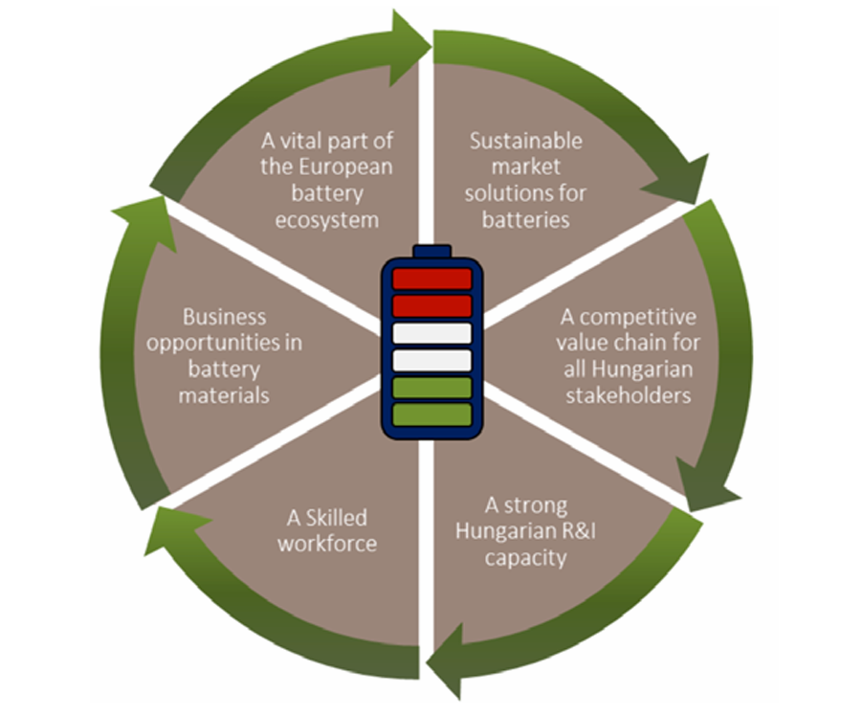
Figure 12 Six key objectives of the strategy for a competitive and sustainable battery value chain in Hungary
calls under environmental and energy-focused operational programs (e.g. KEHOP and successor schemes) also provide funding opportunities for storage and decarbonization projects.
Beyond NKFIH, the National Innovation Agency (NIÜ) and the Hungarian Development Promotion Agency (MFOI) support companies, especially SMEs, in accessing international funding, including Horizon Europe, which is open to battery-related topics along the entire value chain. While there are currently no fully dedicated, battery-only funding lines, the predominantly bottom-up design of many Hungarian and EU programs allows for project proposals at all stages of the R&D cycle, from fundamental research to application-oriented and market-proximate demonstration.

R&D Priorities and Trends
Hungarian battery-related research is conducted across multiple institutions and thematic areas, although coordination through a comprehensive national battery R&D strategy remains limited, but several cross-cutting priorities can be identified. Universities and public research organizations are working on alternative chemistries including lithium–sulfur, solid-state batteries, zinc-based and metal–air systems. In parallel, research groups focus on battery management systems (BMS), electric drivetrains, smart-grid solutions, energy communities, and diagnostic and testing methods, including digital twins and aging simulations for traction batteries and stationary storage.
In the circular-economy field, projects concentrate on the treatment of production scrap, pre- and post-processing of black mass and the reduction or substitution of critical solvents such as N-methyl-2-pyrrolidone (NMP), with increasing attention to full recycling chains and the recovery of secondary raw materials. Most academic work on waste management is still concentrated at lower technology readiness levels (roughly TRL 1–4). Upscaling to TRL 5–7 is constrained by missing infrastructure and dedicated funding.
Beyond battery chemistry research, increasing attention is being paid to testing, certification and validation infrastructure. Universities, automotive research centres and industrial laboratories are expanding capabilities in battery safety testing, lifetime assessment, performance characterization and digital modeling. Such facilities are expected to play an increasingly important role in supporting both industrial qualification processes and the development of next-generation battery technologies.
A notable trend in Hungary is the gradual strengthening of links between industrial companies and higher-education institutions. Firms such as Samsung SDI have signed cooperation agreements with Hungarian universities, launched internship programs and initiated joint projects, for example in the Debrecen region where new battery plants and a university-based battery research institute are being developed. Nonetheless, foreign manufacturers’ R&D activities in Hungary remain limited, and many collaborations are project-based and governed by non-disclosure agreements.
Although Hungary hosts one of Europe’s fastest-growing battery manufacturing sectors, participation in European battery research and innovation initiatives remains comparatively limited. Increasing involvement in Horizon Europe projects, BEPA-related activities, and other European partnerships is therefore regarded as a strategic priority. National stakeholders, including HUBA, are actively working to strengthen international collaboration, improve access to European research networks and increase the visibility of Hungarian expertise within the broader European battery ecosystem.

Ireland

National Ecosystem
The Irish battery ecosystem comprises a number of highly specialized universities and excellent research infrastructures (see Figure 13): At the University of Limerick (UL), the AMPEiRE Centre for Battery and Energy Materials Research is hosted in the Bernal Institute, which is equipped with state-of-the-art manufacturing and testing facilities for rechargeable batteries. Trinity College Dublin (TCD) hosts the AMBER Research Centre, which specializes in advanced materials development. At University College Cork (UCC), the research is focused on additive manufacturing and 3D-printable, fully recyclable batteries. UCC also contributes significantly into smart energy networks through interdisciplinary programs in electrochemistry and sustainable energy systems, with particular emphasis on lifecycle assessment, circular design, and the integration of battery technologies. The Tyndall National Institute acts as a key hub for micro- and nanoelectronics, supporting battery innovation through sensor integration, advanced characterization, and the development of embedded systems for battery management and diagnostics.
These institutions collaborate closely with industrial partners such as ESB (Electricity Supply Board - Ireland’s state-owned electricity company for grid integration and storage development with over 300 MW of battery storage facilities), RWE Renewables Ireland Limited (major European energy company with wind parks and large-scale battery storage), Iberdrola, VPI, Lumcloon Energy (large scale battery storage for all three), Analog Devices (wireless battery management system development), Li-GEN (manufacturing of batteries, esp. LFP and NMC powerpacks, and battery management systems), and Licovolt (University College Dublin (UCD) spin-out, focusing on innovative cathode production and recycling) to implement pilot and demonstration projects in both stationary and mobile energy storage.
The Irish battery ecosystem is characterized by a strong integration of fundamental academic research, applied consortia, and industrial actors.
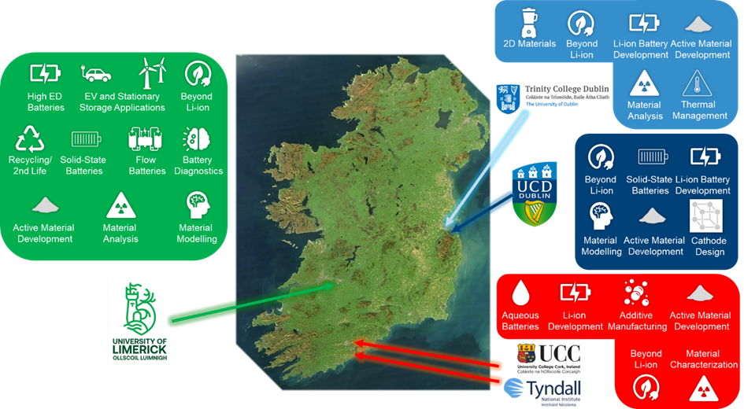
Figure 13 Overview on the Irish university research landscape - main universities and their research topics (Source: Connect To Power Up! Presentation by M. Daly, Research Ireland)

National Funding Schemes
Funding is provided through several state-supported programs. One pillar is the support via funding agencies. The organization Taighde Éireann (Research Ireland) has funding programs for fundamental research (e.g. Frontiers for the Future), a pathway program for emerging investigators, challenge-based funding as well as research infrastructure and career funding (e.g. PhD and postdoctoral scholarships). The agency Enterprise Ireland addresses companies by providing commercialization funding, an innovation partnership program and proof-of-concept funding.
The Irish Disruptive Technologies Innovation Fund (DTIF) supports higher TRL (3-9) funding, including in decarbonization solutions. Regarding research, there is consortium-based funding for industry, SMEs and academia. The same goes for funding from Sustainable Energy Authority of Ireland (SEAI), which also supports private and corporate investments (e.g. in solar power, grid-level storage etc.).

R&D Priorities and Trends
Ireland’s research agenda is centered on three key thematic areas. First, material development is being advanced, ranging from alloying-mode (e.g. silicon nanowire) and 2D material anodes to nickel-rich cathodes and safer ether-based or ionic liquid electrolytes for high-voltage lithium-ion cells. Second, there is a strong focus on additive manufacturing and 3D printing, enabling the realization of custom-shaped, recyclable batteries and integrated electrodes. Third, Ireland supports the integration of new chemistries such as sodium-ion, dual-cation, magnesium-ion, potassium-ion, aluminum-ion, sulfur-based chemistries and redox-flow batteries, alongside the development of solid-state and aqueous battery technologies, to improve safety and lifetime.
This is guided by an overall chemistry-neutral approach for battery research. In parallel, recycling and second-life applications of batteries are being investigated to establish a circular value chain. These activities are motivated by Ireland’s high share of wind energy (accounting for more than one-third of the national electricity mix) and the planned expansion of stationary storage capacity, which is expected to increase fivefold by 2030. In this way, Ireland is positioning itself as an innovation driver for sustainable energy storage solutions in both the European and global context.

Italy

National Ecosystem
Italy’s National Energy and Climate Plan (PNIEC) forms the strategic foundation for the development of electrochemical energy storage and links these objectives with European targets. The PNIEC identifies electrochemical energy storage as a strategic pillar and envisages around 15 GW of storage capacity by 2030. The research landscape is built around the three main national research organizations: the Italian National Agency for New Technologies, Energy, and Sustainable Economic Development ENEA (new battery materials for Li-ion and other post-Li-ion-systems, electrolytes and sustainable/second-life applications), the National Research Council CNR (hybrid systems, flow batteries, critical raw materials substitution) and the Ricerca sul Sistema Energetico RSE (battery materials, system testing, safety and applications). They cooperate with additional players such as Fondazione Bruno Kessler FBK (battery diagnostics, battery management systems and digital technologies for energy storage), Istituto Italiano di Tecnologia IIT and a broad network of over 20 Italian universities, jointly working on battery technologies.
Key academic actors include Politecnico di Milano (electrochemical energy storage systems, battery modeling and integration into energy systems), Politecnico di Torino (advanced battery materials, solid-state batteries and manufacturing processes), Università di Bologna (advanced battery materials, sodium-ion technologies and recycling), Università di Roma La Sapienza (electrochemistry, novel electrode and electrolyte materials and diagnostics), Università degli Studi di Napoli Federico II (materials modeling, interfaces and electrochemical modeling), and Università di Pavia (recycling). Since 2020 the GISEL consortium (Centro di Riferimento Nazionale per i Sistemi di Accumulo Elettrochimico di Energia), hosted by the National Inter-University Consortium for Materials Science and Technology (INSTM), has provided a shared laboratory for battery research and fosters regular collaboration and information exchange among industry, academia and research organizations.
On the industrial side, relevant companies are distributed across the battery value chain:
• Upstream, including Alkeemia (advanced battery materials), Italmatch (electrolytes and specialty chemicals for batteries), and Syensqo (battery polymers and binder materials);
• Midstream, including Seri Industrial (lithium-ion cell manufacturing and battery recycling, through FIB S.p.A, and also lead acid), Midac (lead-acid and lithium batteries for industrial applications), and Flash Battery (lithium battery systems and battery management systems for industrial and off-road applications);
• Downstream, including Enel (battery energy storage deployment and grid integration), Cobat and Erion Energy (battery collection and end-of-life management), and Green Energy Storage (vanadium redox flow battery systems).
Italy also hosts a competitive battery manufacturing equipment industry. Key players include Comau (automation and battery assembly systems), Sovema Group (battery manufacturing equipment), IMA Automation (automated production lines for lithium-ion cells), and OCS Group (battery pack assembly automation).

National Funding Schemes
Since the early 2000s, Italy has operated a dedicated national funding scheme for energy system research, in which energy storage technologies are recognized as a strategic research area. The Ricerca di Sistema program (Research Fund for the Electricity System) finances three-year research plans addressing strategic topics for the national energy system. Funding is allocated by the Ministry of the Environment and Energy Security (MASE) to ENEA, CNR and RSE as the main implementing organizations, while Italian universities also participate in the funded projects. The research line on electrochemical and thermal energy storage typically receives approximately €16–17 million over each three-year program.
In recent years, national funding for the battery value chain also comes from the Recovery and Resilience National Plan (PNRR), from dedicated R&I instruments and regional funds. Under the PNRR, significant resources (total budget of € 1.7 billion) have been allocated to battery technologies through dedicated investment measures supporting renewables, storage and industrial development. Within the NEST (Network for Energy Sustainable Transition) Extended Partnership, Spoke 6 focuses on electrochemical and thermal energy storage technologies and is coordinated by Politecnico di Torino. In addition, Mission Innovation 2.0 calls contribute an additional €12 million on “Flexibility and energy storage”. Italy also benefits from the EU-wide IPCEI programs, receiving €1,170 million public support for collaborative battery projects.
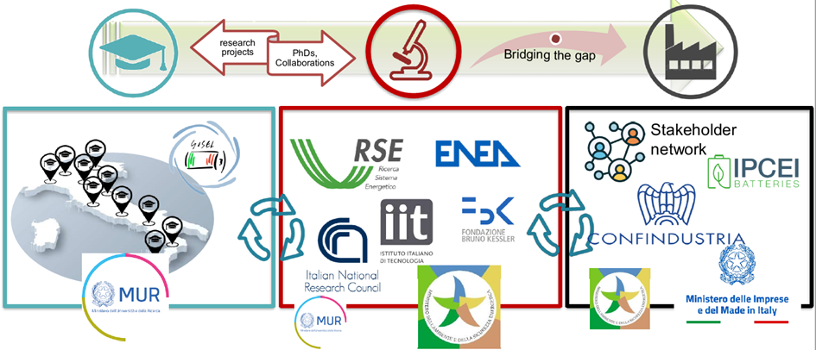
Figure 14 The Italian battery R&I ecosystem (Source: Connect To Power Up! Presentation by M. Moreno)

R&D Priorities and Trends
The current national research agenda focuses on a broad spectrum of technologies, ranging from Li-ion and solid-state batteries to Na-ion systems, as well as redox-flow and metal-air batteries. Most funding is directed toward Li-ion and Na-ion technologies: Key areas include the synthesis of new materials, formulation and processing, forensic analyzes, electrochemistry, modeling, and battery 2nd life and recycling. From a technological perspective, LFP, LMFP, Na-ion, and solid-state cells are at the forefront, supported by accelerated material discovery and system-level testing conducted across different technology readiness levels (TRLs).
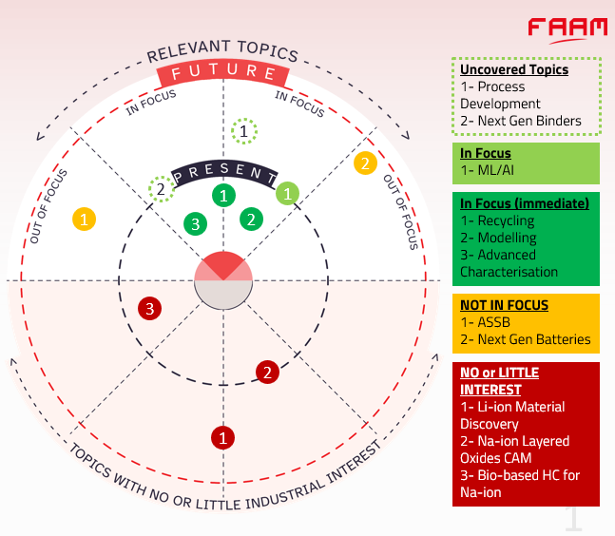
Figure 15 Italian current research trends (Source: Connect To Power Up! Presentation by M. Copley, FAAM)

Latvia

National Ecosystem
Battery research in Latvia is concentrated in a small but increasingly coordinated ecosystem led by the University of Latvia, especially the Institute of Solid State Physics (ISSP UL), which has become the main national hub for battery materials research and related energy-storage studies. The strongest visible research activity is centred on next-generation battery materials, battery ageing, and system-level energy-storage questions, with collaboration extending to Riga Technical University and the Institute of Electronics and Computer Science through the Swiss–Latvian LACISE project. Work on carbon-based materials for lithium- and sodium-ion batteries is done at the University of Latvia's Institute of Chemical Physics (ICP UL).
Latvia’s battery R&D base is still niche rather than large-scale industrial, but recent events indicate a growing effort to connect academic research, public funding, and industrial users. In February 2026, ISSP UL hosted the country’s first Battery Industry Day, which brought together researchers, companies, and public-sector stakeholders and explicitly framed Latvia’s strength as knowledge-intensive battery technologies, materials research, and smart battery management rather than mass production.
On the industrial side, several small and mid-sized companies are taking shape. These include Sidrabe, which makes equipment for depositing metallic lithium films, and Nano Ray-T, which produces carbon nanotubes for battery electrodes.
In terms of grid storage, Latvia brought its first large battery systems online in late 2025, including a 60 MW / 120 MWh system, with further projects planned.

National R&D Funding Schemes
Battery-related research in Latvia is supported indirectly through broader national and international research programs rather than a battery-specific state scheme. The most relevant instruments are the Swiss–Latvian Cooperation Programme, which finances the LACISE applied-research project. The Innovation Fund - Long-Term Research Program, established by the Ministry of Economics is an initiative running in phases to 2032 and targeting commercially oriented applied research in smart materials, electronics, electrical engineering, technologies, and engineering systems.

R&D Priorities and Trends
The clearest battery R&D priorities in Latvia are new battery materials, battery ageing and performance, and energy-storage solutions suitable for renewable integration. Within LACISE, ISSP UL’s battery work is explicitly directed toward “new battery materials and storage technologies,” with the stated goals of improving lifespan, increasing capacity, and reducing dependence on critical materials.⁹³

Lithuania

National Ecosystem
Lithuania has a National Energy Independence Strategy, which includes batteries and flexibility as part of the plan and its scenarios assume 4 GW of battery storage capacity in 2050.
Lithuania’s battery R&D ecosystem is relatively compact and is anchored by the Center for Physical Sciences and Technology (FTMC), the country’s largest research and technology organization. FTMC’s current battery work is concentrated on aqueous Na-ion batteries and computational modeling for Na-ion batteries, while parts of FTMC also do some metal-air battery research.
Vilnius University has long experience in solid-state ionics, including work on solid electrolytes. The Lithuanian Energy Institute coordinated the Horizon 2020 project EnergyKeeper and works on flow batteries and hydrogen technologies.
On the industrial side, Lithuania has a small but active battery-related manufacturing and integration base. In 2021, SoliTek (Lithuania), ABEE (Belgium), and Imecar Elektronik (Turkey) announced a joint venture for battery-pack production in Vilnius, while BATTEC manufactures industrial lead-acid batteries and lithium batteries, Energus Power Solutions produces Li-ion battery packs and related management systems, and EMUS develops battery management systems for lithium-battery applications.
SoliTek is also a partner in SPRINT, a Horizon Europe project developing safe, low-cost sodium-ion batteries for stationary storage.

National R&D Funding Schemes
Lithuanian battery research is financed mainly through competitive research programmes and EU-linked instruments, rather than through a dedicated battery-specific national fund. Relevant mechanisms include the Research Council of Lithuania (RCL), which supports projects such as FTMC’s aqueous Na-ion battery work and related collaborative calls, and international cooperation schemes such as the Polish-Lithuanian DAINA program.

R&D priorities and trends
In Lithuania, the main battery research activity is concentrated at FTMC, where current work focuses on Na-ion and Zn-ion battery materials and systems, particularly framework electrodes, aqueous electrolytes, and strategies to understand and mitigate degradation. FTMC’s published research themes include phosphate, mixed-phosphate, and hexacyanometallate framework materials, indicating a strong emphasis on sodium-ion–relevant cathode chemistry and related materials development.

The Netherlands

National Ecosystem
The Netherlands has a tightly interlinked battery research and development ecosystem guided by the national battery strategy and related public-private ecosystem initiatives. It promotes the safe, responsible and sustainable use of batteries while aiming to leverage the resulting economic opportunities in areas where the Dutch ecosystem has clear strengths. Central to this ecosystem is the Battery Competence Cluster NL (BCC-NL), which serves as the national battery ecosystem organization and connects a broad affiliated network across the Dutch battery value chain. The academic backbone includes Delft University of Technology, the University of Twente, Eindhoven University of Technology, the University of Groningen and Utrecht University. Research institutes such as TNO and the Holst Centre by IMEC and TNO work closely with industrial partners, including established companies and numerous start-ups active in silicon anodes, lithium metal anodes and ALD protective coatings. The two university battery centers, the Twente Centre for Advanced Battery Technology and the e4Battery Institute at Delft University of Technology, pool research on battery materials, manufacturing, recycling and system integration.
Together with consortia of research projects and programs such as NXTGEN Hightech, BCC-NL helps connect activities across different TRL levels in the Dutch battery research landscape. The ecosystem aims to connect the lab to the market through application-driven R&D. The network covers the entire value chain, from raw materials and cell components to battery systems, recycling and second-life applications (see Figure 16). To fill gaps in areas such as large-scale cell production, the Netherlands continues to rely on international cooperation and European value-chain integration. Cell manufacturing is present at pilot and scale-up level, for example through LionVolt, but large-scale cell production is currently not a major strength of the Dutch ecosystem.
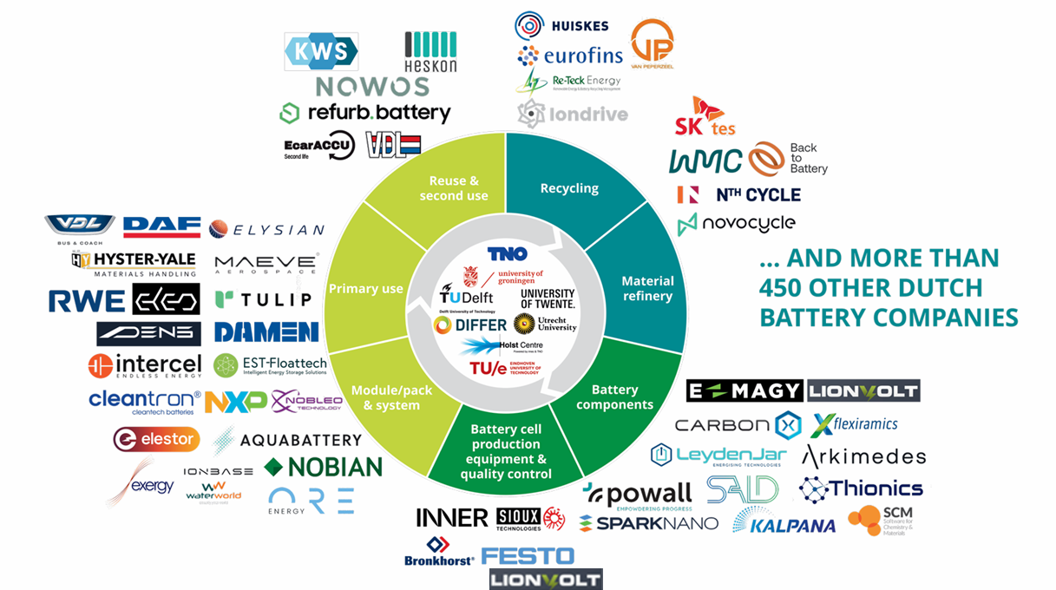
Figure 16 National Ecosystem in the Netherlands, focusing on the industrial side (Source: Connect To Power Up! Presentation by E. Sbenghea, BCC NL)

National Funding Schemes
Several funding programs support the Dutch ecosystem. The National Growth Fund (NGF 3 – Material Independence and Circular Batteries) has a total intended program volume of around €800 million, of which nearly €300 million in public National Growth Fund funding, and runs from 2024 to 2032. It focuses on building a fully circular battery value chain, reducing dependence on critical raw materials, and creating pilot and research facilities. The funded projects also aim to collaborate with users, following a market-pull approach. NGF 2 on Battery Design and Manufacturing provides €60 million over five years to support the development of next-generation equipment, pilot lines, and test facilities, with a focus on silicon anodes, ALD coatings, and 3D batteries.
Under the National Growth Fund scheme, which aims to stimulate economic growth and also supports BCC-NL, the NXTGEN HighTech project (€60 million) develops next-generation production equipment for advanced battery cell manufacturing. Focal points include the realization of pilot lines and research on equipment for thin-film technology, including atomic layer deposition for smart coatings, silicon anodes, and 3D batteries. Another National Growth Fund project is Charging Energy Hubs, which develops local smart energy systems for heavy-duty e-mobility and strengthens the infrastructure and service development for batteries in the transport and energy sectors.
Since 2023, the BatteryNL project has been funded with around €10 million over eight years under the NWA ORC program of the Dutch Research Council (NWO). The research focuses on next-generation batteries through the study of material interfaces. With a broad consortium covering the whole value chain, including international partners such as MEET Münster and Forschungszentrum Jülich in Germany, the BatteryNL project is fundamental to Dutch battery R&I activities. It has supported a national growth initiative worth around €100 million, primarily promoting start-ups working on silicon and lithium-metal anodes and protective ALD layers for both liquid-electrolyte lithium-ion and solid-state batteries.
These national measures are complemented by EU programs such as Horizon Europe.

R&D priorities and trends
The short-term strategy focuses on battery applications, while the long-term strategy aims at sustainable, long-duration technologies e.g. the scale up of new bulk storage technologies based on non-critical materials. The Dutch ecosystem has broad expertise in advanced materials, e.g. developing anodes made of 100% Silicon for high energy density. At the same time, research is conducted on Co- and Ni-free lithium-ion chemistries as well as Na-ion, redox flow and long duration batteries to achieve greater material independence .
One of the research priorities focuses on gaining an in depth understanding of material interfaces, which are key to improving performance and lifetime. The Netherlands is strongly committed to recycling and circularity, with R&D activities that place strong emphasis on end-of-life strategies (e.g. SMART-CBAT project within the BCC- NL cluster). Other focal points include the development of high-tech production equipment for battery materials cells, modules and packs. To improve sustainability, dry, PFAS free electrode production and advanced recycling and second use technologies are being pursued.
On the application side, the focus lays on integration of batteries into heavy duty mobility (trucks, buses, ships) and into sustainable solutions for grid stabilization.
Current trends show that the Dutch ecosystem is increasingly focusing on holistic interface engineering, as well as on advanced production and materials technologies, to achieve higher energy densities, longer lifetimes and enhanced safety. The development of next-generation batteries, including solid-state concepts, is being actively pursued in order to realize safer and higher-energy cells.
The implementation of the circular economy strategy is ongoing, from raw material sourcing and design for recycling approaches through to second use models for stationary energy storage. Digitalization and the expansion of pilot lines, test facilities and digital twins enable rapid validation of new concepts. This includes close links with EU programs and global industrial partners to accelerate technology transfer and market access.

Norway

National Ecosystem
Norway has pursued an ambitious battery strategy since 2022 to improve sustainability in the battery sector, covering the full value chain from raw material extraction to production and recycling. The action plan of the battery strategy is depicted in Figure 17.
Despite having the highest share of electric vehicles worldwide, domestic vehicle manufacturing remains limited in Norway. The Norwegian battery industry combines deep materials expertise with an industrial base spanning the full value chain. Mineral extraction in Norway is limited, one exception being a mine in Skaland (acquired by LNS Holding), a major producer of crystalline flake graphite in a clean and natural quality.
The Fehnsfelt project is ongoing, and has recently been taken over by the state to support its further development. Vianode produces sustainable synthetic graphite for battery anodes, while Cenate develops advanced silicon-based anode materials. Glencore Nikkelverk in Kristiansand is a major processor of battery-grade nickel and cobalt, playing a central role in the European battery materials supply chain. In addition, several smaller startups, including Bergen Carbon Solutions, ZNL Energy and Pentalys Energy, are currently in the commercialization phase, bringing innovative technologies closer to market.
Cell production ambitions in Norway have undergone significant adjustments in recent years. Freyr Battery, now rebranded as T1 Energy, has pivoted away from battery cell production. Morrow Batteries filed for bankruptcy in 2026 and the reminder of the estate is yet to be finalized. Despite these setbacks, new initiatives are emerging: Elinor Batteries and Beyonder represent a new generation of Norwegian cell development, the latter focusing on carbon-based capacitor-battery hybrid technology. Cluster-based collaboration is driven in particular by the Battery Norway platform and the Battery Coast ecosystem in Southern Norway.
The maritime sector, a traditional stronghold of the Norwegian economy, is increasingly electrified. Norway has pioneered electric and autonomous vessels (e.g., Yara Birkeland). Kongsberg Maritime has realized the world’s first fully electric cargo vessel, symbolizing the combination of clean energy and digital innovation that characterizes the Norwegian ecosystem. Corvus Energy specializing in Martime packs are a driving force.
The Norwegian Advanced Battery Laboratory Infrastructure (NABLA) serves as a central bridge between research and industry. SINTEF and the Institute for Energy Technology (IFE) are among the leading research and technology organizations. SINTEF has a particularly broad role spanning battery cell production, testing, process optimization, digitalization, and battery safety - and has built for over a decade competence in digital tools for the battery value chain, including coordination of the EU project DIGIBATT and development of open-source platforms such as BattMo. IFE focuses on materials and cell-process development. Both participate in European initiatives such as BATTERY 2030+ and BIG-MAP. Other Key Norwegian research actors include the University of Oslo (UiO), the Norwegian University of Science and Technology (NTNU), the University of Agder (UiA), and the University of Stavanger.
Norway is strongly oriented toward Nordic partnerships and benefits from cross-border synergies.

National Funding Scheme
The national funding landscape provides long-term and targeted financial instruments. A central component is the research and development center FME Battery. With approximately €30 million over eight years (2024-2032), the center supports the battery ecosystem across battery materials, cell production, battery packs/systems and recycling/reuse. Its goal is to establish a circular battery value chain, with the center acting as a hub for collaborative projects, infrastructure, and human capital development.
The Norwegian government also promotes open standards and digital tools. The national digitalization strategy from 2024 supports areas such as battery passports, traceability, and digital twins. Norwegian R&I actors are setting standards – notably through the BattINFO project’s Battery Domain Ontology - and developing open-source platforms such as BattMo and CellPy, laying the foundation for data-driven battery research and EU battery passport compliance.

R&D Priorities and Trends
Research and development activities focus on the twin transition: simultaneous green and digital transformation. Key priorities include the digitalization of battery data (particularly battery passports), open-source software, traceability, digital twins, and AI-supported analytics to enhance transparency and optimization across the value chain. Universities, particularly the University of Oslo and NTNU, focus on materials science, characterization, and emerging digital methods, while SINTEF plays a leading coordinating role in European digitalization projects. A defining trend is the development of open, interoperable platforms supporting both materials and cell development and digital lifecycle management, contributing to Norway’s ambition to establish one of the world’s most sustainable battery value chains.

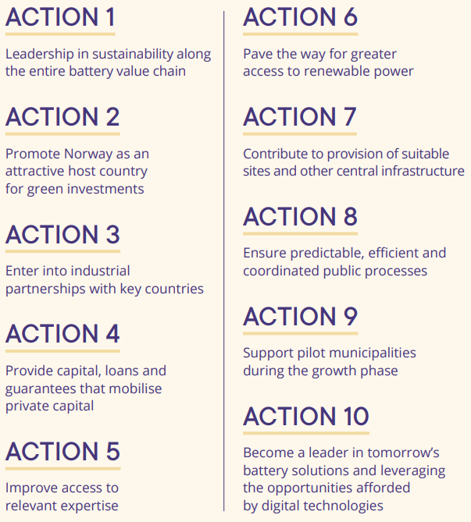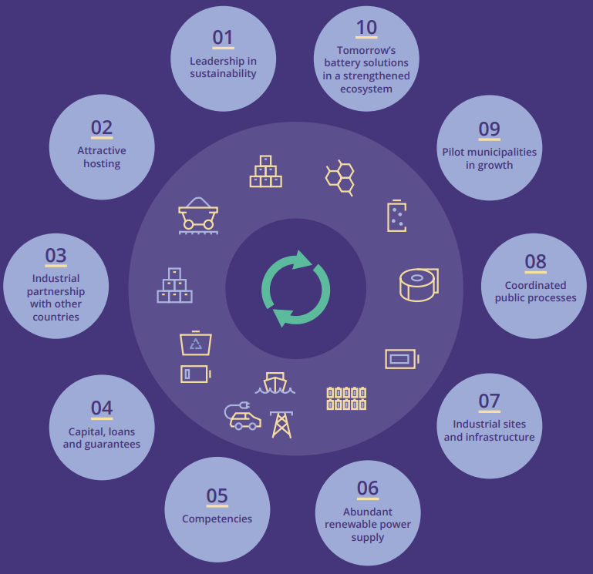
Figure 17 Action plan along the battery value chain from the Norwegian Battery Strategy (2022)

Poland

National Ecosystem
Poland has become a central hub for research, education, and manufacturing of high-performance and next-generation batteries in Europe in recent years. The Polish battery industry is highly diversified across the entire value chain: LG Energy Solution in Wrocław operates Europe's largest Li-ion cell factory, targeting a capacity of 100 GWh, while SK Innovation in Dąbrowa Górnicza supplies the world's biggest separator plant. In Nysa, Umicore & IONWAY (cathode materials) and SK Nexilis (copper foils) complement both forward and backward logistics, and companies such as AE Elemental and Stena Recycling ensure downstream logistics through large-scale Li-ion recycling. This mix of cell/module production, component and material manufacturing, and recycling creates an integrated ecosystem that serves both domestic and international battery markets (see Figure 19).
In research, technical universities play a leading role, in particular the Faculty of Chemistry at Warsaw University of Technology (WUT). WUT is training specialists in electrochemical energy systems, materials synthesis, recycling, and digital twins through the i-MESC master’s program (2023-2029). Gdańsk University of Technology (GUT) focuses on high-performance, environmentally friendly batteries for drones and electric vehicles, while Wrocław University of Science and Technology maintains close industrial partnerships, especially with LG Energy Solution. Additional actors such as AGH University of Kraków, Poznań University of Technology, and Jagiellonian University complement the network through research on solid-state batteries, recycling, and materials design.
The research network Łukasiewicz, including the Institute of Microelectronics and Photonics (IMIF) and the Logistics & Packaging Institute (PIT), coordinates expertise in solid-state and lithium-sulfur technologies, circular economy approaches, and digital twins. The Institute of Non-Ferrous Metals CLAiO in Poznań operates one of the oldest battery laboratories in Poland and provides specialist alkaline batteries as well as expertise in electrode and recycling processes. The Polish Academy of Sciences (IFTR, IChF) also contributes to the ecosystem through upcycling and recycling research. The Research and Implementation Center for Lithium Batteries (IATI) and the EBA Academy Poland strengthen skills development for securing the needed workforce.
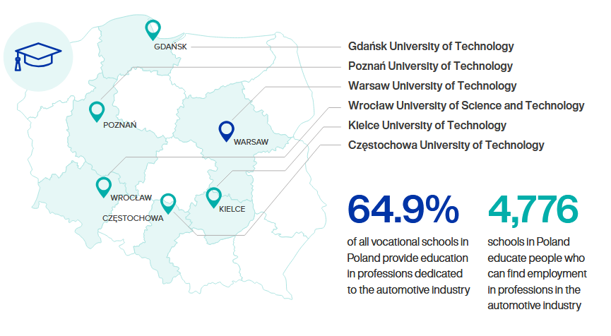
Figure 18 Polish universities educate engineers in the electromobility sector (Source: “Poland Drives e-Mobility 2022” report by PSPA)

National Funding Schemes
The country’s dynamic development is supported by a range of funding programs. At EU level, Horizon Europe funds battery research as well as the Powering the Future IPCEI project at LG Energy Solution on advance EV battery technology with next-generation cylindrical battery cells (new cell design and welding technology for better electrical conductivity, thermal management and structural integrity).
On the national level, the National Centre for Research and Development (NCBR) supports applied research, demonstration activities, and commercialization projects relevant to battery technologies and related industrial scale-up. The country does not have a standalone national battery scheme, but battery-specific funding is available through NCBR calls, IPCEI-related instruments, and selective state aid for strategic battery manufacturing projects. Poland’s current innovation and cohesion-funding architecture for 2021–2027 combines national and EU-backed instruments, including operational regional programs, which can also support battery-related industrial and skills initiatives. In addition, education and training in the battery field are supported through EU-co-funded programs such as i- MESC, rather than just through regional funding schemes.

R&D Priorities and Trends
Current research and development priorities focus on three core areas: (1) solid-state and lithium-sulfur batteries, with an emphasis on electrolyte design, interphase stability, and novel deposition methods, driven by thee Łukasiewicz institutes and WUT; (2) sustainable electrode and binder technologies as well as fluorine-lean electrolytes, developed mainly by PAS institutes in cooperation with universities; (3) circular economy and second-life strategies, including digital logistics and twin systems, advanced by the PIT institute.
At the same time, interest in recycling technologies is growing, particularly hydrometallurgy and black-mass processing, supported by the AE Elemental joint venture in Zawiercie. These trends are underpinned by close ties between universities, research institutes, and industrial partners.
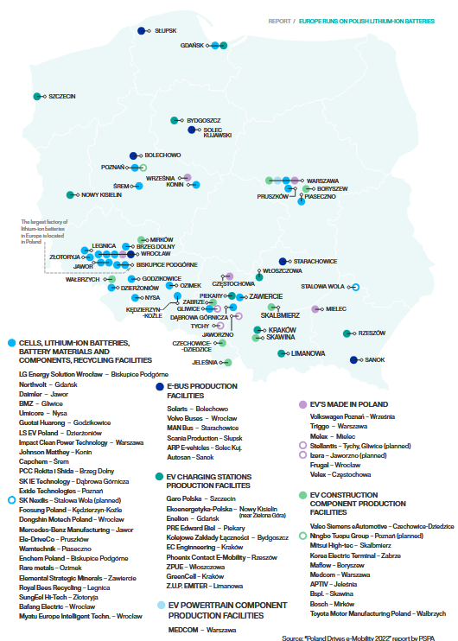
Figure 19 Key market stakeholders in Poland (Source: “Poland drives e-Mobility 2022” Report by PSPA)

Portugal

National Ecosystem
Portugal possesses the ninth-largest lithium reserves worldwide (approximately 60,000 t of lithium content), positioning the country as a critical supplier for the European battery raw materials supply chain. Portugal's largest battery industry includes key companies such as CALB (lithium-ion battery gigafactory for EVs and energy storage), Savannah Resources (lithium mining), Lifthium Energy (lithium hydroxide refinery), DST Group (battery recycling and storage solutions), AddVolt (battery powerpacks for refrigerated transport vehicles) and i-charging (EV fast charging systems), with smaller players having small module productions factories such as Lux Optimeyes Energy, EMDTECH and MeterBoost.
The country has a broad ecosystem in battery research: Universities in Minho (printing battery materials, composite materials for electrolytes and electrodes), Aveiro (advanced ceramics, composites, energy related functional materials), Universidade de Lisboa (electrochemistry, battery systems and management, sustainability), Nova University Lisbon (advanced materials for energy storage, thin-film and flexible batteries) and Porto (electrochemical modeling, advanced materials, recycling) conduct low to mid TRL research. The national Battery Cluster Portugal, a non-profit platform, coordinates stakeholders across the entire value chain, from raw material extraction to cell and battery manufacturing and recycling (see Figure 20).
Key research and technology partners include the International Iberian Nanotechnology Laboratory (INL) located in Braga. It was founded by the governments of Portugal and Spain under an international legal framework to perform interdisciplinary research, deploy and articulate nanotechnology for the benefit of society. The INL supports strategic cluster development in Minho and Porto, aiming to become a world-wide hub for nanotechnology up to mid TRL. This involves the development and advanced characterization of battery materials, development of next generation battery concepts and materials as well as a pilot line for solid-state batteries. The Technology & Science Associate Laboratory Portugal (INESCTEC) focuses on battery storage and the integration of largescale battery systems, including management systems, diagnostics and safety. Centre for Nanotechnology and Advanced Materials (CeNTI) operates battery high TRL pilot lines in cell assembly and recycling helping the industry doing series production and high-level development. The National Laboratory for Energy and Geology (LNEG) provides geological studies, legislation support, material and electrochemical characterization, recycling and sustainability. The Vasco da Gama Energy Storage CoLAB in Portugal (established in 2019) is recognized by FCT (Foundation for Science and Technology) and supported by ANI (National Innovation Agency). It operates a joint center for TRL 5–7 projects, focusing on Na-ion batteries, cell design and battery integration for storage solutions and is designed to link the universities with the industry by operating in this mid-TRL range

National Funding Schemes
Portugal’s climate strategy is primarily guided by the National Energy and Climate Plan (PNEC 2021–2030) and the Decarbonization Roadmap 2050 (RNC2050), both of which aim for strong integration into the European battery industry. Within the Recovery and Resilience Plan, two large-scale “green” programs have been approved: the New Generation Storage (NGS) project by DST Group (~ €220 million) and the Alliance for Energy Transition (ATE) led by Efacec (~ €300 million). Additional investments include a €1 billion program for commercial pilot and pre-commercialization phases, as well as a €480 million program for the development stage, as outlined in the Battery Cluster roadmap document. Funding grants of approximately €10–50 million support individual innovation initiatives, including lithium hydroxide refining (50 ktpa) and a cell manufacturing project with an annual capacity of 15 GWh (approximately 43 million cells).

R&D Priorities and Trends
Research is increasingly focused on solid-state, high-energy batteries and novel concepts. In parallel, recycling and second-life solutions are being expanded, including projects on lithium cathode recovery and modular battery packs. The Digital Battery Passport initiative of the Battery Cluster enhances transparency across the entire lifecycle and supports traceability from raw materials to end-of-life. Furthermore, the cluster’s startup program promotes disruptive storage technologies, while the cross-sector collaboration forum intensifies exchange between industry, research, and public institutions. Overall, a broad R&D portfolio is being pursued, ranging from low-TRL university research to mid-TRL laboratory capacities and high-TRL industrial prototypes.

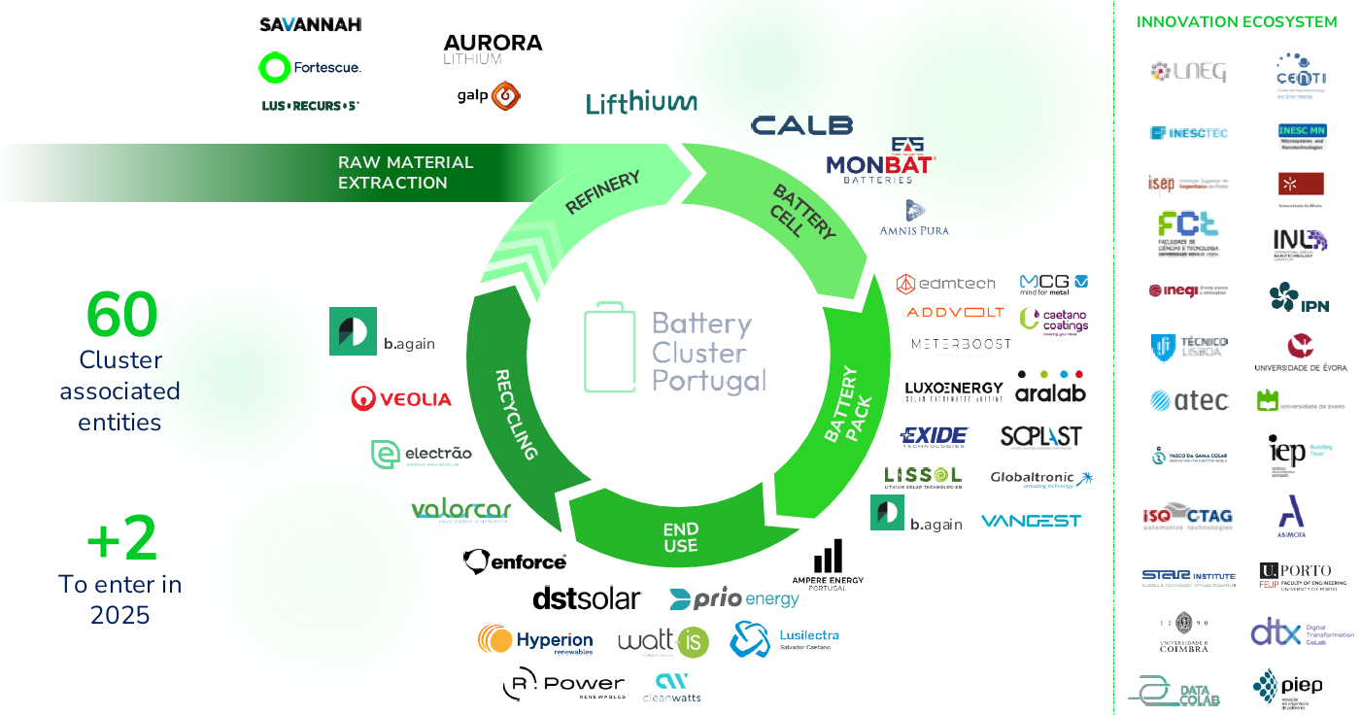
Figure 20 Structure of the Battery Cluster Portugal with involved actors along the value chain (Source: Connect To Power Up! Presentation of Battery Cluster Portugal)

Romania

National Ecosystem
Romania’s battery research ecosystem is still relatively limited, but it is anchored by a few public research and university actors working on electrochemical materials, devices, and recycling. The most visible research activity is associated with INCD ICPE-CA and Babeș-Bolyai University (UBB), where work has focused mainly on Li-ion-related materials, electrodes, and recycling topics.
The national ecosystem is therefore better described as an emerging R&D base than as a mature battery research cluster. Its current strengths lie in materials science, electrochemistry, and application-oriented research tied to energy storage and circularity, rather than in large-scale fundamental battery programs or a broad institutional network.
Romania has a growing but still limited battery manufacturing base. Prime Batteries Technology is the main domestic Li-ion and BESS manufacturer, and it has expanded rapidly since its 2022 partnership with EIT InnoEnergy, with plant capacity now scaling toward the multi-GWh range. Dräxlmaier has also announced a €200 million investment in Timișoara for e-mobility battery production. ,

National R&D Funding Schemes
Romania’s main public support for batteries is currently driven by the National Recovery and Resilience Plan (NRRP) and related energy-storage calls. The European Commission approved a €103 million Romanian scheme to support electricity storage facilities, and the Ministry of Energy later relaunched a call with a budget of €79.6 million for battery storage projects, alongside a separate €199 million call supporting battery and photovoltaic manufacturing and recycling capacities across the value chain. , A newer €150 million state-aid scheme for electricity storage, funded via the Modernisation Fund, further strengthens the policy environment for battery deployment and associated development activity. While these schemes are primarily designed for investment and scale-up rather than research grants, they still matter for R&D because they create demand for testing, validation, integration, recycling, and prototype development across the battery value chain.

R&D priorities and trends
Romania’s battery R&D priorities are concentrated on Li-ion materials, electrodes, and recycling, with a growing policy pull toward full value-chain capability. The most explicit research themes in the public sources are materials and electrode development, together with recycling and conditioning/testing activities linked to the state-backed industrial calls.

Serbia

National Ecosystem
Serbia supports some minor activities in battery development at its research organizations, including the University of Belgrade, the Institute of Technical Sciences of SASA (Serbian Academy of Sciences and Arts) and the Vinča Institute in Belgrade. The research community is rather small and modest in scale, focusing mainly on electrode materials for lithium- and alkaline-ion batteries. Activities related to lithium mining are currently on hold, and there are fairly negative public connotations toward batteries because of this.
On the industrial side, the Serbian company ElevenEs (LFP chemistry) runs a pilot cell factory in Subotica and is now working on a 1 GWh plant there, supported by significant R&D facilities. Separately, InoBat of Slovakia still has plans for a Serbian gigafactory, though this seems linked to the aforementioned lithium mine.

National R&D Funding Schemes
There is currently no dedicated Serbian battery R&D funding scheme comparable to those seen in some other EU Member States. Instead, battery work is supported through broader research and innovation structures, university projects, and international collaboration, e.g. within the framework of EU project HiSuperBat, dealing with new generation of batteries beyond lithium, running under the Program for excellent projects of young researchers – PROMIS by Science Fund Republic of Serbia.

R&D Priorities and Trends
Current activity appears to be rooted in materials science and electrochemical storage research, with emphasis on electrode materials and broader advanced-materials platforms rather than a large dedicated national battery program. Publicly visible research trends also suggest emerging interest in batteries beyond lithium-ion, while the lithium-mining debate should be treated as a separate policy and raw-materials issue.

Slovakia

National Ecosystem
The Slovak battery research and innovation landscape forms a closely connected ecosystem involving universities, research institutes, industry, and public institutions. The Slovak Battery Alliance (SBaA) acts as the central national cluster, facilitating collaboration across public and private sectors, universities, and financial institutions. The SBaA aims to build a comprehensive battery value chain in Slovakia, from raw materials and R&D to recycling. The ecosystem is centred around the Slovak European Battery Academy centres, initiated by Technical University of Košice (TUKE), Pavol-Jozef-Šafárik-Universität in Košice (UPJŠ) – the only BEPA member of Slovakia, University of Technology in Bratislava (STU), University of Žilina and together with the Slovak Academy of Sciences. The Battery Centre develops advanced materials, cells and battery systems.
The Research Centre PROMATECH is the hub in Slovakia for implementation of advanced materials and technologies into manufacturing processes, acting as an integrated, interdisciplinary and sustainable centre for applied research. Regarding technical development, PROMATECH is involved in two national projects on batteries and one Horizon Europe project (Small Scale Hydrogen Valley). Another research centre with its focus on developing, characterizing and applying advanced materials is CEMEA SAS. It is involved in two Horizon Europe projects on batteries, including the HORIZON OPERA project on novel operando experimental techniques for accelerated battery development.
The automotive industry is central: Slovakia remains a world leader in car production per capita, with major manufacturers such as Volkswagen and Stellantis (Peugeot) already producing in the country and further capacity expected with the planned Volvo plant in Košice.
InoBat Auto JSA, which started EV battery cell production at its Voderady facility, aiming for over 24 GWh production, and is a major research partner in the Slovak battery ecosystem. The InoBat gigafactory aims to produce batteries for the German automotive industry. This industrial base drives demand for battery technologies and supports the localization of know-how. Another one is Gotion InoBat Batteries, which is building a large-scale battery plant in Šurany, adding significant investment and manufacturing capacity.

National Funding Schemes
Battery-related R&D in Slovakia is funded through national and European instruments. National programs support laboratory infrastructure and joint projects between the Slovak Academy of Sciences and universities (e.g. in materials, cells and battery systems), as outlined in the national research infrastructure roadmap. At European level, Slovak institutions participate in Horizon Europe and earlier Horizon 2020 projects such as SIMBA (Sodium-Ion and Sodium Metal Batteries), which contributes to next-generation stationary storage and to the establishment of the National Battery Centre. The company InoBat is involved in the European R&D projects StoreAGE and SOLIDBAT.
In addition, qualification is a focal point – education and training activities are supported via the EBA Academy in cooperation with the Slovak Battery Alliance and EIT InnoEnergy, targeting students and upskilling of industrial workers. Slovak version of European Battery Academy is active at three research technical universities (STU, TUKE a Uni Zilina), with 25 certificated trainers. The EduBat initiative strives to create a National Hub for Future Talents, the BATTERY Academy.

R&D Priorities and Trends
Current strategic priorities in Slovak battery research include novel energy storage solutions as part of the green and digital transition, advanced materials and cells (including solid-state electrolytes), battery systems and management, and circular economy approaches such as recycling and second-life applications. Slovakia also excels in automotive engineering, making it well-positioned to integrate battery technologies into electric vehicle production. With its strong academic base, industrial capacity, and strategic alignment with EU goals, Slovakia is emerging as a competitive player in Europe’s battery ecosystem.
At STU Bratislava, researchers work on smart sensing, thermal runaway simulation and prediction, including safety by design, digital twins of batteries and impedance-pulse state estimation. Research and Innovation Lab for Batteries at TUKE and Institute for Materials Research and Institute of Geotechnics at SAS focuses on improved electrodes, electrolytes and cells, as well as innovative battery management systems and monitoring techniques to optimise performance and lifetime. These activities are embedded in broader national goals to support decarbonization, energy security and the development of skilled human resources in the battery field. Regarding the last aspect, Slovakia provides collaborative research and training programs with international partners.
A key trend is the integration of digital technologies, including advanced monitoring and data-driven battery management, to enhance safety, lifetime and efficiency – in some instances by using AI in the BMS.
Another pillar for the R&D strategy is recycling and the circular economy. A critical scientific priority is the entire battery lifecycle, focusing on developing efficient recycling processes for lithium batteries and creating solutions for second-life applications (repurposing EV batteries for stationary energy storage).
International collaboration through the European Battery Alliance, Horizon projects and mobility schemes such as the Marie Skłodowska-Curie Actions (MSCA) strengthens Slovakia’s integration into the European Research Area and accelerates knowledge transfer.

Slovenia

National Ecosystem
Slovenia has a well-interconnected battery research and development ecosystem, supported by numerous public research institutions, universities, and a growing industrial sector. At its core is the National Institute of Chemistry (NIC) in Ljubljana, which has a laboratory for academic research activities and a new prototyping unit offering development up to TRL6. Other academic institutions working on battery-related topics include the University of Ljubljana, with its Faculties of Mechanical Engineering and Chemistry and Chemical Engineering, and the University of Maribor, with its Faculty of Electrical Engineering and Computer Science. Together with the Jožef Stefan Institute and several private research organizations, they form the backbone of academic activities.
On the industrial side, several companies contribute to applied research and prototyping. TAB Tovarna Akumulatorskih Baterij is an internationally established company from Slovenia that produces automotive starter batteries and industrial batteries (Lead-Acid and Li-Ion). . Elaphe Propulsion Technologies produces in-wheel motors, an innovative e-drive technology for vehicles. Other relevant industrial actors include Pipistrel (electric planes) , ELES (energy storage) , Cinkarna Celje (materials producer), Hidria (component provider) , Podkrižnik (marine applications) , and Keko Equipment (equipment manufacturing). Close collaboration between academia and industry is supported through joint projects, shared laboratory infrastructures, and service offerings such as the ZAG (Zavod za gradbeno inženirstvo) test facilities, which specialize in abuse loading tests of battery cells.
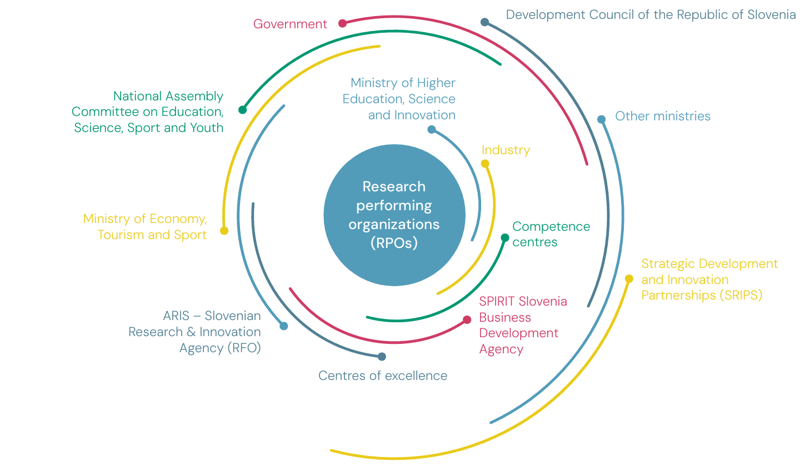
Figure 21 Structure of Slovenia’s Research & Innovation landscape from the viewpoint of the Ministry Of Higher Education, Science And Innovation

National Funding Schemes
The platform SICRIS (Slovenian Current Research Information System) provides an extensive database on current projects and funding schemes. Battery research is primarily funded by the Slovenian Research Agency (ARIS), which managed over €400 million in public funds for research and innovation in 2024, with its budget expected to rise further in 2025. By 2030, the government has set a target to invest 1.25% of GDP in research and innovation.
A central investment project is the Center for Development, Demonstrations and Training for Carbon-Free Technologies (DUBT) in Kisovec, operated by the NIC together with the Ministry of Higher Education, Science and Innovation. The center will be completed in June 2026 and fully operational in early autumn 2026. Total costs of approximately €32.5 million are financed 85% from the Just Transition Fund and 15% from the Cohesion Fund. The center also receives additional support from EU programs such as Horizon Europe and the IPCEI framework, which, together with international partners, provide substantial funding.

R&D Priorities and Trends
Strategic research priorities focus on developing new battery materials and chemistries, scaling prototypes up to Technology Readiness Level (TRL) 6, and integrating Battery Management Systems (BMS) into high-energy and high-power applications.
At the NIC, the long-term research program on batteries aligns with the BATTERY 2030+ roadmap. NIC provides two laboratories: the Laboratory for Modern Battery Systems for TRL 1–4, with test capacities for currents up to 5 A, and the Laboratory for Battery Development and Testing for TRL 4–6, with high-current testing up to 500 A. The new DUBT Center aims to accelerate the green transition, focusing on battery and hydrogen technology, and provides infrastructure for research, testing, and training. This expands capabilities with a large prototyping line in a clean and dry room, as well as a smaller line in ten glovebox modules. These capacities will advance research on solid-state batteries, high-voltage and fast-charging systems, and model-based State-of-X diagnostics.
In parallel, the academic network promotes workforce development through modular teaching programs across several faculties, although no specialized bachelor’s or master’s program in battery technologies has yet been established.
In industrial R&D, TAB focuses on improving energy storage systems and electromobility, testing Na-Ion batteries and cooperating with the Austrian company Rosendahl Nextrom GmbH on battery production technologies. Keko Equipment aims to develop machinery for Gen4b and Gen5 battery technologies.
A key trend is the increasing digitalization and interplay between hardware and software components, as seen in EU Horizon Europe projects. The Faculty of Mechanical Engineering at the University of Ljubljana is currently involved in nine projects, such as RESiLiTE, HiHELIOS, HiVEP, InnoBMS and PULSELiON. These projects combine innovative materials research with data-driven BMS solutions, high-performance hybrid testing, and fast-charging solid-state batteries.

Spain

National Ecosystem
Spain's national Energy and Climate Strategy (PNIEC 2021-2030) defines the strategic roadmap of energy transition to 2030. It sets targets for GHG emission reduction, including installing a total of 22.5 GW of storage capacity (including batteries) and 48% renewables in final energy consumption by 2030, aiming for a carbon-neutral Spanish economy before 2050. For sustainability, Spain focuses on the recovery of critical materials, technological sovereignty in the battery sector and digitalization for efficiency.
The key players in the Spanish battery sector include several research institutions. CIC energiGUNE part of the Basque Research and Technology Alliance, focuses on disruptive knowledge in advanced materials and high-technology energy solutions (electrochemical and thermal energy storage and conversion). CIDETEC Energy Storage (Centro de Investigación Cooperativa en Almacenamiento de Energía) specializes in battery materials, cell design, manufacturing, and recycling. IKERLAN, a technology center within the Mondragon ecosystem, works on battery management systems and coordinates projects such as Sensibat on sensor integration in Li-ion cells. The binational CIIAE (Centro Ibérico de Investigación en Almacenamiento Energético) in Extremadura focuses on next-generation batteries and hybrid storage systems. ICMAB/CSIC (Institut de Ciència de Materials de Barcelona, Spanish National Research Council) conducts research on functional materials for batteries and supercapacitors, while ITE (Instituto Tecnológico de la Energía) is active in battery testing and second-life applications. CIRCE and IMDEA Energía contribute with expertise in energy systems integration, sustainability assessment, and advanced electrochemical storage materials. In addition, the ALBA-ICMAB (CSIC) joint laboratory combines synchrotron-based operando and in situ characterization with battery assembly and testing, including electrode fabrication and various cell formats.
Key industrial actors in Spain PowerCo (Volkswagen Group’s battery company developing large-scale battery manufacturing capacity), CATL-Stellantis (development of a large Li-ion phosphate battery gigafactory), Basquevolt (solid-state battery cell development, pilot-scale manufacturing), Cegasa (an established battery manufacturer focused on energy storage solutions), Bihar (an emerging company developing sodium-ion technology) and Phi4Tech(manufacturing of lithium iron phosphate batteries cell in a planned gigafactory), Gotion High-Tech (developing cathode materials and battery recycling projects), alongside Envision AESC Spain (battery manufacturer; focus on gigafactory-scale lithium-ion production linked to automotive OEM supply chains).
Most of the organizations are members of the two main stakeholder initiatives creating a tightly-connected innovation ecosystem: the national technological platform Batteryplat (107 members in 2023) and the association AEPIBAL (120 members in 2023). The battery ecosystem is supported by CDTI-E.P.E., a public entity under the Ministry of Science, Innovation and Universities, that promotes innovation and technological development of Spanish companies.

National Funding Schemes
Through the EU Recovery, Transformation and Resilience Plan, roughly €40 billion of public and private financing is available for the battery and storage sector. This comprises about €4.3 billion public contribution earmarked for electric mobility and €6.9 billion public contribution for renewables, hydrogen and storage. Within this framework, the PERTE programs for high TRL projects (7-9) have been launched: PERTE ERHA (Renewable Energies, Hydrogen and Storage) focuses on deploying stationary storage with large-scale projects in electrolysis, battery systems, and energy storage infrastructure, while PERTE VEC (Electric and Connected Vehicle) supports the development of battery manufacturing capabilities, aiming to accelerate industrial innovation, including battery manufacturing, energy management systems, and AI integration in automotive supply chains. Major PERTE-VEC projects include the PowerCo gigafactory in Sagunto (approximately €398 million) that is the largest industry-funded project in Spanish history.
Other initiatives are by Lithium Iberia, Envision AESC Spain, Basquevolt (solid-state batteries) and numerous battery-assembly lines from Stellantis, Renault, Ford and others, which receive grants ranging from €10 million to €150 million. There is no large-scale national collaborative program specifically targeting low TRL (1–4) research in batteries, as regional R&D plans focus on emerging technologies in energy storage, renewable hydrogen, and digitalization (TRL 4-7). The call on Innovative Energy Storage Projects Integrated with Renewable Energy Generation Facilities with a budget of €150 million funds large-scale, commercial energy storage projects with various TRLs (except hydrogen-based projects). Also, CDTI Mission provides a €60 million budget, which partly addresses battery topics, focusing on sovereignty in critical minerals for energy transition and sustainable, decarbonized transport.

R&D Priorities and Trends
Research priorities center on advancing next-generation chemistries, with a strong drive in solid-state lithium batteries and sodium-ion systems. At the same time, considerable effort is directed toward alternative storage technologies such as redox-flow batteries and ultracapacitors, a trend reflected in the launch of several start-ups in recent years. Sustainability and circularity are foregrounded: the recovery of critical raw materials (Li, Ni, Co) and the reuse or recycling of batteries are systematically integrated into technology roadmaps. Digital approaches-smart battery-management, digital twins and multiscale modeling-are intended to boost the efficiency and grid integration of energy storage. All these priorities are propelled by close collaboration among research institutions, industry and public funding programs, strengthening Spain's position as a leading actor in sustainable battery systems. This is supported by the provided infrastructure and skilled workforce, while fragmentation of efforts, industrial scaling, funding and lack of fitting talents are bottlenecks.

Sweden

National Ecosystem
Battery research in Sweden is driven by leading, collaborating universities: Uppsala University, Chalmers University of Technology, Lund University, the Royal Institute of Technology (KTH), Linköping University and Luleå University of Technology. They are particularly strong in materials physics, computational modeling, machine learning, solid-state and polymer batteries.
The strategic collaboration platform COMPEL (Competence and Excellence in battery research and education for the transport sector) brings together Uppsala University, Chalmers University of Technology and Lund University in research and education and cooperates with leading players through an industry council (AB Volvo, Volvo Cars Corporation and Scania AB). Its purpose is to provide skills and expertise supply to Swedish industry within the transport sector’s green transition. The initiative is a government assignment.

The European network BATTERY 2030+ is coordinated by Uppsala University and links academic partners with industry and research actors across Europe. Batteries Sweden (BASE) is a national competence center initiated in 2020 and funded by academia, industry, and Vinnova. It has 21 partners, including 17 industrial and 4 academic partners. The partner list includes companies such as AB Volvo, Scania, Volvo Cars, Altris, and Graphmatech.
The Swedish battery industry and research institutions together form a strong ecosystem for building a sustainable battery value chain – also driven by large, export-oriented automotive manufacturers striving for a green transition. Li-ion-battery industry is a European pioneer with the associated difficulties: After Northvolt’s bankruptcy in 2025, Lyten completed the acquisition of Northvolt’s remaining Swedish battery assets in 2026, including Northvolt Labs. At the same time, NOVO Energy was established as the joint venture of Volvo Cars and Northvolt. The aim is to develop and produce batteries in Gothenburg, with an announced target of 50 GWh annual capacity and funding by the European Union but its future is currently unclear.
RISE is an independent, state-owned research institute, which hosts the Battery Safety Lab, Sweden’s national test center for electromobility and battery-related testing being a part of the SEEL initiative. The national competence and test infrastructures supports collaboration in the ecosystem, which provides capacities for spin-offs from Swedish universities, including Altris, Graphmatech and LiFeSiZE from Uppsala University to strengthen innovation across sodium-ion and related battery technologies.

National Funding Schemes
National funding is primarily provided by the Swedish Energy Agency (SEA), which contributes about 60% of total resources. In 2024, the SEA launched the multi-year research program “Sustainable Battery Value Chain of the Future” (running until 2030, approx. SEK 350 million budget) and has already issued several current calls: the FFI Zero-Emissions funding, call for a sustainable value chain of the future (budget of SEK 120 million), pilot and demonstration projects and the “Industriklivet” program for scaling up and commercialization. There is also an upcoming business development support, that funds concept development and verification with customers.
Other key actors in national funding include Swedish Research Council ((Vetenskapsrådet or VR) and Vinnova, which is now investing SEK 316 million through four targeted calls for proposals to support, among other things, tests in real environments, industrial scaling-up, collaboration along the value chain and the development of future rules for industry.

The funding landscape supports both low-TRL research and established competence centers that enable close industry–academia collaborations. Between 2010 and 2023, SEK 3.3–3.5 billion (around 325 million. EUR) have been invested in battery research, with a peak of SEK 950 million in 2021. The Battery Fund accounts for roughly one-quarter of the total budget.

R&D Priorities and Trends
Due to its long tradition in battery research since the 1970s, Sweden’s research focuses on the entire battery value chain, from materials and cells to system integration. Strategic priorities include the academic fundamental research on lithium, sodium, and solid-state/polymer batteries, while strongly promoting industry-academia collaborations through competence centers such as BASE. The Swedish government’s COMPEL program supports low-TRL projects along the entire value chain and strengthens the academic role in these areas. These new programs address the need for knowledge clusters that link excellent research with targeted education and training of skilled technicians and university graduates.
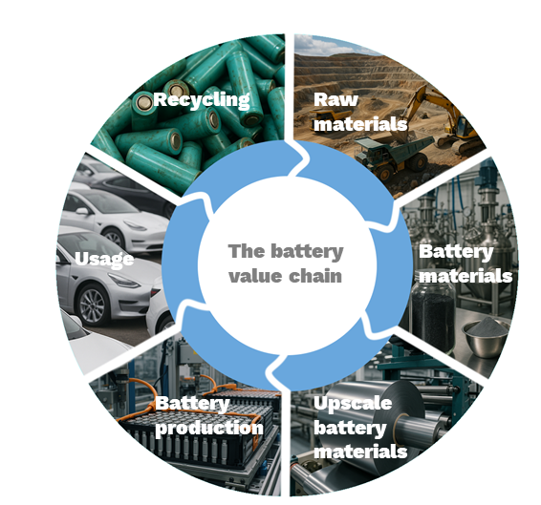
On the application side, the green transformation of the Swedish vehicle sector and the integration of battery storage into the power grid to support the energy transition are the main goals. Current research trends reflect international priorities: operando, in-line and in-situ measurements, interfacial chemistry, (polymer) solid-state batteries and Na-ion technologies, multi-scale modeling, battery control, and EV-centered battery research. At the same time, digitalization and AI-driven approaches are gaining importance to network and optimize the entire supply chain, from raw material extraction and cell manufacturing to recycling. These trends are underpinned by the close integration of research, industry, and public funding, forming the foundation for Sweden’s position as a leader in a sustainable battery value chain.
Figure 22 BASE supporting excellent, long-term battery research and innovation along the entire depicted value chain (Source: Connect To Power Up! Presentation by BATTERY SWEDEN)

Switzerland

National Ecosystem
Switzerland has established a clear electromobility roadmap that promotes the expansion of electric vehicles, but there is no dedicated national strategy for battery materials and cell manufacturing. Despite this, a dynamic battery value chain ecosystem has grown. A central coordinating role is played by the Swiss Battery Assocation iBAT. This non-profit organization was established in 2020 and currently brings together 12 research institutions, 71 industry actors across the whole battery value chain and policymakers, while connected to five national partner associations, including AEEE Suisse, Swiss eMobility, Swissmem, SwissSolar, and the Swiss Touring Club. In addition, iBAT serves as an interface to the European Battery Partnership Association (BEPA) and represents national actors. Through the iBAT Association, regular platforms for networking, knowledge exchange, and idea generation have been established.
Beyond that, Switzerland’s battery research ecosystem is built by well-connected universities and applied research organizations, with ETH Zurich, EPFL, the University of Fribourg, Bern, Zurich, and OST University of Applied Sciences active on materials, interfaces, fabrication, and battery systems. Key RTOs and translational hubs include Empa, the Paul Scherrer Institute, and CSEM.
The battery industry in Switzerland covers the whole value chain in the battery field. As suppliers for materials and equipment, such as Arxada (Prussian blue), Chemours (binders), Dätwyler (polymers, Huntsman (carbon nanotubes), Imerys (graphite), Mathis (pilot electrode coating and cell production lines), the Bühler Group (twin-extrusion mixers for European and Asian gigafactories), Sulzer (equipment for separation technologies), multiple start-ups and spin-offs including 8inks (ETHZ), Unbound Potential (ETHZ), BTRY (Empa) and Swistor (EPFL), and several battery cell developers and manufacturers including Leclanché, Horien, Saleon, Belenos Clean Power Holding, Renata Batteries, Wyon, Medtronic, Innolith, Swiss Clean Battery, Phenogy, and Inesco.
Switzerland has no large automotive OEMs but is home to many companies integrating batteries into mobility solutions including ABB, Stadler Rail trains, Hess buses, Designwerk trucks, Kyburz delivery vehicles, Suncar construction machinery, Wetrok cleaning machinery, Thömus ebikes, FPT developing battery-powered electric drive trains for Iveco. Battery solutions for aerospace applications are developed by H55, Dufour Aerospace, and Smartflyer. Stationary battery solutions based on second-life batteries are developed by Libattion, Modual, and Upvolt and a large battery recycling plant producing black mass from Swiss end-of-life-batteries is operated by Librec.
At the international level, Switzerland is strongly integrated into European battery initiatives, including participation in BATTERY 2030+ projects such as BIG-MAP, HIDDEN, REUSE and coordination of the European LC-BAT-5 project SeNSE (“Lithium-ion battery with silicon anode, nickel-rich cathode and in-cell sensor for electric vehicles”). In addition, researchers benefit from cross-cutting national initiatives such as the Swiss Catalysis Hub, an open technology platform within the ETH domain (providing ML, robotics, advanced analytics), that is also accessible for battery research.

National Funding Schemes
Funding for battery research and innovation in Switzerland is supported through a broad portfolio of instruments. iBAT actively informs companies and research institutions about public funding opportunities, both on national and European level.
On the national level, there are four relevant pillars for funding of battery research, although they are not battery-specific calls: The Swiss National Science Foundation provides basic science funding (both project and career funding) and national competence centers for research as a funding for large consortia. The BRIDGE program is a joint initiative of the Swiss National Science Foundation SNSF and Innosuisse, the Swiss Agency for Innovation Promotion. It funds precompetitive research on various levels from research (discovery, proof-of-concept) to product without industrial partners. Innosuisse also funds battery research on its own, via projects with consortia of academia and industry with a 50% co-funding. The Swiss Federal Office of Energy (SFOE) also funds individual research projects, mainly under specific umbrellas such as the Swiss Energy Research for the Energy Transition (SWEET). In addition, SFOE provides funds for applied and socio-economic research under ERA-NET, the EU funded network for research and innovation on materials and battery technologies, supporting the European Green Deal.

R&D Priorities and Trends
Although Switzerland does not have a dedicated national battery research roadmap, clear priorities can be derived from its broader energy and climate policy framework. The Energy Strategy 2050 and the Climate and Innovation Act of 2023 aim for emphasize increased energy efficiency, the expansion of renewable energy sources, and the gradual phase-out of nuclear power, thereby increasing the demand for advanced energy storage solutions. Due to the public discourse on potential threats to the Swiss energy system, especially blackouts in winter due to electricity shortage, research efforts are increasingly focused on seasonal energy storage, the integration of batteries into the electricity grid, and ensuring security of supply in the context of potential energy shortages.
Leading academic institutions such as ETH Zurich, EPFL, Empa, and PSI form the backbone of materials and cell research, while universities of applied sciences and institutions such as CSEM concentrate more strongly on battery systems and their applications in electromobility and stationary storage. At the same time, topics such as circular battery economy, recycling technologies, and the use of batteries in the building sector are gaining importance. Via the Innosuisse funding, the flagship project CircuBAT with a funding of CHF 7.5 million between 2022 and 2025 focused on improving the circular economy of electric vehicle batteries. Close collaboration, such as the Swiss Catalysis Hub, further supports research into catalytic processes for the sustainable production of battery materials. Overall, these developments reflect Switzerland’s ambition to position itself as a leading hub for sustainable battery technologies while enhancing the resilience of its national energy system.

United Kingdom

National Ecosystem
The UK battery ecosystem includes companies such as Breathe Battery Technologies (physics-based battery charging software and digital twins), About:Energy (battery modeling and simulation), Nyobolt (fast-charging battery systems), Nexeon (silicon-anode materials), and Connected Energy (second-life battery energy storage systems). Additional relevant examples are Ilika (solid-state batteries), and Altilium (battery recycling and materials recovery) as well as automotive companies, such as Jaguar Land Rover, BMW Group UK.
From 2018 to 2025, UK-based electrical vehicle battery start-ups raised $2.7 billion venture capital (VC) investments, making the UK the fourth largest recipient of VC investment in EV batteries in the past five years (after the US, China and Sweden).

National Funding Schemes
The Battery Innovation Program, funded by the Department for Business and Trade and delivered by Innovate UK, is a £452 million program running from 2026 to 2030. It is designed to grow the UK economy by accelerating battery innovation and enhancing the nation’s global competitiveness across automotive, aerospace, off-highway, storage and maritime.
Figure 23 depicts the three pillars of the Battery Innovation Program: Research (Faraday Institution), collaborative R&D (Innovate UK), and scale up (UK Battery Industrialization Centre).
The Faraday Institution and the UK Battery Industrialisation Centre (UKBIC) are delivery partners for the Battery Innovation Program. Funding is aimed at actors from the ecosystem at different stages of technology development. The Battery Innovation Program builds on the momentum of the Faraday Battery Challenge (2017-2025, which supported over 100 start-ups in a £3.2 billion ecosystem).
The Faraday Institution is the UK’s independent institute for electrochemical energy storage research, skills development, market analysis, and early-stage commercialization. It brings together leading academic and industry expertise to strengthen the UK’s battery innovation ecosystem across automotive and related sectors. The Faraday Institution research program spans ten major research projects that bring together 25 UK universities, spanning a network of 500 researchers and 148 UK and 30 international industry partners to drive discovery in application-inspired research, working to solve some of the most challenging energy storage issues.

UKBIC is the UK’s national battery manufacturing development facility, helping innovators scale from research to industrial production. It provides advanced equipment and facilities, laboratory expertise, and specialist training and skills development to support the UK’s transition to net zero.
Business-led innovation is delivered by Innovate UK and focuses on support to help scale up high-tech businesses. It includes a collaborative research and development program, skills development initiatives, and investor partnerships programs.
The Battery Innovation Program will give the UK a competitive edge and a sustainable platform for global innovation. Expanding beyond automotive, it also targets aerospace, defense, maritime, and battery storage to unlock wider industrial impact through: accelerating research and innovation, strengthening supply chains, advancing low-carbon manufacturing, enabling a circular economy, developing skills and ecosystems, and informing policy and investment.

R&D Priorities and Trends
The Faraday Institution research program spans ten major research projects, two nascent Transformational Challenges, focused research and demonstration efforts. This comprehensive portfolio aligns with the UK's strategic battery objectives outlined in both the UK Battery Strategy and the Advanced Manufacturing Sector Plan, applying world-class research capabilities across cross-cutting research strands, next-generation technology demonstrations and transformational research that pushes beyond today's scientific boundaries. The research program is multidisciplinary, highly collaborative and draws together the best of UK university research groups and industrial partners.

Research Strand 1: Materials Development to Pack Design and Performance. Projects within this strand harness worldclass research to deliver advances in battery chemistries, materials systems, and engineered components by integrating advanced computational and experimental approaches to address challenges in battery performance, safety and reliability. For example, the LEAP project, led by the University of Cambridge, is developing a fundamental understand of critical industry-relevant chemistries to identify strategies for supressing degradation and accelerating performance improvements.

Research Strand 2: Sustainable Manufacture, Scale-up and Recycling. These projects target high impact areas to improve battery manufacturing cost, time and energy usage, by improving the fundamental understanding of key manufacturing processes including electrode manufacture. Research is embedding design-for-recycling principles into industry thinking and providing a UK EV battery recycling industry with a pipeline of scalable technologies. Regarding recycling and sustainability, the Universities of Birmingham is leading the ReLiB project) to advance processes for recycling lithium-ion cells.

Research Strand 3: Next-generation Technology Demonstrators and Transformational Challenges. These projects accelerate the real-world validation of breakthrough battery chemistries by bridging fundamental research and practical demonstration. This strand advances research into, for example, solid-state, lithium-sulfur and sodium-ion batteries (NEXGENNA project), Beyond lithium-ion solutions, including sodium-ion batteries, the BIP projects focus on solid-state lithium-metal anodes (SOLBAT project), and lithium-sulfur technologies (LiSTAR project), Transformational Challenges target energy storage applications with extraordinary impact potential where only conceptual solutions currently exist.
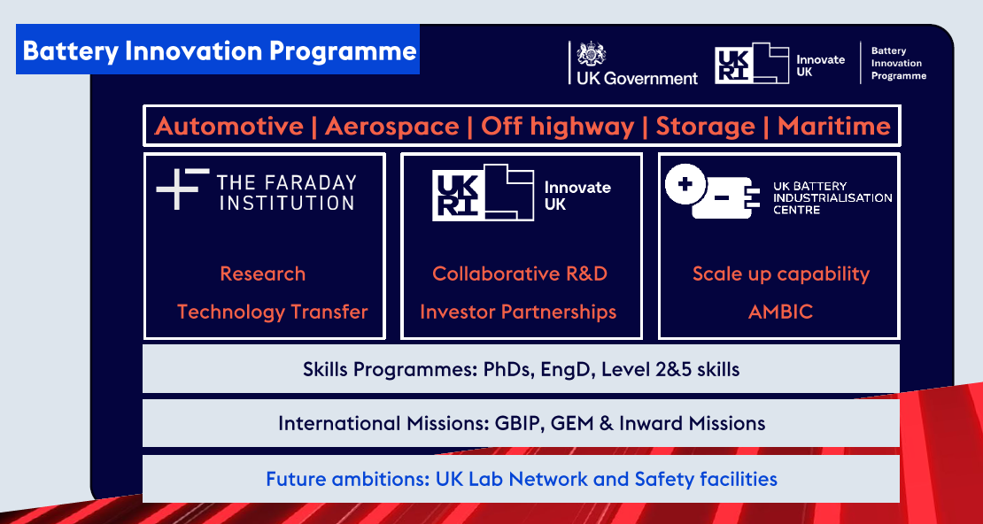
Figure 23: Structure of the UK Battery Innovation Programme (Source: Connect To Power Up! Presentation by J. Gaade, The Faraday Institution)

International

Canada

National research ecosystem and overall information
Canada has a strong battery innovation pedigree, supported by groundbreaking contributions advancing battery technology. Over the past forty years, Canadian universities, industry, and governments have made major contributions to battery innovation that have global impact today. ,
The battery innovation ecosystem is a key enabler of Canada’s extensive critical mineral endowments and serves as a major source of innovation for the automotive and clean energy sectors. Canada has identified a generational opportunity in developing the mineral resources required for battery production and is actively supporting firms and institutions to advance mineral purification technologies for this purpose. Public laboratories at the National Research Council (NRC) and Natural Resources Canada’s CANMET laboratories are working in collaboration with industry and private research organizations to drive innovation across exploration, mineral processing, and the production of battery-grade materials. For the transportation and clean technology sector Canada´s Battery Innovation Roadmap has mapped existing Canadian strengths and gaps from materials research through to cell and system integration, with the aim of building the coordinated national battery innovation ecosystem.
The battery innovation ecosystem comprises multiple institutions focused on battery development, including dedicated battery research centres and networks. Together, they form Canada’s innovation infrastructure, which consists of physical and technological assets, skilled and collaborative resources, and facilities that accelerate the development of new ideas by encouraging innovative thinking and risk taking. These resources and activities exist across industry, along withstand-alone battery innovation research centres in academia as well as government laboratories.
This work is in addition to the efforts of public research facilities such as the NRC’s pilot-scale battery manufacturing line facility and its battery performance and safety evaluation research facility, as well as Hydro-Québec Research Institute’s (IREQ) Centre of Excellence in Transportation Electrification and Energy Storage in advancing material processing and development for battery and energy storage applications.

National R&D funding schemes
Canada has adopted a value chain approach to support battery-related R&D, spanning upstream activities such as geoscience, exploration, and mineral extraction; midstream processes including intermediate processing; and downstream activities focused on advanced manufacturing and the assembly of end-use products; and recycling end-of-life materials.
Most of the funding supports for the upstream segment and a portion of the midstream segment of the battery value chain are delivered under the Canadian Critical Mineral Strategy. Recent funding initiatives supporting upstream R&D include programs supporting the development of critical minerals geoscience and data, the Critical Minerals Research, Development, and Demonstration (CMRDD) Program to support pilot-scale demonstration of innovative critical mineral technologies, and the Global Partnerships Initiative (GPI) for international collaboration to advance critical mineral technologies and projects for sustainable battery value chains. The CMRDD and GPI are contributing an investment of approximately $175 million CAD to 26 demonstration and strategic projects that advance upstream extraction and midstream processing technologies for inputs into the battery value chain.
In addition, Canada’s Critical Minerals Concierge Service connects industry and other stakeholders with programs, resources, and networks to advance critical minerals projects and value chains including battery and clean energy.
R&D for the mid-segment of the battery value chain is supported through a combination of targeted energy innovation programs and horizontal research funding mechanisms. The NRC, through the Collaborative Science, Technology and Innovation Program, is allocating over 10 million CAD for collaborative projects that accelerate the development of new processes and battery materials under the Critical Battery Materials Initiative (CBMI). Natural Resources Canada’s Office of Energy Research and Development (NRCan-OERD) operates the Energy Innovation Program (EIP), which in 2024 launched a dedicated Battery Industry Acceleration Call providing funding to firms conducting R&D projects over periods of up to five years, with a focus on technologies that enhance performance, cost, sustainability and new use cases for batteries. OERD has committed over 75 million CAD to its battery portfolio to date, supporting firms and the establishment of new battery testing centres.
CMRDD has invested up to 92.1 million CAD to support the development of innovative processing technologies to develop domestic critical mineral value chains, across seventy-nine projects conducted across federal labs. Approximately half of this effort has been related to the development of battery value chains, directly or indirectly.
In parallel, infrastructure‑oriented research funding is addressing the fundamental R&D needed for the downstream segment of the value chain. Most of this R&D focuses on the development of prototyping and testing facilities. One example is the Canadian Battery Innovation Centre at Dalhousie University, signalling alignment of federal support for shared experimental and prototyping facilities as a backbone for national battery research and battery innovation.
Broader clean‑technology instruments, including tax credits for clean technology manufacturing and the recycling of qualifying minerals (such as lithium, nickel and cobalt), indirectly support battery R&D by improving the business case for investment in pilot plants and advanced processing technologies. These dedicated schemes complement standard research grants, which continue to fund fundamental work on battery materials, electrochemistry, modeling and systems integration.

R&D priorities
Natural Resources Canada, through OERD’s Strategic Approach to Battery Innovation (SABI), identifies near-term battery innovation priorities to address diverse needs and opportunities under a Battery Sustainability Framework. Drawing on traditional sustainability frameworks, the Energy Trilemma, and the battery value chain, this framework assesses decarbonization in the transport and power sectors, supports industrial competitiveness, and strengthens supply chain resilience. It emphasizes expanding Canada’s sovereign battery supply chain by leveraging domestic minerals and materials while partnering internationally to meet critical infrastructure needs, including grid and defence applications.
OERD also sets research priorities for batteries for federal laboratories, including foundational and applied research for battery materials, systems, and integration with energy systems. This federal research helps de-risk emerging battery technologies before they move to larger-scale programs or private-sector investment. Battery application-oriented R&D is also being supported by Canada’s federal government through programs like NRC's e-Auto Challenge. This initiative aligns with Canada’s automotive strategy, which seeks to position the country as a global leader in EV manufacturing by leveraging its skilled workforce, advanced R&D, and strengths in artificial intelligence, advanced manufacturing, and clean technology.
From an industry perspective, the Battery Innovation Roadmap stresses the need for coordinated research at all stages from upstream mineral processing and active materials through to cell, module and pack design, testing and integration, with particular attention to industrialization and scale‑up of Canadian technologies. Additional high‑priority areas include battery durability and safety, grid‑scale storage solutions suited to Canada’s electricity system, and circular‑economy solutions, such as design for recycling and advanced recycling processes, that can close material loops for lithium, nickel and cobalt. Talent development is also framed as an R&D priority, with initiatives like Dalhousie’s graduate programme in battery technology explicitly aimed at training specialists who can support research and innovation across the emerging EV and stationary storage industries.

R&D trends
Recent R&D trends in Canada show a shift from isolated academic excellence toward a more integrated ecosystem that connects universities, public research organisations and industrial partners along the battery value chain. The creation of shared facilities such as the Battery Innovation Academic Centres and research clusters described above, with open access for external researchers and companies, reflects a trend toward collaborative prototyping and validation environments that can support rapid iteration from lab‑scale discoveries to pre‑commercial cells and systems.
As stated in the SABI, innovation within the battery ecosystem is increasingly driven by efforts to develop more affordable and abundant battery chemistries, tailor solutions to specific applications, integrate upstream and downstream processes through advanced manufacturing, and leverage data-driven modeling approaches. At the same time, there is growing emphasis on circularity, standards and regulation, and new business models to enhance sustainability, interoperability, and market adoption.
At the same time, there is growing research activity in battery minerals processing and materials circularity, driven by both anticipated end‑of‑life EV volumes and innovation incentives, especially under NRC’s Critical Battery Materials Initiative. Across universities and federal programmes, research portfolios increasingly include next‑generation chemistries, solid‑state and high‑energy‑density systems, advanced manufacturing and digital tools for battery management and lifetime prediction, aligned with the federal emphasis on decarbonized, secure and competitive battery supply chains. These trends, combined with substantial foreign and domestic investment in EV and battery manufacturing, indicate that Canada’s battery R&D landscape is evolving from a primarily materials‑ and cell‑focused research base into a comprehensive innovation system that addresses materials, devices, systems and circular‑economy challenges in an integrated manner.
Moreover, Canada’s Defence Industrial Strategy (DIS), released in February 2026, highlights the need to deepen domestic supply chains and improve access to raw materials such as graphite. Processing and transformation R&D for such strategic materials would serve dual-use applications in defence and commercial civilian battery value chains.

China

National Research Ecosystem and Overall Information
China remains the world’s leading actor in the development of battery technologies, supported by strong governmental policies, large-scale manufacturing capabilities, and rapid progress in research and development. The country holds a dominant position in global lithium-ion battery production, has consolidated a full value chain from basic materials research to large‑scale cell and system manufacturing, and is increasingly advancing the commercialization of next-generation battery technologies, including solid-state batteries, hybrid solid liquid state, high‑nickel lithium‑ion, Li-CO₂, lithium-hydrogen (Li-H), lithium-sulfur, high-rate Zn-air and sodium-ion batteries. It is forecasted that Chinas solid-state battery market will grow at a remarkable Compound Annual Growth Rate of 44.00% by 2032.,
Leading universities include Tsinghua University (Beijing), Fudan University (Shanghai), the University of Science and Technology of China (Hefei), Zhejiang University, (Hangzhou) and Xi’an Jiaotong University(Xián),, which act as core scientific hubs for electrochemistry, solid electrolytes, interface engineering, and battery safety. At Tsinghua University, a Battery Safety Laboratory supports international researchers with characterization, thermal analysis and multi‑scale simulation from materials to system level for various chemistries, and it collaborates with cell and automobile manufacturers to improve battery and energy‑storage system designs.
On the industrial side, China hosts global battery leaders such as CATL, BYD, CALB and BTR New Energy Materials, as well as specialized solid‑state players including Beijing WeLion, which develops hybrid solid‑liquid and all‑solid‑state lithium batteries for electric vehicles and energy storage. CATL and other major cell makers have intensified solid‑state battery programs, with CATL announcing a roadmap toward small‑scale solid‑state battery production by 2027, followed by larger‑scale deployment by 2030 using sulfide electrolyte. Domestic automakers and suppliers are actively developing all‑solid‑state battery technology to meet the MIIT’s 2026 priorities: high‑energy‑density lithium‑ion and hybrid solid‑state batteries that can be fast‑charged and withstand very high cycle counts, reflecting a strong coupling between industrial product roadmaps and the national research agenda.

National R&D Funding Schemes
Battery and electric-vehicle research are embedded in China’s broader science and technology planning, notably the 14th Five‑Year Plan (2021–2025) and, from 2026 onward, the emerging 15th Five‑Year Plan for new energy vehicles and advanced manufacturing,. Within the Ministry of Science and Technology’s (MOST) National Key R&D Program, guideline documents for new energy vehicles explicitly list all‑solid‑state lithium‑metal batteries, high‑energy lithium‑ion batteries and all‑climate battery technologies as priority topics for central government support. During the 14th Five‑Year period, these programs contributed to a 3.6-fold expansion of China’s new energy vehicle market, a reduction of lithium‑ion cell costs by about 30%, and a 40% increase in average battery lifespan, creating a favourable environment for higher-risk R&D on new chemistries.248
More targeted funding instruments are now directed specifically at solid‑state technologies. Public reports indicate that Chinese authorities plan to allocate on the order of 830 million US dollars of dedicated support for all‑solid‑state battery R&D, with companies such as CATL, BYD, FAW, SAIC, WeLion and Geely expected to be among the beneficiaries. In parallel, broader industrial policies such as Made in China 2025 and the new 2026 MIIT plan for new energy vehicles emphasize solid‑state batteries, high‑safety chemistries and supply‑chain security as strategic pillars, combining research grants, tax incentives and pilot‑demonstration projects. Provincial and municipal funds, for example in major manufacturing centres such as Guangdong and the Shanghai region, complement national programs by supporting pilot lines, digitalized smart factories and large‑scale demonstration projects in grid‑scale storage and transport.247

R&D Priorities
The national R&D agenda places solid-state and hybrid solid‑liquid batteries at the centre of next‑generation battery research, with explicit energy‑density targets around 600 Wh/kg for all‑solid‑state lithium batteries in key projects of MOST for the 2021–2025 period, compared with roughly 150–250 Wh/kg for today’s commercial lithium‑ion cells. China’s current solid‑state and advanced‑prototype efforts report laboratory and pilot‑scale cells in the 350–600 Wh/kg range, which, if scaled, would enable electric‑vehicle ranges 1,000-1,300 km per charge. Government and industry roadmaps also specify performance goals for cobalt‑free cathode systems and cobalt‑free EV batteries around 500 Wh/kg, reflecting both resource‑security and sustainability considerations.
Advanced battery material research remains broad, ranging from cobalt-free layered oxide cathodes to nano‑Si/C composite anodes, lithium metal anodes, and various inorganic and polymer solid electrolytes, including oxide, sulfide and polymer–ceramic composite systems, as well as solid separators and advanced binders., Parallel work continues on alternative chemistries such as sodium‑ion batteries for lower‑cost EV segments and stationary storage,,, manganese‑based lithium‑ion batteries, aqueous and dual‑ion systems and solid‑state Li‑ion architectures tailored to long‑life grid and industrial applications.
Beyond cell chemistry, Chinese research policy stresses manufacturing and system‑level innovation. China's All-Solid-State Battery Collaborative Innovation Platform (CASIP) held a 2026 planning meeting in Beijing, discussing research progress, technological challenges like manufacturing robustness and scale-up, and the need for collaboration on materials and supply chains. Extended use of embedded sensors, big‑data analytics and AI in batteries and battery packs is promoted to improve lifetime prediction, safety monitoring and failure analysis, and to enable new safety concepts for electric vehicles, aviation and stationary storage systems.,

R&D Trends
A clear trend in China’s battery R&D is the transition of solid‑state batteries from laboratory research to pilot production, with timelines that typically foresee pilot‑scale lines around 2025–2027 and more substantial commercialization toward the end of the decade. CATL, Dongfeng, SAIC and other domestic manufacturers now report prototype or pre‑commercial solid‑state packs with energy densities around 350–600 Wh/kg and projected driving ranges of 1,000–1,300 km, while conservative scenarios anticipate broader market entry between 2028 and 2030, subject to cost and durability constraints. In parallel, Chinese research institutes have reported advances in understanding solid‑state lithium‑battery failure mechanisms and in improving interfacial stability, reinforcing expectations that solid‑state systems can achieve up to about 500 Wh/kg at pack level with enhanced safety compared with liquid‑electrolyte lithium‑ion technology.
China’s overall new energy vehicle strategy continues to rely heavily on rapid electrification, with roughly half of new vehicles projected to be electric by 2030, which implies tens of millions of EVs per year and creates strong pull for advanced battery technologies. During the 14th Five‑Year Plan, increases in battery life, significant cost reductions and faster charging capabilities have already been realized at scale, and the 15th Five‑Year Plan framework from 2026 further elevates solid‑state batteries, high‑safety chemistries and autonomous driving as core innovation areas.246 At the same time, grid‑scale storage is emerging as a major driver of R&D in sodium‑ion, long‑life lithium‑ion and hybrid solid‑state systems, supported by projects such as Tesla’s Superfactory in Shanghai, which is designed to produce around 40 GWh of utility‑scale storage per year and benefits from China’s mature manufacturing and supply‑chain ecosystem.,
In Chinese universities like Tsinghua and Xiamen, AI is increasingly integrated with electrochemistry, materials science, and simulations - as seen in symposia on AI for electrochemistry and projects like DrugCLIP for high-throughput screening - indicating interdisciplinary convergence.,
This integrated approach, supported by substantial national and local funding and by close collaboration between leading universities and large manufacturers, underpins China’s ambition to maintain and extend its leadership in next‑generation battery technologies for electric mobility, aviation, robotics and stationary energy storage over the coming decade.

India

National Research Ecosystem and Overall Information
India’s battery R&D landscape has expanded rapidly, supported by public research institutions, government funding programs, and growing work on next-generation chemistries such as sodium-ion, aluminium-ion, graphene-based, and solid-state batteries. At the same time, India remains heavily dependent on imports of critical battery materials such as lithium, cobalt, nickel, and graphite, which makes mineral security, recycling, and alternative chemistries strategic priorities.,
India hosts a broad ecosystem for battery research anchored in national laboratories, universities and engineering institutes. Under the Council of Scientific & Industrial Research (CSIR), multiple institutes such as CSIR‑CECRI and CSIR‑NCL work on electrode materials, electrolytes, recycling and alternative chemistries, building on the long‑standing network of national labs and outreach centres active in electrochemical and materials research.
The Indian Institutes of Technology (IITs), with IIT Madras, IIT Bombay, IIT Delhi, IIT Kanpur, IIT Hyderabad, have consolidated their role on batteries, battery management systems, AI-enabled thermal monitoring, solid-state ceramic electrolytes, multi-ion chemistries, Na-ion cells using agricultural waste-derived anodes and advancing flow battery architectures for grid-scale EV charging hubs.
In parallel, institutions such as the Indian Institute of Science (IISc) Bengaluru and specialized centres like the Centre for Automotive Research and Tribology (CART) at IIT Delhi work on solid‑state electrolytes, nanostructured electrode materials for high-energy-density sodium-ion cells, and systems‑level integration for EVs and grid storage, reinforcing India’s position as a regional hub for electrochemical energy storage research. ,
India’s strong pharmaceutical and fine‑chemicals base continues to support capabilities in new materials identification, purification and scale-up, which are directly relevant for battery active materials and electrolytes, while partnerships with international actors - such as earlier aluminium‑air battery collaborations between Indian Oil Corporation and Israel’s Phinergy - illustrate India’s openness to joint development in niche chemistries.,
At the same time, the national EV transition agenda has tightened the link between research institutions and domestic manufacturers (for example through joint labs and innovation centres with major Indian battery and EV companies), aligning academic work with industrial deployment timelines. Several major industrial stakeholders are playing an increasingly important role in shaping India's battery R&D ecosystem. Companies such as Reliance New Energy, Tata Group, Exide Industries, Amara Raja Energy & Mobility, Ola Electric, and JSW Energy have announced investments in cell manufacturing, battery materials, energy storage systems, and battery research centres e.g. Tata’s Agratas R&D facility in Bengaluru and Amara Raja’s 16 GWh E Positive Energy Labs.

National R&D Funding Schemes
On the funding side, India has layered several national programs to stimulate battery R&D and local manufacturing. The National Mission on Transformative Mobility and Battery Storage provides a strategic umbrella to coordinate policies for advanced chemistry cells, EVs and charging infrastructure, including support for research, pilots and standardization.
A central economic instrument is the Production Linked Incentive (PLI) Scheme for the National Program on Advanced Chemistry Cell (ACC) Battery Storage, approved in 2021 with a budgetary outlay of about 181 billion Indian Rupee (1,96 billion USD at current exchange rates) to create 50 GWh of domestic ACC manufacturing capacity, designed to be technology‑agnostic so firms can deploy different advanced cell chemistries. As of 2025–2026, around 40 GWh of this target capacity had been allocated in two bidding rounds to four beneficiary firms, indicating that a large share of the envisaged cell manufacturing base is now tied to concrete industrial projects.,
This ACC‑PLI scheme operates alongside the PLI scheme for the automotive and auto components sector and the Faster Adoption and Manufacturing of Electric Vehicles (FAME) scheme, together providing financial incentives across the EV and battery value chain, from vehicles to cells and packs. The government has also linked these programs to broader initiatives like Make in India and Atmanirbhar Bharat (Self‑Reliant India), with the explicit goal of reducing import dependence on batteries and critical materials while building export‑capable manufacturing. In addition, new schemes such as the PM E‑drive initiative include dedicated allocations (e.g. around ₹2,000 crore) for charging and fast‑charging systems, indirectly driving R&D in battery management, high‑power charging interfaces and durability under Indian operating conditions. Within CSIR, thematic calls - such as those under the ASPIRE scheme - have been used to seed investigator‑driven projects, including on energy and materials, which complement mission‑mode funding and encourage exploratory work by academic and national‑lab researchers.

R&D Priorities
Current R&D priorities in India reflect both domestic resource considerations and the needs of a fast‑growing EV and storage market. At the cell and materials level, significant effort is directed toward advanced lithium‑ion chemistries (such as high‑energy NMC and cost‑effective LFP), solid‑state electrolytes, and sodium‑ion batteries, with IISc and several IITs working on solid‑state and sodium‑ion materials and architectures. Sodium‑ion technology has received particular strategic attention as a way to reduce reliance on imported lithium, with Indian groups developing nanostructured electrodes, polymer and ceramic electrolytes, and sodium‑ion cells using locally available precursors including biomass‑derived carbons. Parallel research addresses aluminium‑based systems, including aluminium‑air and aluminium‑ion concepts, building on India’s large bauxite reserves and prior industrial collaborations. These efforts are viewed as long‑term options for specific applications such as range‑extender batteries and stationary storage.
At the system and application level, R&D priorities include robust battery management systems (BMS) tailored to India’s hot climate and variable grid conditions, AI‑enabled thermal monitoring, fast‑charging compatible pack designs, and chemistries optimised for two‑ and three‑wheelers, which dominate the country’s EV fleet. There is also a strong push toward grid‑scale batteries to integrate variable renewable energy and support rural microgrids, with IITs and national labs exploring flow batteries and long‑duration storage solutions alongside conventional lithium‑ion systems. Policy targets - such as the aim for a substantial share of 30% of new private vehicle to be electric by 2030 to support emission reductions and a sustainable transport roadmap - have led ministries to estimate battery demand at around 300 GWh of advanced batteries for e‑mobility alone by 2030 (compared to 20 GWh in 2020), further sharpening priorities around scalable battery technologies, safety and recycling.,,

R&D Trends
Recent trends indicate that India’s battery R&D is moving from isolated projects toward a more integrated innovation and commercialization pipeline. The number of patents and licenses related to advanced chemistries, particularly sodium‑ion, has increased, with national programs under the ACC framework reportedly facilitating more than one hundred technology licensing agreements since 2022, which helps bridge laboratory inventions and industrial deployment. Multiple high‑profile industry–academia collaborations have emerged, such as Ola Electric partnering with IIT Madras on a Battery Innovation Centre, Exide Industries working with IIT Kharagpur on next‑generation LFP and sodium‑ion packs, and large industrial groups leveraging acquisitions or partnerships (for example, Reliance New Energy’s association with UK‑based sodium‑ion firm Faradion) to establish R&D and manufacturing bases in India.
India's private sector is actively investing in battery manufacturing and related advanced materials as part of the Make in India initiative, which promotes domestic production of lithium-ion batteries and gigafactories, with more than 30 sites expected to be in operation by 2030, targeting a total production capacity exceeding ~290 GWh.,
Another visible trend is the diversification of research across chemistries and applications: while lithium‑ion remains central for near‑term EV deployment, academic and CSIR groups increasingly work on sodium‑ion, solid‑state, flow batteries and recycling processes, supported by roadmaps such as those for sodium‑ion battery technology development in India. This is complemented by a growing emphasis on sustainability and circularity, including research on recycling of lithium‑ion and sodium‑ion cells, recovery of critical minerals, and life‑cycle assessment tailored to Indian use patterns and grid mixes.

Japan

National Research Ecosystem and Overall Information
Japan’s battery R&D landscape is framed by a dedicated Battery Industry Strategy and by Japan’s 2050 carbon‑neutrality goal, with a strong emphasis on regaining competitiveness in lithium‑ion batteries while preserving a technology lead in all‑solid‑state batteries (ASSBs).
Japan’s battery research ecosystem is coordinated primarily by the Ministry of Economy, Trade and Industry (METI), which sets industrial and technology policy and oversees the Battery Industry Strategy adopted in August 2022. Within this framework, METI works closely with advisory bodies such as the Advisory Committee for Natural Resources and Energy and the Storage Battery Industry Strategic Council, which provide strategic guidance on technology roadmaps, supply security and industrial competitiveness in the battery sector.
On the implementation side, the New Energy and Industrial Technology Development Organization (NEDO) acts as the central public R&D funding and project‑management agency for energy and environmental technologies, including advanced batteries.
NEDO’s activities are complemented by specialist organizations such as the Consortium for Lithium-Ion Battery Technology and Evaluation Center (Libtec) and the Battery Association of Japan (BAJ), which link major battery and automotive companies with government to coordinate pre‑competitive research, standardization and evaluation activities.

National R&D Funding Schemes
The principal funding instrument for next‑generation battery R&D is the two trillion yen Green Innovation Fund, a long‑term program managed by NEDO to support technologies that contribute to achieving carbon neutrality in Japan by 2050.290 It supports battery R&D along the whole value chain, from advanced materials and cell design to production processes with reduced greenhouse‑gas emissions and end‑of‑life recycling technologies capable of recovering high shares of lithium, nickel and cobalt at costs competitive with primary materials.
In parallel, METI has allocated substantial additional subsidies for battery development and manufacturing; in 2023 alone, more than 330 billion yen were earmarked to support battery development and production, including solid‑state technologies, under Japan’s Green Growth Strategy, and in 2024 over $660 million for all-solid-state batteries.
Japan currently holds the largest global share of patents related to all-solid-state batteries and has progressively developed a dedicated supply chain in recent years, with the objective of enabling large-scale manufacturing. Therefore, the overall funding portfolio links early‑stage research, scale‑up of pilot production and industrial deployment, reflecting Japan’s dual objective of technology leadership and industrial capacity expansion.

R&D Priorities
Japan’s Battery Industry Strategy (Aug 2022) sets three central quantitative targets for 2030: 289
- Establishment of a domestic production base of 150 GWh per year of liquid lithium-ion batteries and materials, considering the production not only for domestic automotive use but also for export and stationary use
- Ensuring 600 GWh production capacity by Japanese enterprises (to ensure 20 % market share even when the global market expands to 3,000 GWh as expected in 2030)
- Full-scale commercialization of all solid-state batteries around 2030 and securing the technology leader position even after 2030.
Within the Green Innovation Fund’s battery program, specific research goals include the development of storage batteries and materials reaching volume energy densities of at least 700-800 Wh/L (exemplified by solid‑state batteries) and, for high‑power systems, output densities of 2,000-2,500 W/kg with volume energy densities of 200–300 Wh/L suitable for automotive applications. Additional priorities concern development of high-efficiency and high-power-density technologies for mobility-related motor systems targeting an average efficiency of 85%, a motor unit output density of 8.0 kW/kg and a motor system output density of 3.0 kW/kg.
In the field of solid‑state batteries, Libtec is a program in which leading Japanese companies such as Toyota, Nissan, Honda, Panasonic, and battery maker GS Yuasa have teamed up with the government to develop solid-state batteries. It aims to develop a solid-state battery that doubles the range of electric vehicles to 800 km by 2030.

R&D Trends
Historically, Japan has strongly focused on the development of solid-state batteries and specific types of alternative batteries. but the rapid global expansion of conventional lithium‑ion production and the loss of market share to competitors have led to a rebalancing of priorities. Recent strategies and funding programs place greater emphasis on expanding domestic and overseas lithium‑ion production capacity, securing supply chains, and ensuring that Japanese companies maintain a significant share of the global battery market while continuing to invest in breakthrough technologies. This trend is reflected in the battery strategy and the funding programs.292,288
These trends indicate a dual‑track approach: on one side, incremental innovation and process optimization in conventional lithium‑ion batteries and related materials, and on the other, sustained, coordinated R&D investments in solid‑state and other advanced chemistries intended to underpin Japan’s long‑term technological leadership in automotive and stationary storage.

South Africa

National Research Ecosystem and Overall Information
The South African battery sector is emerging from a fragmented landscape into a coordinated national ecosystem that links policy, industry and research. At its core is the uYilo National e-Mobility Program, established in 2013 as a government-driven initiative of the Technology Innovation Agency (TIA) under South Africa’s Technology Innovation Act, focused on supporting the transition to electric vehicles (EVs) and related technologies, including batteries and charging infrastructure. The intentional coordination efforts around the battery sector is further evidenced by the establishment of the South African Battery Manufacturers Association (SABMA) in October 2025.
Academic research is directly tied to this program: at Nelson Mandela University, teams work closely with uYilo on EV-infrastructure and battery-material studies, while the University of the Western Cape hosts the continent's only pilot-scale lithium-ion cell production line in its Energy Storage Innovation Lab (ESIL), which is specialized laboratory focused on advanced battery development, manufacturing and validation, with particular strength in lithium-ion and sodium-halide batteries, battery modules and integrated energy storage systems. It grew out of many years of work at UWC’s South African Institute for Advanced Materials Chemistry (SAIAMC).
Although South Africa does not yet have a full-scale lithium-ion cell manufacturer, a modest supply chain for battery packs is already in place. Eveready Ltd. remains the sole primary (dry-cell) battery producer, Auto-X supplies automotive-battery replacements, and First National Battery leads the lead acid batteries market in South Africa with more than 2.2 million units produced annually.

National R&D Funding Schemes
Funding for battery related activities is principally channelled through the Council for Scientific and Industrial Research (CSIR), the national R&D agency that runs energy-storage programs, provides battery testing infrastructure and supports standards development. The Department of Science and Innovation (DSI) sets RDI policy, funds lithium‑ion battery precursor plants and programs to build a local BEV/battery industry and battery RDI infrastructure, while the Department of Trade, Industry and Competition (DTIC) implements industrial-policy tools such as the Automotive Production and Development Program (APDP) and tax incentives-including a 150 % deduction for qualifying EV and hydrogen-vehicle investments-that target battery and NEV localization. The Just Energy Transition Investment Plan (JET-IP) earmarks additional resources for battery and green-hydrogen value chains, reinforcing the policy push toward domestic production and beneficiation of critical minerals.

R&D Priorities
South Africa’s strategic mineral endowment reinforces its long-term prospects, as it accounts for the largest share of global known manganese reserves - an essential material for numerous next-generation cathode technologies. Research priorities are shaped by the need to exploit South Africa's material advantage and to build a resilient, locally-sourced supply chain. A principal focus is the improvement of lithium-ion batteries for both grid-scale storage and vehicle applications, with particular emphasis on chemistries that incorporate locally abundant manganese, nickel and other metals. Parallel lines of inquiry pursue vanadium-redox flow batteries for long‑duration storage, leveraging domestic vanadium mining, and the development of zinc-ion and manganese-based chemistries as lower-cost, regionally anchored storage options306. Universities and research institutes-including Nelson Mandela University, the University of Pretoria, the University of Cape Town, and UWC's ESIL - conduct material-optimization studies and pilot-scale demonstrations, while CSIR supplies standardization, testing and value-chain linkage services. Industry-led labs such as Auto-X's R&D facility complement academic work by focusing on performance under local grid conditions and on novel pack designs for African markets.

R&D Trends
Current trends indicate a gradual shift from pure research toward commercialization and system integration. The pilot-scale Li-ion cell line at UWC is being positioned as a stepping stone to larger-volume manufacturing, supported by policy instruments and industrial partnerships that encourage technology transfer and local content. The emphasis on manganese- and nickel-rich chemistries reflects a strategic move to capture added value from the country's dominant mineral base, reducing reliance on imported cathode materials. Collaborative frameworks that link South African universities, CSIR and international partners are emerging e.g. under the Global Gateway Investment Package South Africa (2025), to accelerate standards development, certification and market entry. Finally, the Integrated Resource Plan (2025) and the Battery Energy Storage Independent Power Producer Procurement Program (BESIPPPP) have created sizable demand for grid-scale storage, prompting both public and private investors to launch large-volume BESS projects, thereby reinforcing the feedback loop between research outputs, policy incentives and industrial deployment.,

South Korea

National Research Ecosystem and Overall Information
South Korea has established one of the most advanced national ecosystems for battery research and development, rooted in a strong alignment between government strategy and the country’s major industrial players, such as LG Energy Solution, Samsung SDI and SK On, acting as technology anchors. These companies are closely integrated with universities and public research institutes and maintain global R&D networks. They also operate pilot and mass-production facilities in South Korea, which are directly linked to internal research centres focused on high-energy lithium-ion cells, advanced cathode and anode materials, and new manufacturing processes.
Public research organizations such as the Korea Institute of Science and Technology (KIST) and universities including KAIST complement this industrial base by focusing on fundamental materials science and alternative chemistries such as sodium‑ion systems and hybrid storage concepts.
The national policy umbrella is provided by the 2030 K‑Battery Strategy (launched in 2021), which explicitly frame batteries as a strategic sector on par with semiconductors. It aims to secure the technological leadership, emphasising early commercialization of next‑generation chemistries such as lithium‑sulfur, solid‑state, and lithium‑metal batteries, while simultaneously strengthening the domestic ecosystem for materials, components, and recycling. Some notable elements of this strategy are to promote large‑scale R&D through public‑private partnerships; secure next‑generation secondary battery technologies at an early stage; strengthen element technologies for parts, materials and equipment for next‑generation secondary batteries; and secure ‘super‑gap’ technological competitiveness through large‑scale R&D.

National R&D Funding Schemes
Korea’s battery R&D is supported by a mix of large‑scale private investment and targeted public funding instruments, with explicit time‑bound goals to 2030. Under the K‑battery strategy, companies committed to invest around 40.6 trillion KRW by 2030 in battery‑related R&D and production capacity, while the government provides tax incentives, financial support, and regulatory facilitation to accelerate deployment of advanced technologies.
Beyond sector‑specific strategies, batteries are embedded in a broader national framework for strategic technologies covering 2024–2028, which increases overall strategic‑technology R&D spending by about 30 percent to 8.6 trillion KRW in 2026. In this framework, batteries are grouped with semiconductors, AI, and clean energy as priority areas, and dedicated funds are used to support coordinated multi‑agency programs as well as to help researchers and startups bring R&D outcomes to market more rapidly. For eco‑friendly vehicles and secondary batteries specifically, the Ministry of Trade, Industry and Energy previously established a massive multi-year financial framework of at least 21 trillion KRW, with roughly 7.9 trillion KRW explicitly executed for the secondary battery industry in 2025 alone, representing a substantial increase over 2024 and illustrating the scale at which Korea now funds battery‑related innovation. In addition, the ministry is running a dedicated “Development Project for High‑Performance Next‑Generation Secondary Battery Technology for Eco‑Friendly Mobility,” with a budget of 117.2 billion KRW to be invested by 2028 to support joint R&D on sulfide‑based all‑solid‑state batteries and other next‑generation chemistries. Concurrently, MOTIE announced to build a next‑generation battery park by 2026, providing shared infrastructure where companies and research organizations can develop and test next‑generation cells, materials, and processes.,

R&D Priorities
Korea’s explicit R&D priorities in batteries are shaped by the K‑Battery Strategy’s targets for commercialising new chemistries: lithium‑sulfur batteries targeting initial roadmap milestones around 2025, solid‑state batteries around 2027, and lithium‑metal batteries by 2028.
This timeline has been further refined by industry; for instance, LG Energy Solution actively targets the commercialization and mass production of its proprietary lithium-sulfur batteries by 2027, prioritizing lightweight aviation and Future Air Mobility (AAM) sectors, such as high-altitude long-endurance drones, where exceptional low-temperature stability and high specific energy are critical. In the solid-state sector, Samsung SDI leads the domestic timeline by firmly committing to the mass production of its sulfide-based all-solid-state cells by the second half of 2027. Backed by extensive proprietary technology, Samsung SDI is scaling its established S-Line pilot infrastructure to supply validation samples for automotive premium EVs., Meanwhile, SK On has opened a dedicated pilot plant for all‑solid‑state batteries and now aims to commercialize all‑solid‑state EV batteries by 2029, initially targeting an energy density of about 800 Wh/L and later 1,000 Wh/L, reflecting a strong focus on high‑energy‑density systems for electric vehicles. Government‑funded projects prioritise sulfide‑based all‑solid‑state batteries optimised for medium‑ and large‑format cells for eco‑friendly mobility, as well as lithium‑metal and lithium‑sulfur batteries, with active consortia linking cell manufacturers, universities, and research institutes.315,
Alongside next‑generation lithium‑based chemistries, alternative systems such as sodium‑ion batteries are emerging as a complementary research priority, particularly for applications where cost and resource availability are critical. The development of hybrid sodium‑ion storage systems at KAIST, which integrate battery‑type and supercapacitor‑type electrodes to achieve both high energy and high power with rapid charging, exemplifies Korea’s interest in diversifying beyond lithium while maintaining high performance. KIST has developed a new type of sodium-ion battery that could replace lithium-ion batteries in some applications. They use a novel, high performance anode material for use in sodium‑ion secondary batteries that is less expensive and more environmentally friendly than traditional lithium-ion.
Another key priority is the resilience of the supply chain for critical materials; recent policy measures allocate a growing share of funding to stabilize supplies of core minerals and designate certain battery‑related materials and processing technologies as national strategic technologies, thereby qualifying them for preferential tax treatment and investment support. Recycling and resource recovery technologies that can achieve high‑purity recovery of nickel and cobalt from spent cells are also receiving attention, reflecting both environmental objectives and the need to mitigate raw‑material price volatility.

R&D Trends
Recent R&D trends in Korea indicate a rapid shift from continuous improvements in conventional lithium‑ion batteries toward integrated programs that couple cell‑level innovation, materials science, and manufacturing process development. Major Korean battery manufacturers are moving from small‑scale demonstrations to pilot‑scale facilities for next‑generation chemistries. SK On’s all‑solid‑state pilot line, utilising a proprietary Warm Isostatic Press (WIP)‑free process, is designed as a bridge between laboratory cells and commercial EV products. At the same time, the government’s mobility‑focused next‑generation battery projects encourages co‑development of materials, cell structures, and pack‑level integration, especially for oxide-based and sulfide‑based all‑solid‑state systems, which require solutions to interfacial stability and scalable processing.315
On the academic side, trends point toward hybrid and multifunctional storage concepts, such as the KAIST hybrid sodium‑ion battery that unites battery‑type and capacitor‑type electrodes, as well as work on novel electrode architectures using metal‑organic frameworks and porous carbons to enhance kinetics and cycle life.322 Investment plans for eco‑friendly vehicles and secondary batteries also stimulate closer coupling between vehicle makers and battery R&D, as seen in initiatives to develop software‑defined and purpose‑built vehicles that depend on advanced, customisable battery systems optimised for different duty cycles and use cases. In parallel, there is a clear trend toward integrating circular‑economy considerations into R&D, with new recycling processes designed to recover up to nearly pure nickel and cobalt from end‑of‑life batteries, thereby feeding high‑purity materials back into the R&D and manufacturing chain and reinforcing Korea’s strategic objective of a robust, self‑sufficient battery ecosystem.,317

USA

National Research Ecosystem and Overall Information
The United States has built a broad battery research ecosystem that links federal laboratories, universities, industry consortia, and mission-driven agencies around the goal of strengthening domestic lithium-battery technology, manufacturing, and supply-chain resilience. This ecosystem was formalised in 2021 through the White House 100-day Supply Chain Review and the Federal Consortium for Advanced Batteries (FCAB) National Blueprint for Lithium Batteries, both of which framed batteries as a strategic technology area requiring coordinated public investment and industrial scale-up. In 2022, the Department of Energy expanded this effort through Li-Bridge, a public-private initiative designed to bring together leading experts and companies to accelerate a robust North American lithium-battery supply chain.
Research leadership is spread across a significant number of major universities and national laboratories, including Argonne National Laboratory, Pacific Northwest National Laboratory (+ partner University of Washington), Lawrence Berkeley National Laboratory (+ partner UC Berkeley), Stanford University (+ partner SLAC), the University of Texas at Austin and Binghamton University. Much of this R&D is performed in large consortia, such as Battery500 (PNNL-led) and ESRA (ANL-led), and tends to be focussed on electrochemistry, materials discovery, cell engineering, and operando diagnostics. There is less activity on applied RD&E on manufacturing technology, safety, and grid-scale storage though this may be beginning to change. This change is driven by a lower emphasis on automotive cells driven by the needs to make the grid more resilient, supply the needs of data centres and to secure more domestic production, technology sovereignty, and research pathways that can reduce dependence on foreign-controlled processing and cell manufacturing capacity. The large number of start-up companies remains as a key source of new science and technologies.
NAATBatt plays a key role for US battery research and innovation as the central industry-research-policy interface. It coordinates stakeholders, provides shared information, and drives initiatives that strengthen domestic manufacturing and supply-chain resilience for advanced batteries. Via collaboration platforms (Li-Bridge, conferences) and tools (supply-chain database, skills surveys), it indirectly steers battery R&D and innovation efforts in the U.S. ecosystem.
Under the Trump administration, the U.S. battery research ecosystem is likely to remain active, but at a lower level and with a sharper emphasis on domestic industrial capacity, critical minerals, and security-driven innovation rather than climate-led deployment. That means, the work of universities, national labs, and industry consortia may be framed more explicitly around strategic autonomy, supply-chain resilience, and manufacturing competitiveness. The AI will play a key role in battery R&D activities, with serious funding anticipated through consortia. At the same time, support for EV-adjacent demand signals appears less predictable than under Biden, which could make the research ecosystem more dependent on state policy and defence-related demand.,,

National R&D Funding Schemes
Federal support for battery R&D in the United States is distributed across multiple schemes rather than through one single national programme. The core framework includes DOE competitive grants, lab programmes, consortium-based initiatives, loan and tax incentives under the Inflation Reduction Act of 2022, and mission-oriented funding linked to energy security, industrial policy, and decarbonisation. The Inflation Reduction Act is especially important because, while it is broader than batteries, it channels large-scale incentives into clean electricity, clean transportation, domestic manufacturing, and commercialisation of critical technologies, creating a policy environment that strongly supports battery research and downstream deployment. However, the IRA activities are being significantly scaled back.
A significant change in the last five years is the investment in and construction of prototyping facilities in a number of universities, such as University of Texas at both Austin and Dallas (Beacons), Ohio State University and Binghamton University (Battery-NY). These exceed $100 million, coming from federal, state and industry partners. This indicates that U.S. battery funding is increasingly being used not only to discover new materials, but also to de-risk manufacturing and accelerate commercialization of promising chemistries. ,,
For long-duration and grid storage, DOE also published its “Pathways to Commercial Liftoff” work in 2023, placing energy storage within the broader net-zero and clean-electricity agenda and signalling stronger federal attention to batteries beyond electric vehicles. DOE also built a joint energy storage building at PNNL pulling together the electricity and vehicle activities in one place.
Federal R&D funding under Trump appears to be moving toward selective support for upstream minerals, domestic manufacturing, and applied industrial technologies, while support for EV adoption and some clean-energy deployment programs faces greater uncertainty. Reports from 2025 and 2026 indicate a willingness to tighten domestic-content rules for federally funded charging infrastructure and to revisit or weaken programs tied to EV uptake. In practice, this would likely preserve some battery research funding, but shift the balance toward projects with clear industrial, defence, or critical-minerals relevance rather than broad decarbonisation goals.,,

R&D Priorities
U.S. battery R&D priorities are cantered on three linked goals: higher performance, lower cost, and stronger domestic supply security. On the materials side, the main focus remains lithium-ion, especially improving cathodes, anodes, electrolytes, and cell architectures to increase energy density, extend lifetime, and improve fast charging and safety. Silicon-based anodes and advanced high-energy-density cathodes have become clear priorities in federal funding, showing that the U.S. research agenda is still pursuing incremental gains within lithium-ion while also preparing for next-generation performance requirements.329,331 There is continuing R&D interest in enabling lithium-metal anodes for enhanced energy density, as well as some interest in sulfur-based cathodes.
Manufacturing research is beginning to attract more attention. DOE funding has increasingly emphasised electrode manufacturing, cell assembly, pack integration, and process-scale engineering because bottlenecks in production quality, yield, and cost remain major barriers to domestic scale-up. Safety is another major priority, especially thermal runaway mitigation, fault detection, and robust pack-level design, since battery deployment in vehicles and grid systems depends on demonstrable safety under real-world operating conditions.337
A broader strategic priority is supply-chain resilience. The National Blueprint and related initiatives emphasise domestic access to critical minerals, recycling, material recovery, and North American manufacturing networks as core research and industrial needs rather than secondary policy issues. In practice, this means U.S. battery R&D now extends beyond cell chemistry into extraction, refining, precursor processing, recycling, and circular-economy design, because innovation in the supply chain is increasingly seen as part of innovation in the battery itself.328,332
The main R&D priorities under Trump look set to remain battery performance, manufacturability, and supply-chain security, but with a stronger bias toward domestic sourcing of lithium and other critical minerals. Research on recycling, refining, and materials recovery should gain importance because it aligns with the administration’s stated focus on mineral dominance and reduced import dependence. By contrast, policy support for EV deployment, charging buildout, and renewable-linked storage may become less central, which could slow some commercialisation pathways even if core battery science continues.,335,343

R&D Trends
The clearest trend is that U.S. battery research has become more translational and system-oriented. Earlier work often focused on isolated materials breakthroughs, but current programmes increasingly connect lab-scale discovery to manufacturing readiness, qualification, and deployment pathways. This is visible in DOE funding calls that ask not only for better battery materials, but also for manufacturable solutions with defined cost, performance, and safety targets.337,338
A second trend is diversification across applications. While electric vehicles remain a central driver, the federal research agenda now gives greater attention to grid storage, long-duration storage, and resilience-oriented applications, reflecting the need to support high-renewable electricity systems and broader electrification. Much emphasis is focussed on the various needs of data centres and on drone and electric aircraft. This is important because it expands the battery R&D ecosystem beyond automotive supply chains and creates demand for chemistries optimised for different duty cycles, durations, and cost structures.
A third trend is stronger alignment between industrial policy and scientific research. The IRA, FCAB blueprint, and Li-Bridge all point to a national strategy in which R&D is expected to feed domestic production capacity, secure supply chains, and accelerate commercialisation at the same time. The result is a U.S. battery research landscape that is more coordinated than before, but also more explicitly tied to geopolitical competition, critical-mineral security, and the industrial requirements of the energy transition.332
The clearest trend under Trump administration is a move from climate-policy-led battery expansion toward a security-and-industrial-policy model. That means more attention to domestic content requirements, mining and processing capacity, and technologies that can serve both civilian and defence markets. In addition, there is also greater policy uncertainty for downstream battery demand, especially where federal EV incentives or charging programs are reduced or reshaped, which may make private R&D more cautious and increase the importance of state-level support. 334,341

Conclusions

Battery research is internationally regarded as a strategic cross-cutting task for decarbonization, industrial competitiveness, and security of supply. At its core lies a comprehensive funding and innovation system that connects European support mechanisms with national programs and regional initiatives. This report demonstrates how batteries are driving the transformation of mobility, industry, and energy systems, making them a key enabler of the European Green Deal and a resilient European energy and raw materials strategy. The in-depth analysis of the R&D frameworks across several countries revealed that battery research worldwide is shaped by the interplay of technological progress, industrial policy objectives, and a reliable supply of raw materials.

Numerous EU-wide funding frameworks structure battery research. Battery-related Important Projects of Common European Interest (IPCEI) support strategic industrial projects, Horizon Europe funds battery-related topics, and additional instruments include the Innovation Fund for accelerating innovative net-zero technologies as well as the Temporary Crisis and Transition Framework (TCTF), which facilitates state aid for investments in strategic technologies. The BATTERY 2030+ roadmap serves as a long-term scientific framework, aimed at developing the tools needed to accelerate battery research, while the BATT4EU partnership under Horizon Europe focuses on building a competitive, sustainable, and circular battery value chain.

In addition, national funding programs exist in all analyzed European countries, such as the PEPR Batteries Program (Priority Research Programs and Equipment) in France, Sustainable Battery Value Chain of the Future Program in Sweden, the “Innovate UK” program in the United Kingdom and the National Growth Fund in the Netherlands. The funding programs are often battery-specific, but many belong to broader renewable-energy programs.
Beyond Europe, battery funding frameworks also consist of a combination of targeted research funding, innovation programs, tax incentives, and public-private partnerships. For example, Canada supports the sector through the Battery Industry Acceleration Call, while India uses the Production Linked Incentive Scheme and the National Mission on Transformative Mobility to accelerate domestic battery manufacturing. All of these approaches share the aim of strengthening the entire value chain, from raw-material extraction through cell production to recycling.

The national ecosystems analyzed in the report illustrate battery research is increasingly shaped by national industrial strengths and strategic priorities. Despite significant differences in size, institutional density, and funding volume, the country profiles reveal recurring structural characteristics: the establishment of networking organizations and specialized clusters on batteries, close involvement of universities and non-university research institutions, the growing importance of pilot and demonstration infrastructures, and the linkage of research with industrial scaling and regional value creation. This development is shaped by both scientific excellence and strategic use of public funding. Consequently, the report demonstrates that fundamental research, piloting, production, regulation, and circular economy approaches are closely interlinked within national battery ecosystems.

Regarding research topics, there is an increasing consolidation of battery R&D priorities. At the material and cell chemistry level, high-energy, cobalt-free systems, solid-state electrolytes, and post-lithium technologies such as sodium-ion and redox-flow batteries dominate. At the same time, chemistry-neutral approaches are gaining importance, as outlined in the BATTERY 2030+ roadmap. The aims are to optimize existing lithium-ion technologies and to systematically explore future cell concepts. In manufacturing, the focus is on scalable processes, digitalization, automated quality assurance, and AI-driven materials and process development – as outlined in the thematic areas “Manufacturing and Digital Twins” and “Accelerated Materials Discovery” of the BATTERY 2030+ roadmap. Second-life and recycling concepts are key topics for increasing sustainability, which is encouraged by the European regulatory on batteries. Also, system integration, battery management, the digital battery passport, are becoming more prominent. This reflects a shift toward a holistic value chain perspective. Safety and lifetime topics remain critical for industrial scaling and market adoption.
Overall, a transition toward a diversified technology portfolio is evident, with post-lithium systems gaining relevance. At the same time, battery research is becoming increasingly data-driven, with AI, digital twins, and standardized data formats playing a key role. Regulatory frameworks such as the EU Battery Regulation are fostering transparency and circularity throughout the battery value chain. In parallel, geopolitical uncertainties are increasing the focus on resource security and the development of resilient regional value chains.

BATTERY 2030+ has significantly advanced the establishment of common R&D objectives through the continuous engagement of a broad European scientific community. The initiative systematically defined project topics, produced extensive analyses of material and cell chemistries, and thereby created the basis for coordinated research activities. Building on this foundation, BATT-Bridge further strengthens cooperation between basic and applied research, by fostering cross-sector collaboration and developing a digital platform alongside networking activities.

Despite this positive development dynamic, significant challenges remain:
- For Europe, the fragmentation of national programs in terms of funding priorities, instrument logic, and implementation timelines hampers a coherent orientation and coordination.
- Substantial financing and investment risks persist, particularly in the transition from research and piloting to industrial deployment. Current uncertainties in the gigafactory landscape indicate that even the politically prioritized battery industry is affected by market, cost, and location-related challenges. Both within Europe and globally, the development of the battery industry is in a critical phase.
- Another aspect is that the shortage of qualified personnel will become a structural bottleneck if the rapid expansion of research, piloting, production, and recycling is not sustainably supported by adequate education and training structures.
- Research and development hurdles also remain an issue. Technological obstacles persist in scaling advanced systems - especially solid-state and high energy density batteries and particularly with regard to process stability, material compatibility, safety, and costs.

This yields concrete courses of action: Particularly relevant is the intensification of transnational cooperation through joint cluster structures, interoperable data platforms, and coordinated standardization activities. The objective is to reduce fragmentation and make better use of synergies between national programs. Equally important is the targeted promotion of validation projects between basic and applied research and industrial deployment, as this transition phase is where key innovation barriers arise. Initiatives such as BIG-MAP exemplify the importance of integrated, data-driven research approaches. In parallel, the expansion of master’s, PhD, and continuing education programs should be systematically understood as an integral component of battery policy in order to secure research capacity and industrial implementation over the long term. Finally, the country analysis shows that research topics such as raw material security, recycling, and local processing are treated as integral R&D priorities. Funding instruments should be further developed to support technology-neutral and flexible innovation pathways.

Overall, the analysis confirms that the future of battery research does not lie in isolated individual programs, but in coordinated, data-driven, and circular innovation ecosystems that combine scientific excellence, industrial scalability, and strategic resilience. The successor project BATT- Bridge also contributes to this, as it focuses on strengthening Europe’s battery research and innovation ecosystem and enhancing the impact of the Batt4EU Partnership.

https://www.energy.gov/eere/vehicles/battery-policies-and-incentives-search#/
https://energy.ec.europa.eu/topics/research-and-technology/strategic-energy-technology-plan_en
https://ec.europa.eu/info/strategy/priorities-2019-2024/european-green-deal_en
https://commission.europa.eu/strategy-and-policy/priorities-2019-2024/european-green-deal/repowereu-affordable-secure-and-sustainable-energy-europe_en
https://www.bruegel.org/sites/default/files/2026-04/europe-has-a-solid-basis-for-battery-and-electric-vehicle-manufacturing-growth-11631.pdf
Fraunhofer ISI: Forecasting Battery Cell Production in Europe: A Risk Assessment Model. Link: https://www.mdpi.com/2313-0105/11/2/76
Batteries Europe: Battery Innovation System of European Union (Factsheet). Link: https://www.vdivde-it.de/de/media/2790
The geostrategic race for leadership in future electric vehicle battery technologies. Link: https://pubs.rsc.org/en/content/articlelanding/2025/ee/d5ee00301f
https://battery-news.de/en/europe-battery-cell-production/
https://www.ipcei-batteries.eu/fileadmin/Images/accompanying-research/market-updates/2025-11-BZF_Kurzinfo_Marktanalyse_Q4_ENG.pdf
https://www.ipcei-batteries.eu/
https://single-market-economy.ec.europa.eu/industry/sustainability/net-zero-industry-act/net-zero-navigator/list-instruments/batt4eu-horizon-europe-partnerships_en
https://climate.ec.europa.eu/eu-action/eu-funding-climate-action/innovation-fund/calls-proposals/if24-battery-call_en
https://climate.ec.europa.eu/eu-action/eu-funding-climate-action/innovation-fund/battery-booster-facility_en
https://ec.europa.eu/commission/presscorner/detail/en/ip_23_1563
https://battery2030.eu/wp-content/uploads/2026/03/Deliverable-2.2_Roadmap_260209.pdf
https://energy.ec.europa.eu/topics/research-and-technology/strategic-energy-technology-plan_en
https://www.iea.org/commentaries/global-battery-markets-are-growing-strongly-and-so-are-the-supply-risks
Energy Transition Outlook for Lithium 2025, Wood Mackenzie, 2026
https://www.belfercenter.org/explainer-what-are-critical-minerals
https://rareearthexchanges.com/news/securing-the-new-resource-frontier-critical-minerals-and-the-geopolitics-of-dependence/?utm_source=chatgpt.com
https://www.goldmansachs.com/insights/articles/resource-realism-the-geopolitics-of-critical-mineral-supply-chains?utm_source=chatgpt.com
https://www.iea.org/reports/global-energy-review-2026
https://fti-mobilitaetswende.at/de/highlights/batterieinitiative.php
https://battery2030.eu/battery2030/projects/highmag/
https://www.tugraz.at/institute/ictm/projects/cd-laboratory
https://www.tugraz.at/news/artikel/tu-graz-startet-christian-doppler-labor-fuer-festkoerperbatterien
https://www.cdg.ac.at/forschungseinheiten/labor/fortschrittliches-recycling-von-lithium-ionen-batterien
https://www.silicon-alps.at/news/f-und-e-call-batterieforschung/
https://www.tugraz.at/en/news/article/tu-graz-startet-christian-doppler-labor-fuer-festkoerperbatterien0
https://battery2030.eu/battery2030/projects/#running-projects
https://commission.europa.eu/system/files/2023-07/CROATIA_%20DRAFT%20UPDATED%20NECP%202021%202030%20%282%29_0.pdf
https://oie.hr/en/croatia-as-part-of-the-european-consortium-for-creating-a-battery-value-chain-rimac-among-friends/
https://ceskybateriovyklastr.cz/en/
https://czechinvest.gov.cz/Homepage/Novinky?tagID=49
https://tacr.gov.cz/en/
https://gacr.cz/en/overview/
https://battery-news.de/en/partner/fom-technologies/
www.daces.dk
www.batteriselskab.dk
www.energycluster.dk
https://www.big-map.eu/
https://daces.dk/wp-content/uploads/2024/01/Policy_Brief_UK_Final.pdf
https://etag.ee/en/
https://taltech.ee/en/centres-of-excellence
https://eis.ee/en/innovate-and-safeguard-your-business/applied-research/
https://www.hm.ee/sites/default/files/documents/202210/taie_arengukava_kinnitatud_15.07.2021_211109a_en_final.pdf
https://www.sei.org/projects/estonian-national-energy-development-plan-2030/
https://julkaisut.valtioneuvosto.fi/server/api/core/bitstreams/c42c0634-6422-4602-92a0-a7d0bcfb8737/content
https://www.mineralsgroup.fi/
https://akkuteollisuus.fi/en/
https://sciencebusiness.net/network-updates/aalto-universitys-batcircle30-provides-leap-battery-material-and-recycling-research
https://www.businessfrance.fr/en/invest-in-france/key-sectors/batteries
https://www.energie-rs2e.com/en
https://www.info.gouv.fr/grand-dossier/france-2030-en/understanding-france-2030
https://www.pepr-batteries.fr/en/the-pepr/
https://franceforbatteries.fr/french-battery-strategy/
https://www.tu-braunschweig.de/blb
https://www.tu-braunschweig.de/en/blb/research/projects/liplanet
https://www.uni-muenster.de/MEET/en/institute/index.shtml
https://www.fkf.mpg.de/en
https://www.mpip-mainz.mpg.de/en/home
https://www.mpikg.mpg.de/en
https://hiu-batteries.de/en/
https://www.helmholtz.de/ueber-uns/struktur-und-governance/helmholtz-institute/helmholtz-institut-muenster/
https://www.fraunhofer.de/en.html
https://www.ffb.fraunhofer.de/en.html
https://www.zsw-bw.de/en.html
https://klib-org.de/startseite_en/
https://www.batterien.fraunhofer.de/en.html
https://hiu-batteries.de/forschung/drittmittelprojekte/celest/
https://www.bundeswirtschaftsministerium.de/Navigation/EN/Home/home.html
https://www.bmftr.bund.de/EN/Home/home_node.html
https://www.fz-juelich.de/en/imd/imd-2/news/publication-in-advanced-energy-materials-in-frame-of-a-german-american-project
https://www.hipobat.de/en/news/franco-german-project-hipobat-officially-kicked-off-in-paris
https://www.bmftr.bund.de/EN/Technology/HightechAgenda/HightechAgenda_node.html
https://inerrant-batteries.eu/
https://graphergia.eu
https://www.pleione-energy.com
https://www.sunlight-group.com
https://energy.ec.europa.eu/system/files/2020-03/el_final_necp_main_en_0.pdf
https://www.sustainable-bus.com/news/hungary-battery-plants-ev-projects/
https://balkangreenenergynews.com/slovenian-firm-andrada-to-build-battery-recycling-plant-in-hungary/
https://www.hu-ba.hu/wp-content/uploads/2024/01/Hungarian-National-Battery-Industry-Strategy-2030_ENG.pdf
1 HUF is currently worth 0,0027 Euro
https://hungarianbatteryday.hu/wp-content/uploads/2021/09/InnoEnergy_Reference_Strategy_Final.pdf
https://esb.ie/
https://ie.rwe.com/rwe-renewables-ireland/
https://www.iberdrola.com/about-us/power/energy-storage/gorman-battery
https://vpi.energy/locations/ireland/
https://lumcloonenergy.com/
https://www.analog.com/en/index.html
https://www.li-gen.net/
https://licovolt.com/about
https://www.enea.it/en/
https://www.itae.cnr.it/it/
https://www.rse-web.it
https://www.fbk.eu/en/
https://www.iit.it/
https://www.instm.it/ricerca/cr_instm/schede_cr/gisel_centro_di_riferimento_nazionale_per_i_sistemi_di_accumulo.aspx
https://www.cfi.lu.lv/en/lacise/
https://www.ess-news.com/2025/10/30/latvia-adds-big-batteries-to-complete-grid-sync-with-europe-two-major-estonian-projects-secure-finance/
https://www.em.gov.lv/en/article/long-term-national-research-program-innovation-fund-long-term-research-program
https://app.climatepolicyradar.org/document/national-energy-independence-strategy_ec55?l=lithuania
https://enmin.lrv.lt/public/canonical/1740735085/5963/NENS%202024-2.12_EN.pdf
https://sprint-he.eu/
https://lmt.lrv.lt/en/research-funding/
https://lmt.lrv.lt/news/call-for-proposals-lithuaniapoland-research-projects-daina-4-7dF/
https://www.eesg.ftmc.lt/research
https://www.hightechnl.nl/wp-content/uploads/2024/12/value-proposition-battery-technology-netherlands-evs37.pdf
https://netherlandsinnovation.nl/wp-content/uploads/2024/05/battery-nl_flyer_nlb_digital.pdf
https://batterycompetencecluster.nl/en/news/launch-of-the-action-agendas-for-the-national-technology-strategy
https://smart-cbat.nl/
https://batterycompetencecluster.nl/en
https://www.rug.nl/research/zernike/news/newsitems/202301-batterynl?lang=en
Note: The numerical information included in this chapter reflects publicly available program information at the time of drafting and is intended to provide an indicative overview. As program budgets, allocations and consortium structures may change over time, the latest official sources should be consulted for confirmation.
https://www.regjeringen.no/contentassets/a894b5594dbf4eccbec0d65f491e4809/norways-battery-strategy_spreads_web.pdf
https://www.mineralcommodities.com/operations-projects/graphite/norway/; https://en.highnorthnews.com/business/graphite-mine-in-the-north-back-in-norwegian-ownership/1105912
https://www.sintef.no/en/all-laboratories/sintef-battery-lab/
https://ife.no/en/project/norgibatf/
https://www.uio.no/english/; https://www.nablalab.no/category-fields/uio/
https://www.ntnu.edu/; https://www.sintef.no/en/sintef-research-areas/batteries/
https://battery-coast.uia.no/
https://www.ntnu.edu/fmebattery
https://www.regjeringen.no/en/dokumenter/the-digital-norway-of-the-future/id3054645/
https://github.com/emmo-repo/domain-battery/
https://github.com/BattMoTeam/BattMo.jl https://cellpy.readthedocs.io/en/latest/
https://www.regjeringen.no/contentassets/a894b5594dbf4eccbec0d65f491e4809/norways-battery-strategy_spreads_web.pdf
https://lgensol.pl/en/46ineu/
https://www.energynomics.ro/en/prime-batteries-technology-expands-battery-production-capacity-to-8-5-gwh/
https://www.electrive.com/2021/06/15/draxlmaier-to-set-up-production-in-romania/
https://balkangreenenergynews.com/draxlmaier-to-open-eur-200-million-electric-vehicle-battery-plant-in-timisoara/
https://energy.ec.europa.eu/news/state-aid-commission-approves-eu103-million-romanian-scheme-support-construction-electricity-storage-2023-03-21_en
https://balkangreenenergynews.com/romania-invites-fresh-bids-to-support-batteries-for-renewables-integration/
https://www.green-forum.eu/energy/20240209/romanias-ministry-of-energy-relaunches-two-calls-for-batteries-and-pv-panels-876
https://ec.europa.eu/commission/presscorner/detail/en/ip_26_524
https://arhiva.rect.bg.ac.rs/en/index.php
https://www.euro-mic.org/partner/institute-of-technical-sciences-of-sasa/
https://elevenes.com/news/interview-elevenes-finalising-plans-for-1-gwh-battery-plant-in-serbia/
https://balkangreenenergynews.com/rio-tinto-backed-firm-inobat-selects-location-for-battery-gigafactory-in-serbia/
https://www.diplomacyandcommerce.rs/hisuperbat-new-generation-of-batteries-beyond-lithium/
https://fondzanauku.gov.rs/?lang=en
https://www.tni.org/en/article/serbias-lithium-gamble
https://projects2014-2020.interregeurope.eu/fileadmin/user_upload/tx_tevprojects/library/file_1626088231.pdf
https://www.sav.sk/index.php?doc=services-news&news_no=9186&lang=en
https://www.sario.sk/sites/default/files/sario-automotive-sector-in-slovakia-2024-02-20.pdf
https://www.inobat.eu/newsroom/gib-to-build-an-advanced-gigafactory-in-slovakia/
https://www.minedu.sk/data/files/11490_roadmap-of-research-infrastructures-sk-vi-roadmap-2020-2030-eng.pdf
https://cordis.europa.eu/project/id/963542
https://cordis.europa.eu/project/id/101119913
https://cordis.europa.eu/project/id/101147533
https://edubat.eu/
https://www.sav.sk/index.php?doc=services-news&news_no=9186&lang=en
https://www.tab.si/
https://in-wheel.com/en/technology/
https://www.pipistrel-aircraft.com
https://www.eles.si
https://www.hidria.com
https://podkriznik.si
https://www.keko-equipment.com
https://www.zag.si/en/
https://www.gov.si/assets/ministrstva/MVZI/Znanost/Dokumenti/ScienceDiplomacyFactsheet-210x148mm-web.pdf
https://cris.cobiss.net/ecris/si/en
https://www.aris-rs.si/en/index.asp
https://balkangreenenergynews.com/slovenian-tab-plans-to-develop-its-own-sodium-ion-batteries/#:~:text=Slovenian%20battery%20manufacturer%20TAB%20recently%20obtained%20approval%20for%20a%20trial%20production%20of%20sodium%2Dion%20cells.
https://cordis.europa.eu/project/id/101202433
https://cordis.europa.eu/project/id/101137626
https://cordis.europa.eu/project/id/101192720
https://cordis.europa.eu/project/id/101137975
https://cordis.europa.eu/project/id/101069686
https://www.manglai.io/en/glossary/pniec-integrated-national-energy-and-climate-plan
https://cicenergigune.com/en
https://www.cidetec.es/en/energy-storage/
https://sensibat-project.eu/partner/partner-1/
https://ciiae.org/
https://www.icmab.es/
https://www.ite.es/
https://www.fcirce.es/
https://www.energia.imdea.org/
https://www.cells.es/en/public/news/opening-of-the-joint-laboratory-csic-alba-for-energy-transition
https://basquevolt.com/en
https://www.nanomate.es/en/news/visit-of-authorities-to-the-new-phi4tech-battery-laboratories-in-noblejas/
https://www.linkedin.com/posts/aesc-spain_join-the-envision-aesc-team-activity-7036701163055915008-F4bC
https://www.batteryplat.com/
https://aepibal.org/en/
http://www.cdti.es/en/cdti
https://commission.europa.eu/publications/spain-final-updated-necp-2021-2030-submitted-2024_en
https://www.idae.es/en/information-and-notifications/national-integrated-energy-and-climate-plan-pniec-2021-2030
https://www.seat.com/company/news/company/7billions-for-electrify-spain
Uppsala University, “Broad collaboration around batteries for Sweden’s green transition” https://www.uu.se/en/news/2024/2024-06-11-broad-collaboration-around-batteries-for-swedens-green-transition
https://www.lth.se/english/research/profile-areas/the-energy-transition/compel/
https://www.batteriessweden.se/w/bs/about-us/partners
https://www.eib.org/en/stories/northvolt-lithium-ion-battery; https://northvolt.com/articles/northvolt-files-for-bankruptcy-in-sweden/
https://lyten.com/northvolt-acquisition/
https://www.novoenergy.se/
https://ec.europa.eu/commission/presscorner/detail/en/ip_25_1727
https://www.ri.se/en/energy-and-electrification/energy-storage/batteries
https://www.ri.se/en/seel
https://www.altris.se/
https://graphmatech.com/en
https://lifesize.se/
https://www.vr.se/english.html
https://www.vinnova.se/en/news/2026/06/the-entire-battery-value-chain-determines-swedens-competitiveness
https://www.energieschweiz.ch/programme/roadmap-elektromobilitaet/
https://ibat.swiss/
https://ethz.ch/en/news-and-events/eth-news/news/2024/07/innovative-battery-design-more-energy-and-less-environmental-impact.html
https://www.epfl.ch/en/
https://www.unifr.ch/home/en/
https://www.empa.ch/home
https://www.psi.ch/en
https://www.csem.ch/en/
https://www.chemours.com/en/
https://www.imerys.com/
https://www.mathisag.com/EN/product_group.php?txtProductID=2030
https://www.buhlergroup.com/global/en/industries/batteries.html
https://www.belenoscleanpower.com/
https://www.renata.com/de/
https://wyon.ch/en/home
https://www.swisscleanbattery.com/
https://ec.europa.eu/info/funding-tenders/opportunities/portal/screen/opportunities/projects-details/31045243/875548
https://swisscatplus.ethz.ch/
https://www.bfe.admin.ch/bfe/en/home/policy/energy-strategy-2050.html/; https://www.prognos.com/de/projekt/energieperspektiven-schweiz-2050
https://www.bfh.ch/en/research/research-projects/2022-371-176-437/
Innovate UK (2024): Electric vehicle battery tech in the UK 2024. Investment Landscape Study for Faraday Battery Challenge to identify investment opportunities in the UK battery value chain. Link: https://dealroom.co/guides/fbc-uk-battery-study-2024?utm_source=social&utm_medium=linkedin&utm_term=innovate+uk&utm_content=9d183067-c7ce-47e5-91f2-1ad389358b5e&utm_campaign=#content
https://relib.ac.uk/
https://www.nexgenna.org/
https://www.solbat-faraday.org/
https://www.listar.ac.uk/
https://www.faraday.ac.uk/battery-innovation-programme
Batteries Europe factsheet on Canada: https://www.vdivde-it.de/de/media/2788
Accelerate. 2023. Battery Innovation Roadmap https://acceleratezev.ca/reports/oPRqn5EM1Q
The Canadian Critical Minerals Strategy - Canada.ca https://www.canada.ca/en/campaign/critical-minerals-in-canada/canadian-critical-minerals-strategy.html
https://bir.acceleratezev.ca/?
https://www.canada.ca/en/campaign/critical-minerals-in-canada/contact-us.html
https://fundsforcompanies.fundsforngos.org/events/energy-innovation-program-battery-industry-acceleration-call-canada/
https://natural-resources.canada.ca/funding-partnerships/program-energy-research-development
NRC e-Auto Strategy accelerates Canada toward an electric future - National Research Council Canada
https://natural-resources.canada.ca/science-data/science-research/strategic-approach-battery-innovation
https://nrc.canada.ca/en/research-development/research-collaboration/programs/critical-battery-materials-initiative
https://cleanenergycanada.org/wp-content/uploads/2021/05/Turning-Talk-into-Action_Building-Canadas-Battery-Supply-Chain.pdf
Batteries Europe Factsheet on China: https://www.vdivde-it.de/de/media/2789
https://rareearthexchanges.com/news/china-sets-the-next-gear-for-new-energy-vehicles-as-15th-five-year-plan-begins/
https://www.marketsandmarkets.com/ResearchInsight/china-solid-state-battery-market.asp
https://www.energyhubblog.com/post/top-universities-leading-the-charge-in-battery-research-and-innovation
https://www.yicaiglobal.com/news/chinas-gotion-high-tech-fudan-university-set-up-battery-research-center
https://www.powermag.com/chinese-research-group-unveils-new-lithium-hydrogen-battery-system/
https://en.hangzhou.com.cn/News/content/2024-03/01/content_8695516.html
http://rd.zju.edu.cn/rden/2024/0827/c23962a2955196/page.htm
https://subsites.chinadaily.com.cn/xjtu/2024-06/08/c_1001913.htm
https://en.xjtu.edu.cn/2024-10/28/c_1039967.htm
https://www.inet.tsinghua.edu.cn/ineten/info/1080/1752.htm
https://www.welion-energy.com
https://www.sikebattery.com/2025-china-top-10-leading-solid-state-battery-companies/
https://carnewschina.com/2026/01/14/china-accelerates-solid-state-batteries-and-l3-autonomous-driving-in-2026-nev-plan/
https://www.globalpolicywatch.com/2021/06/chinas-14th-five-year-plan-2021-2025-spotlight-on-new-energy-vehicles-nevs/
https://rareearthexchanges.com/news/china-sets-the-next-gear-for-new-energy-vehicles-as-15th-five-year-plan-begins/
https://carnewschina.com/2026/01/14/china-accelerates-solid-state-batteries-and-l3-autonomous-driving-in-2026-nev-plan/
https://cnevpost.com/2024/05/29/china-may-devote-830-m-support-solid-state-battery/
https://discoveryalert.com.au/china-solid-state-batteries-technology-innovation-2025/
https://crcu.jlu.edu.cn/EN/volumn/volumn_176.shtml
https://adma.ustb.edu.cn/en/AcademicResearch/InstitutesandLaboratories/InstituteofPowderMetallurgy/ed6f4ff9a0104f42b72d6f219706f56c.htm
https://www.thebatteryshow.asia/sodium-ion-battery-technology-breakthroughs-in-china-are-driving-the-energy-future/
https://www.ess-news.com/2025/11/07/lg-chem-sinopec-to-jointly-develop-sodium-ion-battery-materials/
https://cnevpost.com/2026/02/05/catl-sodium-batteries-begin-deployment-in-production-passenger-vehicles/
https://pubmed.ncbi.nlm.nih.gov/39686794/
https://carnewschina.com/2026/02/08/byd-chery-and-chinas-battery-titans-set-2026-solid-state-roadmap-at-beijing-summit/
https://www.large-battery.com/blog/ai-driven-bms-lithium-battery-performance/
https://nenpower.com/blog/chongqing-power-leads-industry-with-ai-driven-battery-system-for-chinas-cr450-high-speed-train/
https://evdances.com/de/blogs/news/china-advances-solid-state-ev-battery-tech-with-2026-launch-plan
https://www.chinadaily.com.cn/a/202504/22/WS6806f195a3104d9fd3820c08.html
https://www.pv-magazine.com/2026/02/05/china-sets-capacity-price-floor-for-grid-scale-storage-tying-payments-to-coal-benchmarks/
https://www.energytrend.com/news/20240524-47168.html
https://ai4ec.ac.cn/en/post/activity_iSAIEC2025
https://www.academicjobs.com/research-publication-news/ai-science-surge-chinese-universities-accelerate-layout-research-agents-transforming-scientific-paradigms-7970
Batteries Europe factsheet on India: https://www.vdivde-it.de/de/media/2791
https://mines.gov.in/admin/download/649d4212cceb01688027666.pdf
https://ddnews.gov.in/en/national-critical-mineral-mission-indias-roadmap-to-mineral-security-and-energy-transition/
https://www.csir.res.in/en/about-us/about-csir
https://www.telegraphindia.com/edugraph/campus/iit-delhi-madras-and-bombay-signs-mou-with-hyundai-to-advance-battery-and-electrification-research/cid/2067978
https://gesh.iitb.ac.in/site/knowledge-hub-documents/88815c6d-a4dc-11f0-9098-bc2411738d23.pdf
https://www.alcircle.com/news/indianoil-partners-with-phinergy-of-israel-for-manufacturing-of-aluminium-air-batteries-in-india-51008
https://www.carandbike.com/news/indianoil-and-isreals-phinergy-form-jv-to-build-aluminium-air-battery-systems-for-evs-2406372
https://economictimes.indiatimes.com/industry/renewables/tata-group-jsw-to-plow-1-billion-in-ev-battery-tech/articleshow/130887600.cms
https://www.amararaja.com/press_release/amara-raja-batteries-limited-is-now-amara-raja-energy-mobility-limited-2/
https://www.niti.gov.in/verticals/e-mobility-national-mission-transformative-mobility-and-battery-storage
https://www.pib.gov.in/PressReleasePage.aspx?PRID=2225877&reg=3&lang=2
https://www.eqmagpro.com/allotment-made-for-50-gwh-of-battery-capacity-to-4-successful-bidders-for-incentive-under-pli-scheme-for-advanced-chemistry-cell-acc-battery-storage-eq-mag-pro/
https://www.indianchemicalnews.com/battery/india-requires-300-gwh-of-advanced-batteries-for-e-mobility-by-2030-says-vimal-anand-joint-secretary-ministry-of-commerce-and-industry-24653
https://gesh.iitb.ac.in/site/knowledge-hub-documents/88815c6d-a4dc-11f0-9098-bc2411738d23.pdf
https://energy.economictimes.indiatimes.com/news/power/india-to-need-300-gwh-batteries-for-e-mobility-by-2030-govt/117039172
https://www.indianchemicalnews.com/battery/india-requires-300-gwh-of-advanced-batteries-for-e-mobility-by-2030-says-vimal-anand-joint-secretary-ministry-of-commerce-and-industry-24653
https://www.climatescorecard.org/2025/03/indian-government-sets-target-to-achieve-30-electrification-of-the-countrys-vehicle-fleet-by-2030/
https://www.pv-magazine-india.com/2026/02/18/indias-2030-battery-gigafactory-ambition-strengths-bottlenecks-and-solutions/
https://www.makeinindia.com/
Batteries Europe factsheet on Japan: https://www.vdivde-it.de/de/media/2793
https://japan-nrg.com/deepdive/road-to-japans-battery-future-meti-sets-goals-for-developing-the-burgeoning-industry/
https://www.meti.go.jp/english/report/pdf/0520_001a.pdf
https://www.hpc2023.org/wp-content/uploads/2023/05/Japan-Profile-of-NEDO-2022.pdf
https://linchpin-consulting.com/the-race-for-solid-state-batteries-japans-strategic-push-in-the-ev-market/
https://green-innovation.nedo.go.jp/en/project/next-generation-storage-batteries-motors/summary/
https://paultan.org/2018/05/08/toyota-nissan-honda-battery-makers-and-japan-govt-to-jointly-develop-solid-state-battery-tech/
https://www.tia.org.za/uyilo
https://www.engineeringnews.co.za/article/new-battery-manufacturing-body-wants-local-content-designated-in-large-industrial-and-utility-scale-projects-2026-01-16
https://www.uwc.ac.za/news-and-announcements/news/uwc-launches-energy-storage-innovation-lab-1138
https://www.eveready.co.za
https://www.proagrimedia.com/innovation/autox-powering-a-better-south-africa-through-csi
https://www.azomining.com/Suppliers.aspx?SupplierID=3656
https://www.mordorintelligence.com/industry-reports/south-africa-battery-market
https://www.csir.co.za/battery-research-centre-developing-materials-based-technologies-energy-storage-systems
https://www.dsti.gov.za/index.php/media-room/latest-news/2891-minister-nzimande-calls-for-roadmap-to-support-battery-electric-vehicle-expansion
https://www.thedtic.gov.za/sa-must-accelerate-new-energy-vehicle-transition-to-secure-competitiveness-minister-tau/
https://www.giz.de/sites/default/files/media/els-document/2025-09/h2-sa-ii-technical-advisor-focus-private-sector-finance-battery-value-chain-development.pdf
https://www.ferro-alloys.com/en/News/Details/330317
https://saesa.org.za/wp-content/uploads/2023/06/SA-and-Southern-Africa-Battery-Market-and-Value-Chain-Assessment-Report-Flagship-Report.pdf
https://auto-x.co.za/research-development/
https://www.uwc.ac.za/news-and-announcements/news/uwc-and-battcos-home-grown-lithium-ion-battery-948
https://saesa.org.za/wp-content/uploads/2023/06/SA-and-Southern-Africa-Battery-Market-and-Value-Chain-Assessment-Report-Flagship-Report.pdf
https://www.pinsentmasons.com/out-law/analysis/south-africa-irp-2025-renewables-roadmap
https://www.sanews.gov.za/south-africa/agreements-signed-battery-energy-storage-projects
Batteries Europe factsheet on South Korea: https://www.vdivde-it.de/de/media/2794
https://www.investkorea.org/ik-en/bbs/i-308/detail.do?ntt_sn=490762
https://www.koreaherald.com/article/2649017
https://view.asiae.co.kr/en/article/2025051916082272529
https://en.yna.co.kr/view/AEN20210707004000320
https://www.spglobal.com/energy/en/news-research/latest-news/metals/011525-south-korea-injects-14-bil-to-revitalize-green-vehicle-battery-industries
https://inside.lgensol.com/2024/05/game-changer-battery-%eb%8d%94-%ea%b0%80%eb%b3%8d%ea%b2%8c-%eb%8d%94-%eb%a9%80%eb%a6%ac-%eb%82%a0%ec%95%84%ea%b0%88-%eb%a6%ac%ed%8a%ac%ed%99%a9%eb%b0%b0%ed%84%b0%eb%a6%ac/
https://news.samsungsdi.com/ko/articleView?seq=438
https://www.e-science.co.kr/news/articleView.html?idxno=130051
https://electrek.co/2025/09/16/sk-ons-all-solid-state-ev-batteries-will-arrive-ahead-of-schedule/
https://news.kaist.ac.kr/newsen/html/news/?mode=V&mng_no=36310
https://www.eurekalert.org/news-releases/660074
https://interestingengineering.com/energy/recycling-nickel-cobalt-ev-batteries?utm_source=substack&utm_medium=email
https://electrek.co/2025/09/16/sk-ons-all-solid-state-ev-batteries-will-arrive-ahead-of-schedule/
https://www.linkedin.com/posts/community-energy-taranaki_new-recycling-tech-recovers-nearly-pure-nickel-activity-7404999834249867264-KweW/
Batteries Europe factsheet on the USA: https://www.vdivde-it.de/de/media/2795
https://bidenwhitehouse.archives.gov/wp-content/uploads/2021/06/100-day-supply-chain-review-report.pdf
https://www.energy.gov/sites/default/files/2021-06/FCAB%20National%20Blueprint%20Lithium%20Batteries%200621_0.pdf
https://www.anl.gov/li-bridge/about
https://www.vdivde-it.de/sites/default/files/document/Battery%20Innovation%20USA_2025.pdf
https://www.csis.org/analysis/new-phase-us-battery-industry
https://www.naatbatt.org/
https://clcouncil.org/blog/improving-supply-chain-security/
https://www.eenews.net/articles/trumps-renewable-crackdown-threatens-us-battery-boom/
https://carnegieendowment.org/research/2025/10/securing-americas-critical-minerals-supply
https://www.govinfo.gov/content/pkg/PLAW-117publ169/uslm/PLAW-117publ169.xml
https://www.electrive.com/2024/08/12/us-department-of-energy-funds-more-battery-research/
https://www.energy.gov/cmei/vehicles/funding-notice-fiscal-year-2024-vehicle-technologies-office-batteries-funding
Li-Bridge Report “Building a Robust and Resilient U.S. Lithium Battery Supply Chain” (Argonne National Laboratory, February 2023). Link: https://netl.doe.gov/sites/default/files/2023-03/Li-Bridge%20-%20Building%20a%20Robust%20and%20Resilient%20U.S.%20Lithium%20Battery%20Supply%20Chain.pdf
https://www.sandia.gov/app/uploads/sites/256/2023/09/Pathways-to-Commercial-Liftoff-LDES-May-5_UPDATED.pdf
https://www.evinfrastructurenews.com/ev-policies/trump-administration-opens-new-attack-on-ev-charging
https://www.manufacturingdive.com/news/lithium-ion-battery-recyclers-trump-doe-cirba-abtc-li-cycle/757376/
https://clcouncil.org/blog/improving-supply-chain-security/
https://www.eenews.net/articles/trumps-renewable-crackdown-threatens-us-battery-boom/
https://battery2030.eu/wp-content/uploads/2026/03/Deliverable-2.2_Roadmap_260209.pdf

